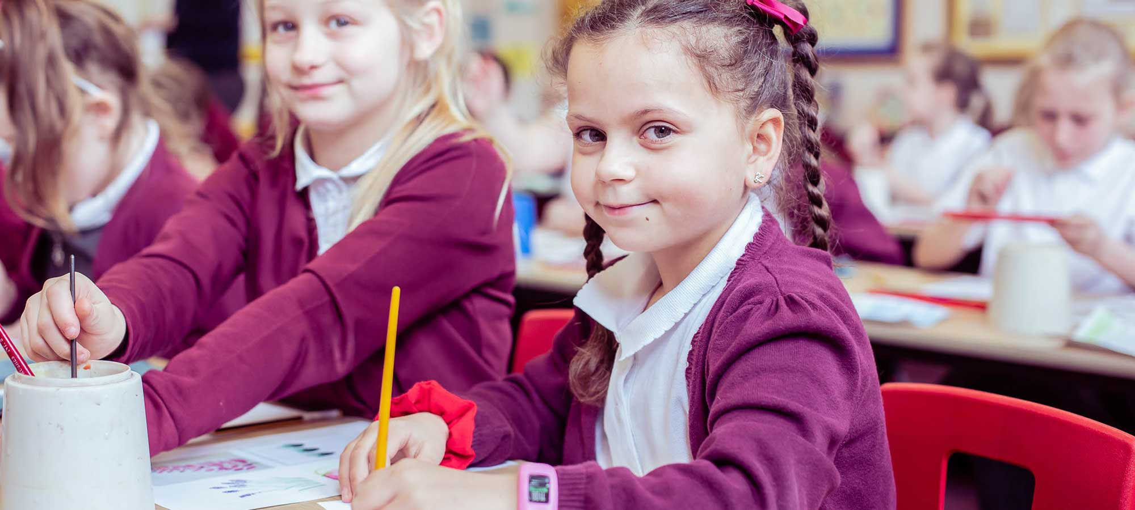

Relationships and Sex Education Policy

Table of Contents
Aims 2
Statutory Requirements 2
Policy Development 2
Openness and access to RSHE materials 2
Definition 2
Curriculum 3
Delivery of RSE 4
Roles and Responsibilities 5
Training 5
Monitoring Arrangements 5
Appendix 1: Relationships and sex education curriculum map (attached under PSHE overview) 7
Appendix 2: By the end of primary school pupils should know. 8
Appendix 3: Parent form - withdrawal from sex education within RSE 10

Aims
The aims of relationships and sex education (RSE) at our school are to:

- Provide a framework in which sensitive discussions can take place.
- Prepare pupils for puberty and give them an understanding of sexual development and the importance of health and hygiene.
- Help pupils develop feelings of self-respect, confidence and empathy.
- Create a positive culture around issues of sexuality and relationships.
- Teach pupils the correct vocabulary to describe themselves and their bodies.

Statutory Requirements

This policy has been developed with regard to the Department for Education’s statutory guidance Relationships Education, Relationships and Sex Education (RSE) and Health Education (July 2025). The policy will be reviewed and updated as required to reflect any future changes to statutory guidance.

Policy Development
This policy has been developed in consultation with parents, pupils and staff, and approved by the Trust. It is reviewed regularly to ensure it remains aligned with statutory guidance and reflects the needs of the school community.

Openness and access to RSHE materials
We are committed to openness and transparency with parents in relation to relationships education, relationships and sex education (RSE) and health education.

Parents may request to view the curriculum content and teaching materials used in RSHE, including any resources provided by external organisations or visitors.

The school does not enter into any agreements that restrict parents’ access to RSHE materials. All external providers are required to share materials in advance and to deliver content that is age-appropriate, factually accurate and aligned with statutory guidance. Requests to view materials will be responded to in a timely and supportive manner.

Appendix 1 provides a summary of the RSE curriculum in our school, and Appendix 2 sets out the knowledge pupils are expected to have by the end of primary school.

Definition
By clearly differentiating between Relationships Education and Sex Education, this policy aims to ensure transparency and clarity for parents, enabling them to make informed decisions about their child’s education while supporting the school’s mission to foster safe, respectful, and well-informed pupils.

Relationships Education
Relationships Education is a statutory requirement for all primary school pupils and focuses on teaching the fundamental building blocks and characteristics of positive relationships.

This includes:
- Families and people who care for us, emphasising the diversity of family structures.
- Caring friendships, exploring the qualities of healthy friendships.
- Respectful relationships, promoting mutual respect and understanding.
- Online relationships, teaching safe and respectful behaviour in digital environments.
- Being safe, ensuring pupils understand personal boundaries and how to seek help if they feel unsafe.

The primary aim of Relationships Education is to equip pupils with the knowledge, skills, and attitudes to build healthy, respectful, and safe relationships throughout their lives.

Parents do not have the right to withdraw their children from Relationships Education, as it is considered essential learning for all pupils to navigate modern society safely and respectfully.

Sex Education
Sex Education in primary schools is non-statutory, except for the biological aspects covered within the science curriculum.

At our school, the focus of Sex Education includes:
- Preparing boys and girls for the physical and emotional changes that adolescence brings.
- How a baby is conceived and born.

Sex Education lessons are designed to be age-appropriate and sensitive to the needs of all pupils, helping them to understand and manage the physical and emotional changes they experience as they grow.

Parents have the right to withdraw their children from the non-statutory aspects of Sex Education.

Requests for withdrawal must be submitted in writing to the headteacher, using the form provided in Appendix 3 of this policy. The school will provide alternative educational activities for pupils who are withdrawn from these lessons.

Curriculum
Our RSE curriculum is set out in Appendix 1. The curriculum is kept under review and may be adapted where necessary to ensure it remains age-appropriate, responsive to pupils’ needs and aligned with statutory guidance. It has been developed in consultation with parents, pupils and staff, and reflects the age, needs and lived experiences of the pupils in our school.

Relationships education and relationships and sex education are taught in a factual, balanced and legally accurate manner. Teaching is age-appropriate and based on the law and statutory guidance. The school does not promote partisan views, political positions or activist agendas through RSE. Where topics may be sensitive or contested, teaching focuses on helping pupils understand the law, respect others, and develop the knowledge and skills they need to keep themselves and others safe.

RSE is taught in a way that is accessible to all pupils, including those with special educational needs and disabilities (SEND). Teaching is adapted where necessary through the use of appropriate resources, additional support, alternative approaches or adjusted pacing, so that all pupils can engage with the curriculum in a way that meets their needs and supports their understanding.

Further detail on the content and sequencing of the curriculum can be found in Appendix 1.

Delivery of RSE
RSE is taught through the personal, social, health and economic (PSHE) education curriculum. Biological aspects of RSE are taught within the science curriculum, and other aspects are included within religious education (RE). Pupils also receive stand-alone sex education sessions delivered by a trained health professional where appropriate. Any external visitors or professionals involved in the delivery of RSE are subject to the same safeguarding, quality assurance and statutory guidance expectations as school staff.

Relationships education focuses on teaching the fundamental building blocks and characteristics of positive relationships. RSE is delivered through a combination of planned lessons, discussion-based activities and age-appropriate resources.

Details of curriculum content and progression are set out in Appendices 1 and 2.

Teaching takes place within the context of family life, taking care to ensure that there is no stigmatisation of children based on their home circumstances. Families may include single-parent families, LGBT parents, families headed by grandparents, adoptive parents, foster parents or carers, alongside other structures. Teaching also reflects sensitively that some pupils may have different forms of support around them, for example looked-after children or young carers.

Where pupils ask questions about sex education content that is not included in the primary curriculum, or where a pupil has been withdrawn from sex education, staff respond in a sensitive, age-appropriate and professional manner. Responses are consistent with this policy, statutory guidance and safeguarding requirements.

Staff do not provide detailed sex education content beyond the agreed curriculum, but ensure pupils are supported, signposted appropriately, and encouraged to speak with a trusted adult where necessary.

Roles and Responsibilities
The CEO will approve the RSE policy and hold the Headteacher to account for its implementation.

The Headteacher is responsible for ensuring that RSE is taught consistently across the school, and for managing requests to withdraw pupils from non-statutory/non-science components of RSE (see Parents’ right to withdraw).

Staff are responsible for:
- Delivering RSE in a sensitive way
- Modelling positive attitudes to RSE
- Monitoring progress
- Responding to the needs of individual pupils
- Responding appropriately to pupils whose parents wish them to be withdrawn from the non-statutory/non-science components of RSE.

All staff are expected to contribute to the delivery of RSE in line with this policy. Staff who have concerns about teaching RSE are encouraged to discuss these with the headteacher so that appropriate support or guidance can be provided.

Pupils are expected to engage fully in RSE and, when discussing issues related to RSE, treat others with respect and sensitivity.

Parents’ right to withdraw - Parents do not have the right to withdraw their children from relationships education. Parents have the right to withdraw their children from the non-statutory/non-science components of sex education within RSE. Requests for withdrawal should be put in writing using the form found in Appendix 3 of this policy and addressed to the headteacher. Alternative work will be given to pupils who are withdrawn from sex education.

Training
Staff are trained on the delivery of RSE as part of their induction and it is included in our continuing professional development calendar. The Headteacher will also invite visitors from outside the school, such as school nurses or sexual health professionals, to provide support and training to staff teaching RSE. Any external visitors supporting RSE delivery are subject to the same quality assurance and safeguarding expectations set out in this policy.

Monitoring Arrangements

The delivery and content of relationships education, relationships and sex education and health education are monitored by school leaders to ensure they remain aligned with statutory guidance. Trustees provide oversight and assurance that the curriculum, teaching materials and use of external providers comply with statutory requirements and this policy.

The delivery of RSE in our school is monitored by school leaders through:

- Lesson observations
- Pupil voice
- Consultation with staff, children & families

Pupils’ development in RSE is monitored by class teachers as part of our internal assessment systems.

This policy is reviewed by the Trust at least every two years and sooner where required in response to changes in statutory guidance. Each review is approved by the CEO.

Appendix 1: Relationships and sex education curriculum map (attached under PSHE overview)

Appendix 2: By the end of primary school pupils should know.

Topic | Pupils should know
Families and people who care about me | - That families are important for children growing up because they can give love, security and stability  - The characteristics of healthy family life, commitment to each other, including in times of difficulty, protection and care for children and other family members, the importance of spending time together and sharing each other’s lives  - That others’ families, either in school or in the wider world, sometimes look different from their family, but that they should respect those differences and know that other children’s families are also characterised by love and care  - That stable, caring relationships, which may be of different types, are at the heart of happy families, and are important for children’s security as they grow up  - That marriage and civil partnerships represent a formal and legally recognised commitment of two people to each other which is intended to be lifelong  - How to recognise if family relationships are making them feel unhappy or unsafe, and how to seek help or advice from others if needed
Caring friendships | - How important friendships are in making us feel happy and secure, and how people choose and make friends  - The characteristics of friendships, including mutual respect, truthfulness, trustworthiness, loyalty, kindness, generosity, trust, sharing interests and experiences and support with problems and difficulties  - That healthy friendships are positive and welcoming towards others, and do not make others feel lonely or excluded  - That most friendships have ups and downs, and that these can often be worked through so that the friendship is repaired or even strengthened, and that resorting to violence is never right  - How to recognise who to trust and who not to trust, how to judge when a friendship is making them feel unhappy or uncomfortable, managing conflict, how to manage these situations and how to seek help or advice from others, if needed
Respectful relationships | - The importance of respecting others, even when they are very different from them (for example, physically, in character, personality or backgrounds), or make different choices or have different preferences or beliefs  - Practical steps they can take in a range of different contexts to improve or support respectful relationships  - The conventions of courtesy and manners  - The importance of self-respect and how this links to their own happiness  - That in school and in wider society they can expect to be treated with respect by others, and that in turn they should show due respect to others, including those in positions of authority  - About different types of bullying (including cyberbullying), the impact of bullying, responsibilities of bystanders (primarily reporting bullying to an adult) and how to get help  - What a stereotype is, and how stereotypes can be unfair, negative or destructive  - The importance of setting, respecting and communicating boundaries, including permission-seeking and giving, in relationships with friends, peers and adults
Online relationships | - That many social media platforms have a minimum age requirement, and that these rules are designed to help keep children safe online  - That people sometimes behave differently online, including by pretending to be someone they are not  - That the same principles apply to online relationships as to face-to face relationships, including the importance of respect for others online including when we are anonymous  - The rules and principles for keeping safe online, how to recognise risks, harmful content and contact, and how to report them  - How to critically consider their online friendships and sources of information including awareness of the risks associated with people they have never met  - How information and data is shared and used online
Being safe | - What sorts of boundaries are appropriate in friendships with peers and others (including in a digital context)  - About the concept of privacy and the implications of it for both children and adults; including that it is not always right to keep secrets if they relate to being safe  - That each person’s body belongs to them, and the differences between appropriate and inappropriate or unsafe physical, and other, contact  - How to respond safely and appropriately to adults they may encounter (in all contexts, including online) whom they do not know  - How to recognise and report feelings of being unsafe or feeling bad about any adult  - How to ask for advice or help for themselves or others, and to keep trying until they are heard  - How to report concerns or abuse, and the vocabulary and confidence needed to do so  - Where to get advice e.g. family, school and/or other sources  - How to recognise when a relationship or interaction feels unsafe or harmful, and that it is always right to seek help if something does not feel right

Appendix 3: Parent form - withdrawal from sex education within RSE

To be completed by parents
Name of child |  | Class
Name of parent |  | Date
Reason for withdrawing from sex education within relationships and sex education
Any other information you would like the school to consider
Parent signature

To be completed by the school
Agreed actions from discussion with parents

Document Detail
Document Name: |  |  | Relationships and Sex Education Policy
Version: |  |  | 3
Chief Officer Signature: |  |  | 
Effective From: |  |  | 01/09/2026
Approved by: |  |  | D Dickinson
Approval Meeting Reference:
Next Review Date: |  |  | 01/04/2027
Version Control
Version | Date | Author |  | Change/Reference
1 | 01/02/2023 | M Bretherton |  | New Policy
2 | 01/01/2025 | M Bretherton |  | Expanded definitions in relation to Sex Education and Relationships Education
3 | 09/02/2026 | M Bretherton |  | Updated to reflect the DfE’s Relationships Education, Relationships and Sex Education (RSE and Health Education statutory guidance (July 2025). Updates clarify the school’s duty to have regard to the revised guidance and strengthen assurance in the following areas: transparency and parental access to RSHE materials; quality assurance of external visitors and resources; factual, balanced and legally accurate teaching, including political neutrality; accessibility and adaptation for pupils with SEND; handling of pupil questions and withdrawal from sex education; and monitoring and governance oversight, including trustee assurance of compliance with statutory requirements. Minor amendments made to Appendix 2 to reflect July 2025 statutory guidance, including updated references to marriage and civil partnerships, strengthened language on boundaries and respectful relationships, clearer expectations around online safety and age restrictions, and recognition of harmful or unsafe relationships.

