BEREAVEMENT POLICY

Period of Review: | 3 Yearly
Next Review Date : | July 2024
Person responsible for implementation and monitoring : | Headteacher  SLT
Other relevant policies : | Safeguarding Policy  Crisis Management Plan Educational Visits Policy  Health and Safety Policy Attendance Policy  Evacuation policy  Positive Handling Policy  First Aid Policy  Data Protection GDPR Policy  E-Safety and Computer Usage Policy

BEREAVEMENT POLICY

INTRODUCTION

Every year 20,000 children under the age of 16 years will be bereaved of a parent and many more will experience the death of someone else special in their life. In addition to these individual pupils, schools may also experience the death of a child at the school or a staff member. It is almost inevitable therefore, that at some time all schools will have to deal with a death that affects the school community.

As children spend the vast majority of their time at school, teachers and staff members will be the primary source of care and support. Bereaved children will see our school as a safe haven away from the turmoil of emotions at home and will look to trusted staff members for help.

Death is something that most people choose not to think about so when faced with it we often find ourselves ill prepared. The purpose of this Bereavement Policy is to help everyone involved at a time when there may be shock, upset and confusion, ensuring that there is as little disruption as possible, effective communication takes place and each member of the school community is supported to help them through a very difficult time.

THE IMPACT OF DEATH ON YOUNG PEOPLE

The impact of death upon children should not be underestimated. While it is true that their understanding of death develops over a prolonged period of time, it is clear that:
  - Young children can suffer deeply as a result of the death of a member of their family.
  - This suffering is more intense when they do not have opportunities to talk or to grieve openly, and do not feel that those close to them recognise their feelings - even though they themselves may not yet have the words to express them.

Reactions to bereavement can include:
Withdrawal Open distress
Tears Panic
Aggression Anxiety
Fear Other signs of stress.

Bereaved children may act out this stress in unexpected ways, such as:
Nervous giggling Stoical bravery
Untypical aggression Becoming the class clown Or total denial

They may also become extremely tired, to the point of exhaustion, as so much emotional energy goes into dealing with the loss and the stress of the changes in the family.
For some children, there may be additional terrors; if the death has been referred to as ‘falling asleep' or ‘being taken', then it is sometimes the case that children become afraid of sleep; words like ‘loss' or ‘lost' can put fear into a young child's mind, too, and they are afraid of losing other family members. Children can become particularly clinging and attached to the members of the family who remain.

An expected bereavement
In addition the death of a terminally ill pupil or member of staff can be planned for with full support being given before the actual event. Often pupils will want to create a memory board to allow their emotions to be shared with others. Open discussion and realistic language are often the best way to deal with issues that arise. Once the pupil or member of staff dies then it is important that all emotional support is given and the need to mourn is recognised.

THE IMPACT OF THE DEATH OF A PET OR LOVED ANIMAL
School should also be aware of the emotional impact the death of a family pet or, for example, a horse or farm animal, might have on a pupil or a member of staff. Emotional support can be offered through the normal channels (pastoral meetings/ELSA groups) and discussion and honesty are vital. Terminology is again important. Again pupils and staff should be encouraged to be honest with their emotions and talk about their memories of their pets. Whilst much of the Bereavement Policy deals with the death of people we should not underestimate how important the death of a pet can be to pupils and staff.

INFORMATION SHARING PATHWAYS RELATING TO EXPECTED OR UNEXPECTED DEATH OF INDIVIDUALS WITHIN SCHOOL COMMUNITY

Headteacher Staff Member

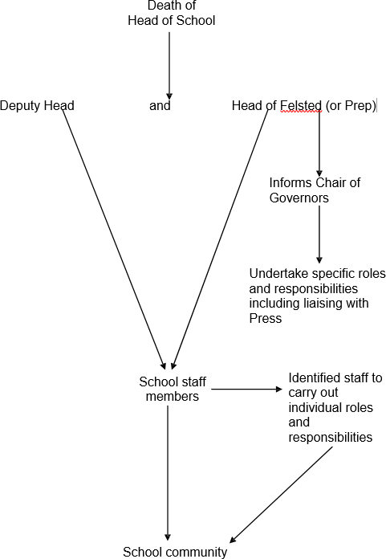
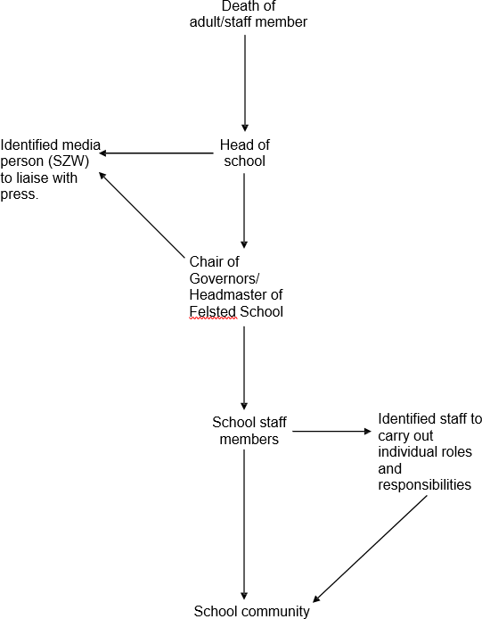

Death of pupil (FPS) Death of pupil (Senior)
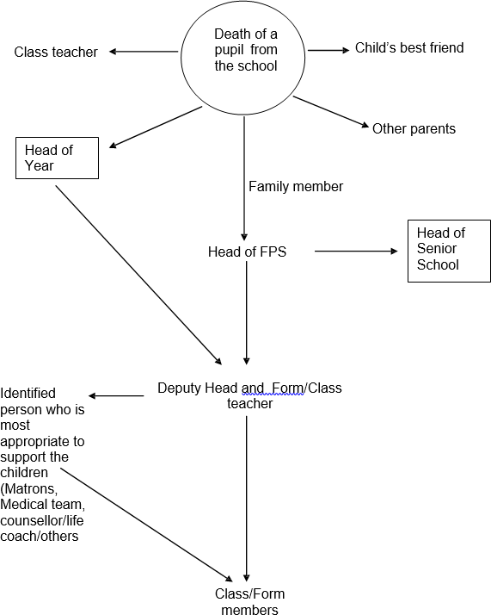
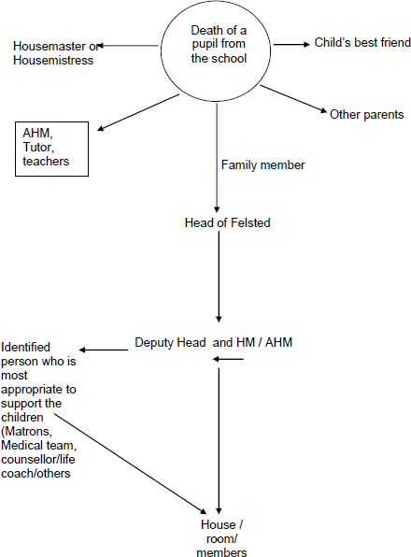

Death of family member (FPS) Death of family member (Senior)

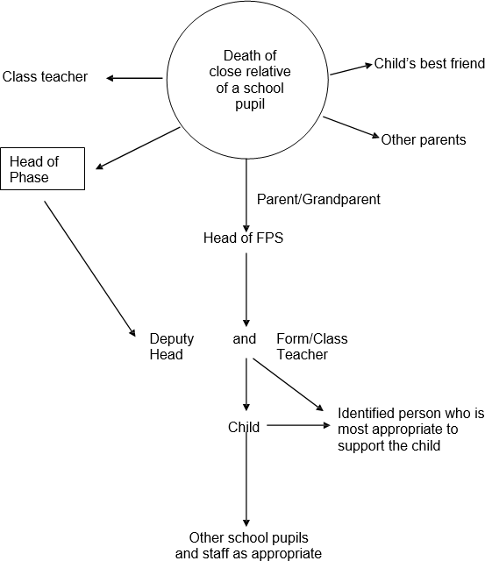
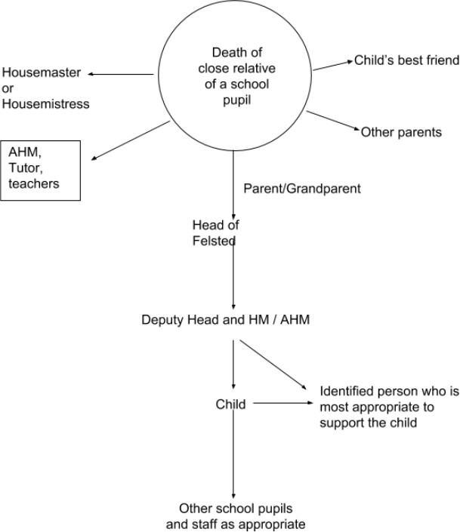

Unexpected death of child Information sharing

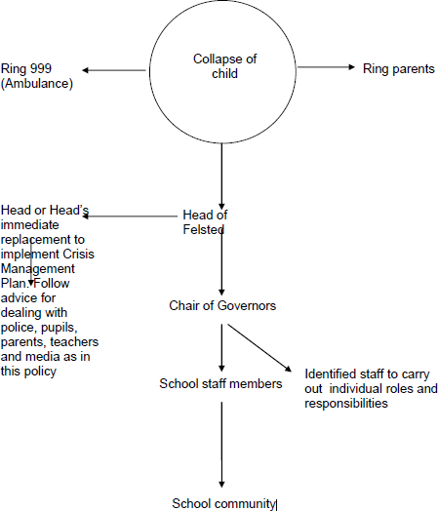
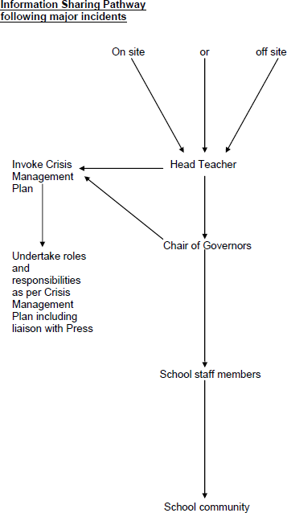

DEATH OF A CHILD

Please see Appendix 1 for full details of handling a death at school or off site. If a child dies at school or on a school trip the Crisis Management Plan should be put into operation immediately. All staff should be issued with sections 2.1 and 2.2 of the Plan.

SPECIFIC ADVICE FOLLOWING A DEATH FOR WORKING WITH POLICE, PARENTS, CHILDREN AT SCHOOL, TEACHERS AND MEDIA

6a Working with the police
Very soon after the death is announced the police should visit as they have to carry out an investigation into the circumstances.

You will need to clear rooms or spaces for them to work in. They may want to collect evidence. The police will normally tell the child's next of kin and will want to speak at once to the (usually very upset) teacher who will need someone with them and will probably need to stay at school.

The police will almost certainly tell you that you must not speculate on the cause of death. But remember that the media are under no such restriction.

6b Telling pupils
Where a pupil collapses during the school day when other pupils are present, is rushed to hospital and subsequently dies, those pupils will need to know what has happened before they leave at the end of the school day. The School will consult with the family regarding their wishes in sharing the information with the School community.
It is important to agree with the police the timing and content of the information that you give to pupils so as to meet the needs of the pupils whilst not impeding any police investigation.
Are there any siblings, close relatives, or friends who need to know first? Advise them first, but only when parents are ready to collect them.

Gather the year group together at an appropriate time. The pupils will listen until you tell them that the pupil has died. Then they stop hearing. If the pupil has died as the result of an accident you may want to ask them not to speculate about the causes of the accident and not to spread rumours. Getting them to hear this is very difficult. Allow them ten minutes to just be together as a year group. They will need to cry. Expect that some pupils will contact the local press.

6c Telling teachers

This may have to be after you have told the key pupils. You will need to tell the teachers who were nearest to what happened first. Depending on who that teacher is, they will probably need someone with them. If you want teachers to tell other pupils for you, have a statement ready for them to read out before you advise them.

6d Telling parents

The police will tell the parents of the child. Getting a letter to other parents, which both expresses sympathy and gives factual information about the death, is very important. It saves rumours, which can be intensely hurtful to pupils, parents and teachers.

DEALING WITH THE MEDIA
The nominated press officer should field enquiries. You may well need intense help. A press officer may be required for the whole day.

The press and local TV channels may contact the parents and may speculate about the cause of death. This is a very hard thing to deal with, especially if a TV crew has filmed this speculation by distraught parents.

You may find you have no time to prepare interviews but aim to filter statements through the Head and Press Officer (SZW). Keep expressing your sympathy for the parents so that editors will find it hard to cut this part of your statement.

If there is a post-mortem, this may happen very quickly, possibly within 24 hours of the death. Ensure you are advised of the results of any post-mortem as soon as possible. The best way to stop speculation is to give facts.

ASSISTANCE FROM THE EDUCATION BODIES

The Department for Education helpline: 0370 000 2288. IAPS – Press and Communications: 01926 887833.
HMC - Press and Communications Officer: 01858 461953 DfE Schools and Education policy:
Chief Media Officer: 020 7340 7488
Senior Media Officers: 020 7340 7442
Media Officers: 020 7654 6085, 020 7340 8086 or 020 7340 8093

MONITORING AND EVALUATION
When an individual case arises, the policy is adhered to and therefore is monitored through this process and adjusted as required. The policy is evaluated in accordance with the policy monitoring and evaluation cycle and the date of renewal is stated on the header of this policy.

C. J. Townsend Head Felsted School

S. C. James
Head Felsted Preparatory School

APPENDIX 1: DEATH OF A CHILD POLICY

- IMMEDIATE ACTION

If a child dies at school or on a school trip the Crisis Management Plan should be put into operation immediately. All staff should be issued with sections 2.1 and 2.2 of the Plan (see below). On discovery of a possible death, the member of staff should:

  - Call the emergency services at once, including paramedics and police.
  - Summon Medical Centre staff (if on site) and Deputy Headmaster (to activate Crisis Management Plan)
  - Secure scene and remain with the body until help arrives

FROM THE CRISIS MANAGEMENT PLAN

All staff should be familiar with the following immediate actions required to activate the Crisis Management Plan (Sections 2.1 and 2.2 of the Crisis Management Plan)

Immediate Response to an Emergency
  - At School
In responding to an emergency during normal school activities it will be the responsibility of the Housemistress, Housemaster or Boarding Master, Head of Department or Member of Common Room in charge to ensure that:

    - The building, if appropriate, has been evacuated.
    - The necessary Emergency Services have been summoned.
    - A roll call has been taken to ascertain that all pupils, staff and any visitors are safe.

Off-Site Activity
It is the responsibility of the Teacher in Charge of the Group, or, where necessary, by delegation to another Member of Staff or Responsible Adult, to:

    - Make sure that all members of the party are accounted for and that they are safe.
    - If there are injuries immediately establish their extent and administer appropriate first aid.
    - Call emergency services if required.
    - Ensure that the remainder of the party is adequately supervised throughout and make arrangements for their return to base, either School or Field Trip Base.
    - Arrange for at least one adult to remain at the incident site to liaise with the emergency services and to ensure that all the staff and pupils are accounted for.
    - Control access to telephones until contact is made with the Headmaster or Headmistress (as appointed), emergency contact point or designated senior member of staff and until he/she has had time to contact any parent whose children are directly involved.

It will be the job of the DSL to ensure that school records are updated.

ALL OTHER ASPECTS OF THE CRISIS MANAGEMENT PLAN APPLY

Specifically, there should be due regard paid to the priorities listed in Section 1.2, and to the specific guidance in Appendixes E and F amongst others. The death of a child is an extremely serious occurrence and must be handled correctly, appropriately and sensitively towards all parties involved at all times.

CARE FOR THE BEREAVED AND THE COMMUNITY

Following the death of a child either at school or on a school off-site activity every measure will be taken at appropriate times to provide support and counselling for those who need it:

- to liaise with the family and to support them
- to establish appropriate ways for pupils and staff to assist grieving
- to honour memory
- to manage the shock and loss of such an event
- to organise and re-establish normal daily business within the school.

Measures may include:

- specific support for those closest to the child who has died
- the opportunity for quiet time out of normal activities if appropriate in the weeks immediately following the death . The Wellbeing Centre may be an appropriate place for this.
- permission for close friends not to compete in a fixture or take part in a concert etc if they do not feel able to
- the completion of a special circumstances examination form for close friends if the loss is close to an examination period
- Counselling support from one of the school counsellors
- other such reasonable steps.

It is usually appropriate for the whole community to achieve some closure through a memorial service or similar event, after a period of time has elapsed. It may be that members of the child’s family would be able to attend a memorial event of this kind, and draw some comfort from attending and meeting their son’s or daughter’s friends.

CHILD DIES AWAY FROM SCHOOL

If a child dies during the school holidays and away from school, the points in section 4 should still be followed. The member of SLT on duty at the time should contact the Headmaster, the Head of the Preparatory School and the rest of the Senior Leadership Team, as well as the HMs, and other senior staff.

All staff may need support, and pupils should be contacted, especially any known close friends. A letter from the School to the rest of the school community should be sent as soon as possible.

REVIEW
This Policy will be reviewed and updated three yearly by the Heads and Senior Leadership Teams.

APPENDIX 2:

TEMPLATE OF A LETTER INFORMING PARENTS OF THE DEATH OF A MEMBER OF STAFF

Felsted School Felsted
Essex CM6 3JD

<Date>

Dear Parents

I have had the sad task of informing the children of the tragic death of
<Name> who has been a teacher at this school for a number of years.

Our thoughts are with <Name …….’s> family at this time. All the pupils have been informed. Many will have known <Name….> for many years and have been taught by him / her. They will have different memories, but will share the common bond that one of their teachers has passed away. He / she has given so much to the school and will be sadly missed

When someone dies it is normal for family and friends to experience many different feelings such as sadness, anger and confusion, and young people can sometimes become quiet or withdrawn, angry, seek the company of their immediate friends, or ask questions about the meaning and purpose of life, and the nature of death.

The pupils have been told that their Housemaster or Housemistress, Tutor, or any member of the teaching staff, will provide support and help if they wish to discuss their feelings. The school can offer counselling support for those most deeply affected.

We will of course keep you informed as to the funeral arrangements and the date and time of any memorial service. I am very sorry to have to write to you in this way.

Yours sincerely

Mr Chris Townsend Headmaster

APPENDIX 3:

TEMPLATE OF LETTER INFORMING PARENTS OF DEATH OF A PUPIL

Before sending a letter home to parents about the death of a pupil, permission must be gained from the child’s parents. The contents of the letter and the distribution list must be agreed by the parents and school.

Felsted Preparatory School Felsted Essex CM6 3JL

<Date>

Dear Parents

Your child‟s class teacher/form tutor/had the sad task of informing the children of the death of <Name>, a pupil in <Year>.

<Name> died from the illness we know as cancer. As you may be aware, many children who have cancer get better but sadly <Name> had been ill for a long time and died peacefully at home yesterday.

He/She was a very popular member of the class and will be missed by everyone who knew him/her.

When someone dies it is normal for their friends and family to experience lots of different feelings like sadness, anger and confusion. The children have been told that their teachers are willing to try to answer their questions at school but if there is anything more that you or your child needs to know, please do not hesitate to ring the school office and we would be more than happy to help you.

We will be arranging a memorial service in the school in the next few months as a means of celebrating <Name..‟s> life.

Yours sincerely

Mr S James

APPENDIX 4:

GUIDELINES FOR BREAKING NEWS ABOUT A DEATH TO STAFF AND GOVERNORS

- Arrange a staff meeting which should take place as soon as possible.
- Impart factual information. Never make assumptions or repeat what has been said by rumour.
- Give news sensitively and empathetically, being aware that people may react in different ways.
- Be cognisant of the relationships staff may have had with the person who has died.
- Ensure that there is someone responsible for telling people who are unable to attend the staff meeting i.e. part time staff, peripatetic staff, lunch time supervisors. Consider the best way of imparting the information to those absent e.g. by doing home visit, by telephone, text or e-mail etc.
- Identify individual members of staff who feel able to:
- support members of staff
- support groups of children
The most appropriate person to support the children should be well known to them and trusted.
- Identify a member of staff who will liaise with the individual’s family, to deal with staff condolences and any funeral arrangements (if necessary).
- Identify an appropriate member of staff who will take ‘phone calls and/or direct them as appropriate. Try to establish a “protected” telephone line to ensure free flow of accurate information.
- Identify a member of staff who will provide a newsletter for parents (see examples of letter templates) which should be sent the same day.
- Arrange a staff meeting at the end of the day to ensure staff are coping with the situation.
- Identify any unresolved problems or ongoing issues.
- Ensure that those staff that live alone have contact numbers of friends in case of need.
- Identify sources of advice and support to access for help in coming to terms with the bereavement (see bereavement toolkit).

APPENDIX 5:

GUIDELINES FOR BREAKING NEWS OF THE DEATH TO THE PUPILS

- Inform the pupils as soon as possible about the death.
- Where possible, the pupils should be informed in small groups i.e. class or tutor groups, or House groups by age.
- Identify those children who had a long term and/or close relationship with the person who has died so they can be told separately.
- If appropriate, a special assembly could be held at a later time in the day to remember the person who has died.
- Allow the pupils to ask questions and answer them honestly and factually in terms that they will understand.
- Allow the pupils to verbalise their feelings.
- Allow the pupils to discuss the situation and share their experiences of death.
- Be honest about your own feelings and talk about your relationship with the person.
- Avoid using euphemisms.
- Those pupils who have had more involvement with the person should be given the opportunity to share their feelings and experiences either within the group or in a one-to-one situation.
- Reassure them that not all people who are ill or have had an accident will die and that many people get better.
- Put an appropriate time limit on the discussion. It is preferable to resume normal school activities as soon as possible thus ensuring minimal disruption within the school.
- Conclude the discussion with a prayer or special poem to remember the person who has died and their family.
- Be available for any pupil who needs additional help and support.
- Refer to the bereavement toolkit for further guidance.

APPENDIX 6:

THINGS TO CONSIDER IN THE DAYS FOLLOWING THE NEWS OF THE DEATH

- It is important to consider any cultural or religious implications and seek advice if necessary.
- Ensure nominated staff with responsibilities for supporting staff and children, are available to do so.
- It may be necessary temporarily to provide staff cover for their normal activities.
- Identify an allocated quiet place where children, young people and staff can go if necessary (the School Chapel would be an obvious place).
- It is preferable for there to be minimum disruption to the timetable but some flexibility may be required.
- Try to engender an awareness of when people need help and support, particularly those who worked closely with the person who has died and secretaries/administrative staff who are taking telephone calls, dealing with parents etc.
- Through the nominated staff member who has responsibilities for liaising with the individual’s family, ascertain their wishes about the school’s involvement in the funeral, if any.
- Putting an obituary in the paper, sending flowers to the home or to the funeral, making a collection etc.
- Who will attend the funeral, making a collection etc.
- Cover for any staff who may be going to the funeral.
- Transport to and from the funeral.
- Informing the parents of those pupils who will be involved.
- Possible closure of the school. If this is the case remember to tell appropriate staff in advance.

APPENDIX 7:

BEREAVEMENT TOOLKIT
The Bereavement in School Toolkit is a resource to be used at Felsted School offering guidance, examples and possible solutions to problems encountered on a day to day basis when trying to help bereaved children. It also includes a list of resources and useful contact details when looking for help and support.

How the school can help

- Make sure that the right people are informed

It is essential that all staff, including support staff, know about the bereavement, so that they can respond sensitively.

Make sure that children are given an opportunity to discuss their feelings of bereavement with an adult that feels confident in this area and is able to give each child space for their different and normal feelings.

When the report of the death first comes to school, it may be appropriate for the relevant staff (for each bereaved sibling), to talk to the House or year- group within it, to create opportunities for them to ask questions and discuss how they can help their bereaved classmate. On the child's return to school, even close friends may need encouragement to voice difficult feelings, to say, “I'm sorry your brother died”. One of the key ‘hurts' which bereaved children recall is the feeling that few people, if any, acknowledged their loss.

Most children welcome the opportunity to talk privately to an adult about their loss. Even if the child cannot verbalise his or her feelings, it is helpful for a trusted teacher to show sympathy (without saying “I know how you feel”), and to use words like sad, lonely, upset, afraid, so that the child realises the school knows about the death. The family may be so overwhelmed by the trauma that little individual acknowledgement is given to the child's feelings when they are at home.

Some children need a retreat when grief overtakes them, and it helps if the school accepts a pupil's need to express their grief, providing a ‘safe place' and a trusted adult to be with them. Once the bereaved child returns to school routine, it is helpful to share concerns with parents so that they know how he or she is coping in school. Most families appreciate some sort of direct communication from the school, especially if the child who has died was a former pupil.

Be prepared to create exceptional circumstances for particular children who need particular help. Set up clear boundaries and make it clear that you have allowed certain behaviours to happen. When the child is ready you can

reverse these arrangements. A bereaved child for example may well need to be allowed to behave in a special way according to how they are dealing with the situation. The key is to try to create a normal environment for them by asking what they want to do. Talking, sharing with a Counsellor, writing or drawing are very common forms of expression which can help. It is always best to talk this through and share ideas with Deputy Heads, Deputy Head (Welfare) or the Designated Safeguarding Officer. They will help you to decide what to share with other children.

Notes in italics from Jane Addis of Suffolk County

Seek creative, but sensitive ways of constructively moving the child forwards

Books, stories, music and art can be very helpful in exploring loss, both with other pupils and with the bereaved child. There are many excellent books written on bereavement for different ages of children, both in the fact and fiction sections, now available from shops, libraries or the web, and many school libraries have a selection of such recommended publications. Sensitivity is needed so that deep grief is not triggered at an inappropriate time. For example, a school assembly using literature on the subject might help the school to explore grief and loss, but not when a newly-bereaved child is present. The Scholastic book ‘100 Assemblies’ contains some good ideas on assemblies dealing with loss and change (p.66 – 80).

Be aware that this is likely to take a long while and be prepared to allow for anniversaries and gestures over time

The grief caused by the death will be long-lasting, and schools need to recognise that anniversaries and celebrations will be difficult – especially the first birthday and Christmas or other religious festivals. It will help if key dates and times are noted and passed on to the next class teacher or next school, along with other records and information. As children mature, the death is felt and questioned at new levels, both emotionally and intellectually, often causing renewed grief and distress.

Close friends of the bereaved boy or girl, or of the child who has died, will suffer varying grief reactions. Their teachers will probably need the support of colleagues at this time; they might need to be reassured that their ideas for giving comfort to the children are wise, and that they will be of benefit to those in their care. Many younger teachers themselves may not have experienced bereavement, especially of this kind, before.

If the person who died was a pupil at your school, you might feel it appropriate to send a representative to the child’s funeral or a Memorial or Thanksgiving service – if the family are in agreement with this idea. Also, in these circumstances, the child’s books and work should be kept carefully and returned to the family by a teacher at a suitable time.

Helping the school recover
This is a long-term issue. You can help a school recover through a memorial service or assembly and through the use of counsellors. Recognise that those who go to counsellors may well not be those whose need is greatest. A brother or sister may well have intense needs that appear later. It is very difficult for the school to know when to stop making allowances.

APPENDIX 8

Suggested Reading

Prep/Years 3 + 4

Alicia Sims : Am I still a sister? Big A & Co, 1986. ISBN 0-9618995-0-6

Susan Varley : Badger’s parting gifts HarperCollins, 1992. ISBN 000 664 3175 Remembering my brother Ginny Perkins A&C Black, 1996ISBN 0-7136- 4541-5
Doris Stickney: Waterbugs and dragonflies Mowbray, 1997. ISBN 0 264 66904 5
Diana Crossley: Muddles, Puddles and Sunshine Hawthorn Press (2 Oct. 2000) ISBN 1869890582

Years 3 – 8

E. B. White : Charlotte’s web Penguin, 1993. ISBN 014 036 4498

Gloria Houston: My brother Joey died - TCF (USA), 1982. ISBN 0-671- 42401-7

Dwaine Steffes : When someone dies: help for young people coping with grief Cruse Bereavement Care, 1997 (student edition). ISBN 0 900 321 113

Linda Hoy: Your friend, Rebecca Heinemann Educational, 1992. ISBN 043 512 3882 Charlotte Moundlic: The Scar Walker (7 Feb. 2013) ISBN 140634415X

Cloisters Pupils

Oliver Jeffers: The Heart and the Bottle

Courtauld House Pupils

Jacqueline Wilson:Vicky Angel by (for the loss of a friend)

Years 7-9
Charlotte’s web E. B. White Penguin, 1993. ISBN 014 036 4498
My brother Joey died Gloria Houston TCF (USA), 1982. ISBN 0-671-42401-7 When someone dies: help for young people coping with grief Dwaine Steffes Cruse Bereavement Care, 1997 (student edition). ISBN 0 900 321 113
Your friend, Rebecca Linda Hoy Heinemann Educational, 1992. ISBN 043 512 3882

Teachers
Forgotten mourners, The: Susan Smith Guidelines for working with bereaved children Jessica Kingsley, 1999 (2nd edition). ISBN 1 85302 758 8
Good Grief – No. 2: Over 11s and adults Barbara Ward Jessica Kingsley, 1995 (2nd edition). ISBN 1 85302 340 X
Talking with children and young people about death and dying Mary Turner Jessica Kingsley, 1999. ISBN 1 85302 563 1
When someone dies: how schools can help bereaved students Dwaine Steffes Cruse Bereavement Care, 1997 (teachers’ edition). ISBN 0 900321 10
5

Supporting Bereaved Students in Primary and Secondary Schools — practical advice for staff is a booklet that has been developed by King’s College London and the National Council for Hospice and Specialist Palliative Care Services, now the National Council for Palliative Care (NCPC). It offers advice and support to school staff and includes tips from teachers who have had experience with bereaved children. An extensive resource list is included for those who wish to look further into the issues explored or enlist further support.
The booklet can be ordered from NCPC by contacting Nick Hayes by email
n.hayes@ncpc.org.uk or by telephone 020 7697 1520.

Addendum to the Bereavement Policy (Covid 19 Pandemic)

The School realises the need for a specific bereavement protocol applicable during the current pandemic. In the unfortunate event of a death from Covid 19 of a member of staff, a pupil or a pupil’s close relative, the School must find ways to respond appropriately, supporting all members of the School community and enabling them to process their grief. The death of a child is an extremely serious occurrence at all times and must be handled correctly, appropriately and sensitively toward all parties involved at all times.

This addendum sets out evaluation of the impact of such a death, appreciating the unexpected nature of the death from Covid 19 and the extraordinary social circumstances (social distancing, temporary school closure, community lockdown) which affect the ability to enact the standard Felsted School Bereavement Policy. In these circumstances, it is important that all emotional support is given and the need to mourn recognised. It is also vital to remember that Felsted students are likely to have been frightened and alarmed already by the large numbers of deaths from Covid 19 and experiencing a bereavement in this context may prove to be extraordinarily upsetting.

Death of a member of the Felsted Community from Covid 19

Information-sharing pathway:

Death of a Prep or Senior School Pupil

In accordance with the wishes of the family, the Heads of both schools should be informed together with the class teacher/tutor/HM of the pupil, the Leadership Teams, the Senior HM, the Heads of Phase and the Chaplain.

Then, the parents of all other pupils (Senior and Prep) should be informed via email which contains advice on how to speak about death with young people so that they can inform their children face-to-face. The template in Appendix 3 may be helpful. The Governors should be informed and the Press Officer (SZW) should be made aware.

In the current situation where the School is temporarily closed and access to the Wellbeing Centre or Chapel is not possible, social media or a dedicated section of the school website could be used (e.g. a Facebook Page or other online document shared by all) so that pupils and parents may record their feelings and come together in community to share their grief. Special focus should be given to the siblings and close friends of the deceased pupil as well as their teachers.

A member of staff should be identified to liaise with the family of the deceased during this time. Other key staff should be assigned to the different, affected parties (e.g. friends, Boarding House staff (AHMs, Resident Tutors, Matrons, domestic staff], Tutor) to help them in the following weeks.

When School reopens, there should be a gathering or memorial service for the pupils and staff to come together in grief and support of one another. The Chaplain may wish to address the whole school community and lead an online service of remembrance at a later date. It is to be expected that there will continue to be considerable grief felt by the community for some time and this may affect pupils’ academic work and behaviour detrimentally.

The Chaplain, together with the counsellors of the Wellbeing Centre, the HoPs, HMs and Tutors should be available to support any children affected by the bereavement and contact between the parties should be regular. Peer counsellors may play a part in the support team if they feel able.

Pupils should be given access to other external support services. A list of these can be found at the end of this document.

Death of a Staff Member

The Head, Leadership Team and Governors should be informed, as should the President of the Common Room and the Press Officer. The counsellors and Chaplain should be alerted.

Then, staff should be informed by email with links to an online document where they can record their grief if desired. Support for staff will also be available via the Employee Assistance Programme. At this point the parents and pupils should be informed by email with links to further support. The template in Appendix 2 may be of use.

Particular support should be offered to any children of the deceased who attend the school. The effect of the death of a staff member upon his/her pupils should not be underestimated and the HoD could offer support to affected classes by offering a time of remembrance as well as signposting the pupils to other support.

The Head should liaise with the family of the deceased to ensure their wishes are respected. Further on, a memorial service could be organised by the Chaplain. The nature of this would be determined by the restrictions of movement and social- distancing.

Death of the parent or sibling of a Felsted pupil

The Heads of both schools should be informed with the news disseminated to all staff by email. Particular attention should be given to the family members of the deceased and to pupils who are close to the family. The HM/HoP and tutor of the affected pupil/s should be informed and they can coordinate the support offered. The counsellors will be made available as will other external sources of support.

Advice from Essex County Council regarding Critical Incidents

If the incident involves a death within your community and you feel you can manage the incident response without any further support, please complete the Notification Form, but selecting 'no' to support.

If you require further support after looking at the resources, then please complete the Notification Form, selecting 'yes' to support.

Please send completed forms to schools.communication@essex.gov.uk

The Schools Communication Team will then pick the form up and pass it on to the relevant services for support and information. The requested services will then make contact with you, within 24 hours.

If you feel like you need to speak to someone to discuss what support is available, then please call the Schools Communication Team on 0333 013 9880.

This line monitored Monday to Friday 8am - 4pm. If you call and there is no answer, please leave a message. If a message is left between the mentioned hours, someone will get back to you the same working day, however if you leave a message after these hours, your call will be returned first thing the next working day.

Additional guidance for specific incidents is available below.

Guidance for Specific Incidents:

- Coping with Bereavement - schools consider preparing for such an eventuality and consider developing a Bereavement Policy. Have a look at the Checklist for Schools dealing with a Critical Incident, consider how to Share Sad News and see Information and Resources for Helping to Cope with Bereavement and Loss

External sources of support Winston's Wish
https://www.winstonswish.org/coronavirus/

Grief Encounter https://www.griefencounter.org.uk/serviceupdate/

Childhood Bereavement Network http://www.childhoodbereavementnetwork.org.uk/covid-19.aspx

Hope Again (youth section of Cruse) https://www.hopeagain.org.uk/

The bibliography of suggested reading for young people and children can be found under Appendix 8.

