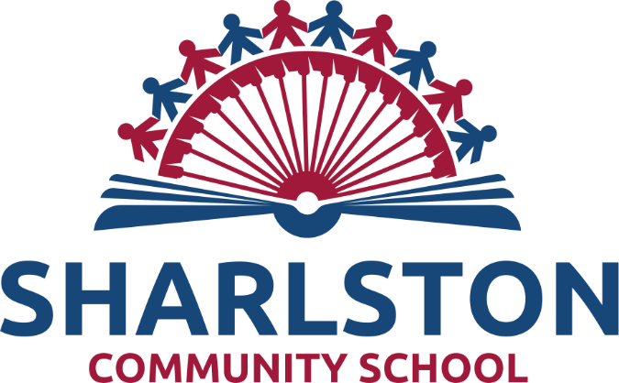

Sharlston Stars
Wraparound Childcare

Booklet for parents
2023

Sharlston Stars
Wraparound Childcare provided by Sharlston Community School

At Sharlston Community School, we aim to create an inclusive, caring, safe and stimulating environment in which each and every child can reach their full potential. We are a happy and hard working community and believe every child should have the opportunity to SHINE and experience success.

Our caring staff provide support and encourage children to be the best they can be. Wraparound childcare in Sharlston Stars Breakfast and Afterschool provision offers positive, memorable experiences with opportunities for high quality play and positive social interactions.

Sharlston Stars wraparound childcare is open to children from Reception to Year 6. It offers Breakfast and After School childcare, term time only, for pupils on-role at the school.

Management of Sharlston Stars Wraparound Child Care
Overall responsibility of is held by the headteacher, Mrs Dunderdale.

Our Breakfast Club Supervisors are Mrs Beecher and Robinson.
Our After School Club Supervisors are also Mrs Beecher and Robinson, who work on a rota basis with Mrs Maryse Coyle. All the staff at Sharlston Stars are also lunchtime supervisors.

Mrs Loxton, in the office, manages the My Child At school App online bookings and payments for both clubs – sharlstonadmin@watertonacademytrust.org

Staff at Sharlston Stars hold First Aid and Food Hygiene training, as appropriate.

Regular communication between all school staff takes place to ensure the best care is provided for the children attending Sharlston Stars. The Wraparound childcare provision adopts all the appropriate policies, including:
• Safeguarding • Health & Safety • Special Educational Needs • Behaviour
Copies of these policies are available on the school’s website or on request and, if parents have any queries or concerns, they should contact the school.

Bookings and Payments
All places for Breakfast or Afterschool childcare must be PREBOOKED. We are unable to accept last minute requests for places unless there are exceptional circumstances. Cashless payments for both clubs should be made by purchasing places via the school’s My Child At School App.
Please ensure you inform the school office if your child has any allergies that school need to be aware of
Please note that regularly failing to pay on time for childcare will result in places being withdrawn.

Sharlston Stars Breakfast Club
The cost of Breakfast Club is currently £2:50 per session.
Breakfast Club begins at 7:45am and runs until the start of the school day, when children are taken to their classrooms.
Entry to the Breakfast Club is via the main door by the school office.
Breakfast is served up to 8:30am.
Typical menu
We offer a selection of healthy cereals:
Cornflakes – Cheerios – Shreddies – Rice Krispies – Weetabix
We offer toast with:
Butter – reduced sugar jam – marmalade
Sliced fruit is always available
Drinks: Water, milk, high fruit orange or blackcurrant
We occasionally offer bagels, crumpets or hot cross buns as a treat.
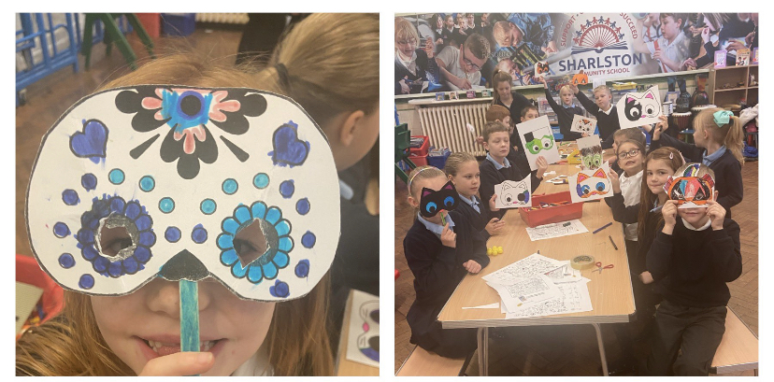

Typical Activities
7:45- 8am Active sports and games in the hall
8:am Breakfast is served, followed by indoor activities in our Wraparound Childcare room, near the Reception Classroom
8:40 Tidy away ready for children to go to classrooms for their register to be taken

Indoor activities include:
Colouring, crafts, Twister, board games, card games, jigsaws, role play area, Jenga, mini pool
and many more fun games!

After School Childcare
The cost of after school childcare at Sharlston Stars is:
£4 for a 4:15 pick up (with no food)
£6:50 for a 5pm pick up, which includes a light meal
Collection from Sharlston Stars is via the main door by the school office at the above times. Please ensure you are on time to avoid being billed for late fees.
If anyone other than you will be collecting your child, you need to let us know. Please do this as early as possible so we can pass the information on to the After School Care Supervisors.
The Sharlston Stars after school staff work on a rota basis:
Mon | Tues | Weds | Thurs | Fri
Mrs Beecher | Mrs Beecher | Mrs Beecher | Mrs Beecher | Mrs Beecher
Mrs Robinson | Mrs Maryse-Coyle | Mrs Robinson | Mrs Maryse-Coyle | Member of SLT

Typical Menu
Healthy snacks are provided after 4:15pm, for those children staying until 5pm. Lots of options are offered during the week, including:
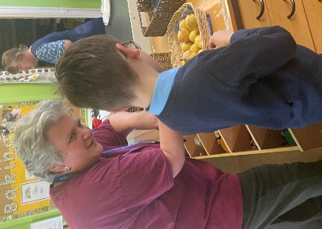
Toasties - pizza pittas - crackers and cheese – wraps – soup - beans on toast - boiled or scrambled eggs – range of sandwiches - pasta
Sliced fruit and/or vegetables are always available
We occasionally offer pancakes, bagels, crumpets or hot cross buns as a treat.
Drinks:
Water, milk, high fruit orange or blackcurrant juice
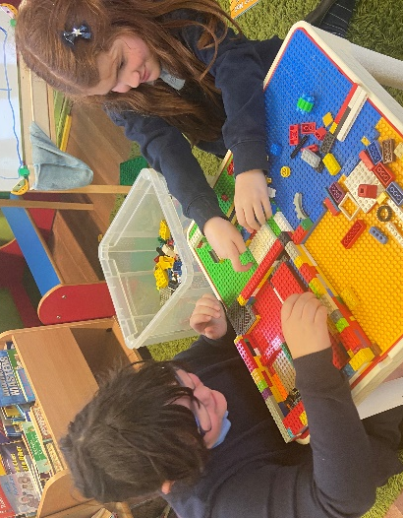
Typical Activities
There are always a range of quiet and more active games available:
Quieter games
Board games – construction activities – jigsaws – puzzles – drawing and colouring activities – snap cards
Supervisors also plan themed Arts and Crafts activities
Active games
Role play area – dancing - dressing up games – Operation – Wire game – Twister – Pass the Beachball – mini pool – puppet theatre
Supervisors also lead games such as Charades, Simon Says, Music Statues and Sleeping Lions.

Behaviour at Wraparound Childcare
Sharlston Community School is a happy, friendly school and we encourage the children to be thoughtful and polite in their interactions with each other. All adults and children involved in any way in the life of the school, including Sharlston Stars Childcare, are expected to follow the school’s Behaviour Policy and keep the three simple, clear and positive rules: Ready Respectful Safe
All our supervisors act as a good role model in their own behaviour and actions. They also understand that the best way to deal with poor behaviour is to establish a positive ethos where pupils are valued for being good.
Supervisors proactively deal with behaviour issues before they occur e.g. by planning fun, motivating activities, by consistent use of praise and by establishing good relationships so children feel safe, thus minimising incidences of poor conduct.
Wrap Around Care Colour Chart Behaviour System
Sharlston Stars uses a visual Colour Chart Behaviour system as the one children are used to in class. This incorporates both rewards and sanctions to support good choices.
All children start the Sharlston Stars session on the Green; Ready Respectful Safe
Our motto in school is that ‘It’s Good to be Green’ therefore it is expected that children will follow the three school rules at all times and therefore remain on Green. Children may then make choices which result in them moving up (exceptionally good behaviour) or down (poor behaviour choices) the Colour Chart.
Children can earn smiley tokens by being extra kind, helpful and well-mannered during the sessions.
The way that adults speak to pupils (and about pupils), and the way that adults allow pupils to speak to each other, directly impacts on the self-­‐esteem, confidence and motivation that a pupil has, which in turn impacts on the pupils’ behaviour. Therefore, at Sharlston Stars, we strive to ensure that:
- all adults act as good role models for pupils including the way that they speak, dress, behave, etc.
- any negative comments only refer to the behaviour that the pupil has displayed and not about the pupil personally
- adults never use sarcasm to embarrass a pupil and never publicly ridicule/reprimand a pupil
- adults avoid shouting, except in extreme situations, (remembering the less we shout the more effective it is if we have to)
- in every possible situation, ALL adults model the behaviour they expect from our pupils
- In every possible situation, ALL adults praise pupils displaying the good behaviour expected at this school
- All staff promote a restorative approach to dealing with conflict, but are aware that this works best when pupils are ready and able to participate

What to do if your child is having a problem during Sharlston Stars Wraparound Childcare
At Sharlston Community School, having kind and healthy children who feel safe and happy at school is a priority for us. including the time they spend at Sharlston Stars.
Hopefully your child is settled and happy and is enjoying their time spent at Sharlston Stars. However, there may be a time when your child is having a difficulty and you may need help in resolving the problem.
Please talk to the Supervisors, or alternatively your child’s classteacher. We can’t ‘fix’ something if we don’t know it’s ‘broken’!
Please complete and return the form below to school if you wish your child to attend
our Breakfast or After school child care provision

Sharlston Stars Childcare
I would like to request places for my child(ren) at Sharlston Stars
Child(rens) name(s) ______________________________________________________________________
I understand that places need to be pre booked and paid for at the time of booking.
I understand that places are dependent on my child(ren) following the school rules and places may be withdrawn if their behaviour is disruptive or unsafe.
I understand that non payment will result in places being withdrawn.
I understand that pick up times are 4:15pm or 5pm and regular late pick up will result in late fees being charged.
I understand that I should provide here any medical information and alerts of allergies that Wraparound Childcare Supervisors should be aware of
Please tick:
No important medical information needed to be passed on
Or
Important Medical information you need to be aware of :
___________________________________________________________________________________________________________________________________________________________________________________________________________________________________________________________________
Please name, sign and return this form to the school office
Name: __________________________________
Signed: __________________________________
Date: __________________________________

