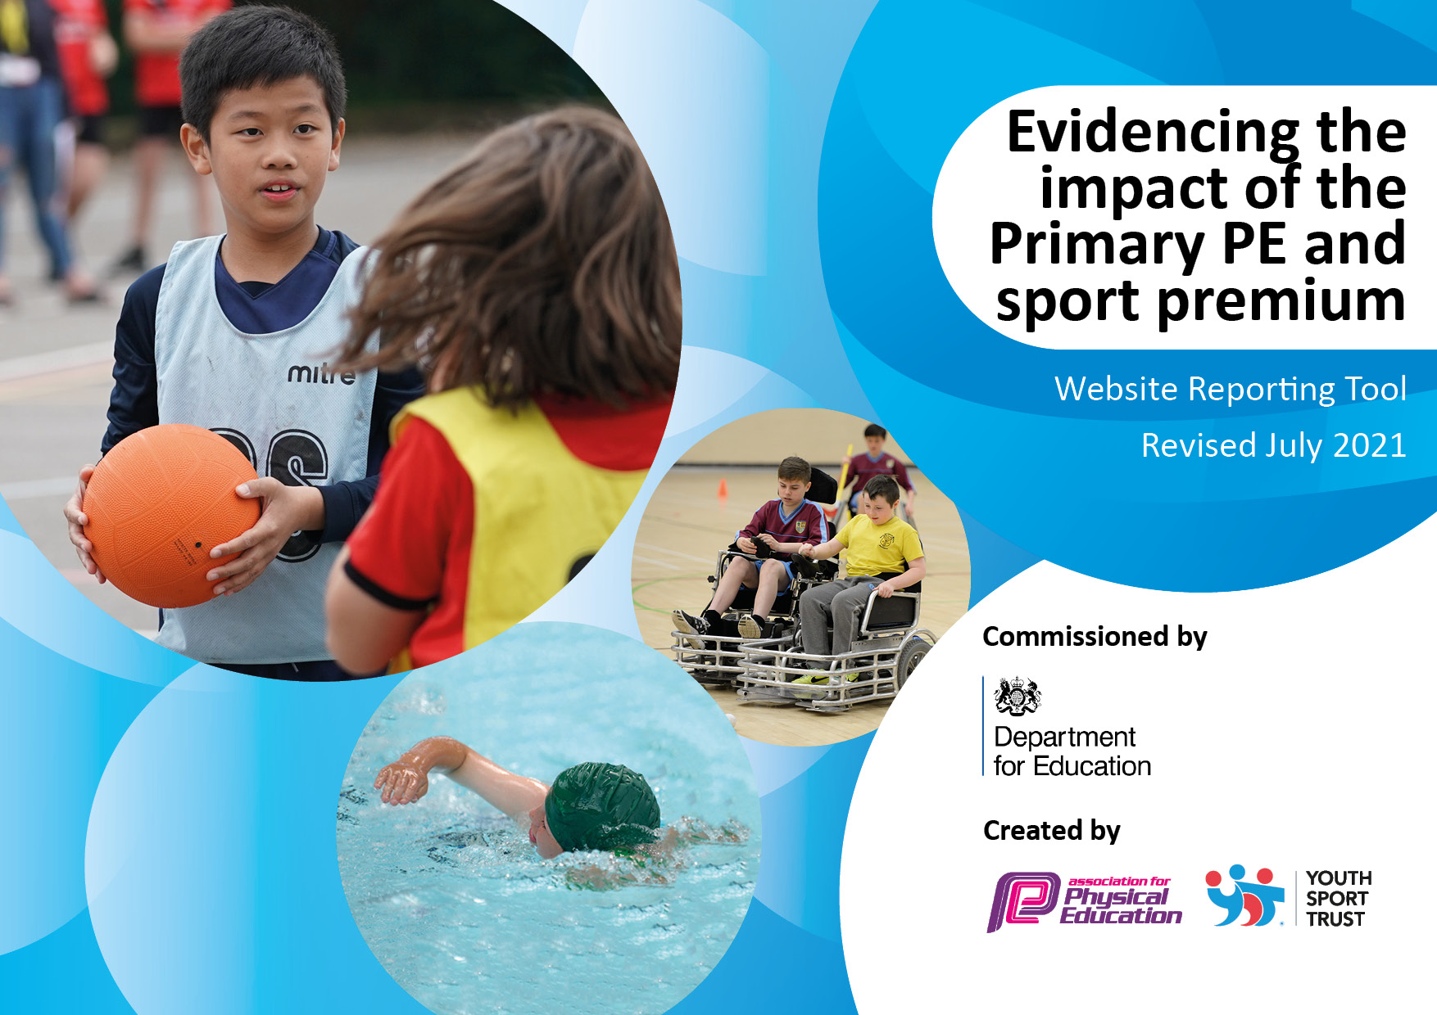

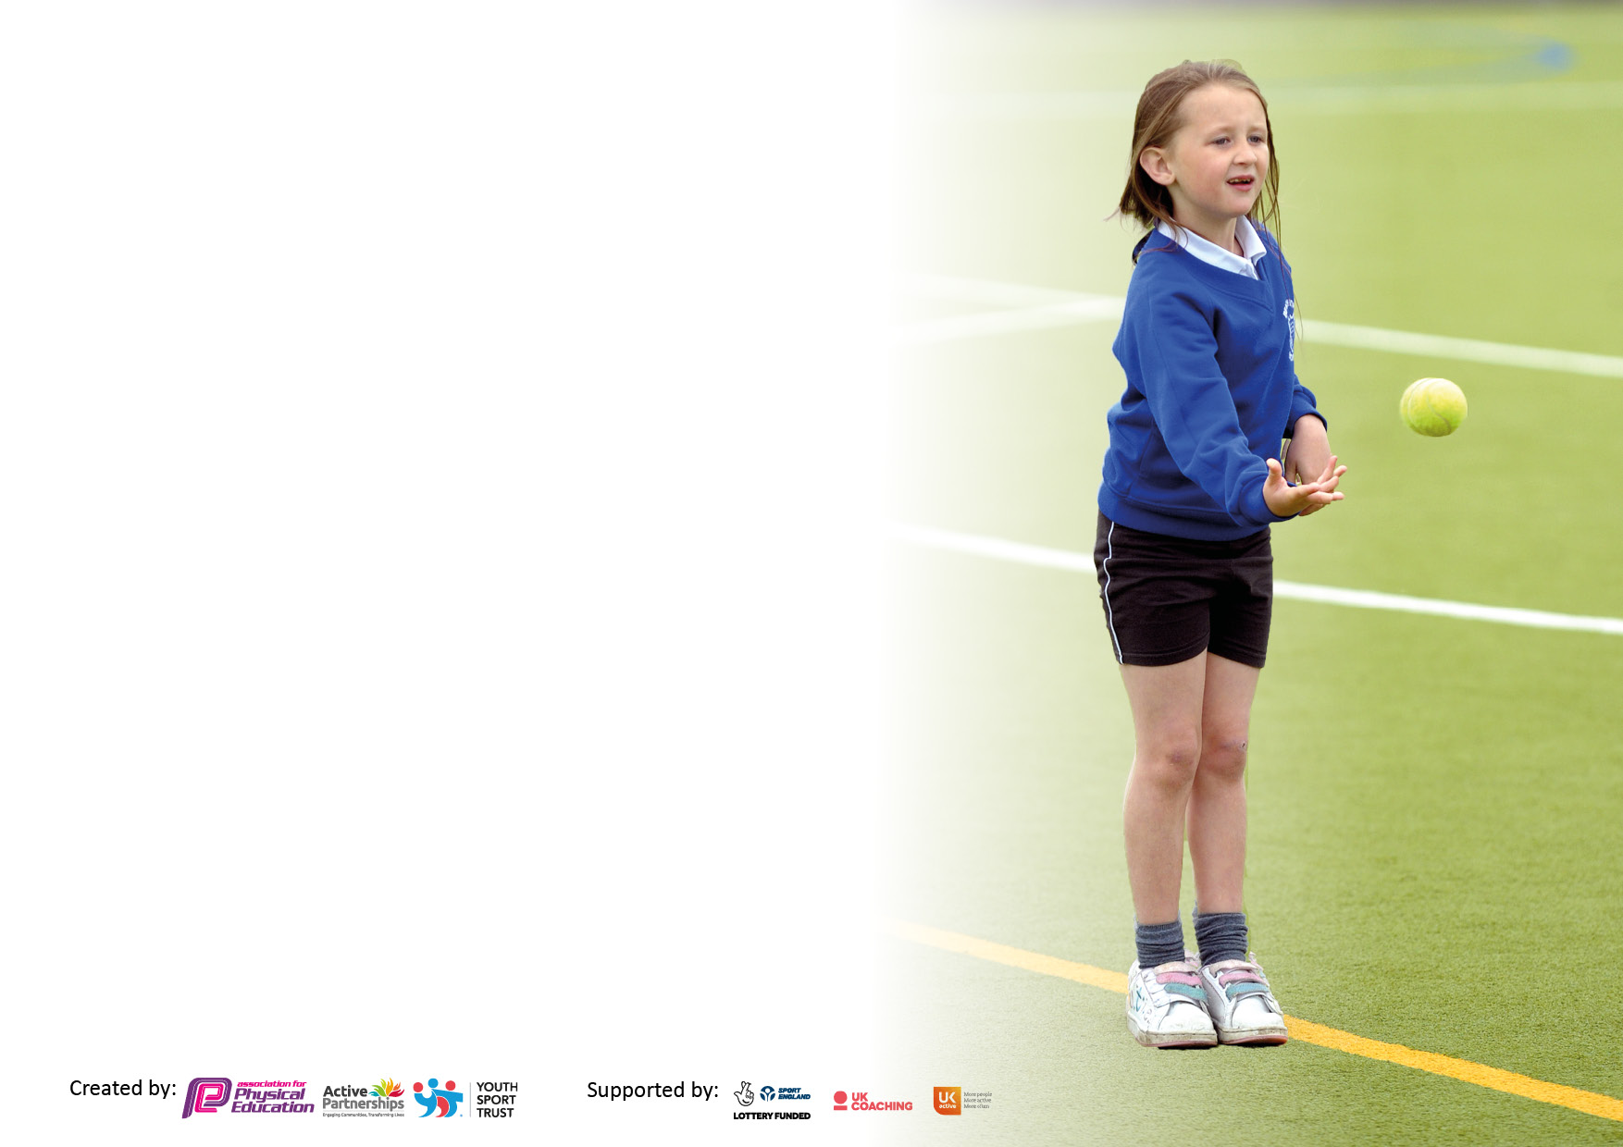

It is important that your grant is used effectively and based on school need. The Education Inspection Framework makes clear there will be a focus on **‘whether leaders and those responsible for governors all understand their respective roles and perform these in a way that enhances the effectiveness of the school’**.

Under the Quality of Education Ofsted inspectors consider:

**Intent** - Curriculum design, coverage and appropriateness

**Implementation** - Curriculum delivery, Teaching (pedagogy) and Assessment

**Impact** - Attainment and progress

To assist schools with common transferable language this template has been developed to utilise the same three headings which should make your plans easily transferable between working documents.

Schools must use the funding to make **additional and sustainable** improvements to the quality of Physical Education, School Sport and Physical Activity (PESSPA) they offer. This means that you should use the Primary PE and sport premium to:

* Develop or add to the PESSPA activities that your school already offer
* Build capacity and capability within the school to ensure that improvements made now will benefit pupils joining the school in future years
* The Primary PE and sport premium should not be used to fund capital spend projects; the school’s budget should fund these.

Pleasevisitgov.ukfortherevisedDfEguidanceincludingthe5keyindicatorsacrosswhichschoolsshoulddemonstrate animprovement.Thisdocumentwillhelpyoutoreviewyourprovisionandtoreportyourspend.DfEencouragesschools to use this template as an effective way of meeting the reporting requirements of the Primary PE and sport premium.

We recommend you start by reflecting on the impact of current provision and reviewing the previous spend.

Schools are required to publish details of how they spend this funding, including any under-spend from 2019/2020, as well as on the impact it has on pupils’ PE and sport participation and attainment. **All funding must be spent by 31st July 2022.**

We recommend regularly updating the table and publishing it on your website throughout the year. This evidences your ongoing self-evaluation of how you are using the funding to secure maximum, sustainable impact. Final copy must be posted on your website by the end of the academic year and no later than the 31st July 2021. To see an example of how to complete the table please click HERE.

Created by: Supported by:

**Details with regard to funding**

Please complete the table below.

|  |  |
| --- | --- |
| Total amount allocated for 2022/23 | £19,020 |
| Total amount of funding for 2022/23. To be spent and reported on by 31st July 2022. | £19,020 |

**Swimming Data**

Please report on your Swimming Data below.

|  |  |
| --- | --- |
| Meeting national curriculum requirements for swimming and water safety.  N.B. Complete this section to your best ability. For example you might have practised safe self-rescue techniques on dry land which you can then transfer to the pool when school swimming restarts.  **Due to exceptional circumstances priority should be given to ensuring that pupils can perform safe self rescue even if they do not fully meet the first two requirements of the NC programme of study** |  |
| What percentage of your current Year 6 cohort swim competently, confidently and proficiently over a distance of at least 25 metres?  **N.B.** Even though your pupils may swim in another year please report on their attainment on leaving primary school at the end of the summer term 2022.  Please see note above | 81% |
| What percentage of your current Year 6 cohort use a range of strokes effectively [for example, front crawl, backstroke and breaststroke]?  Please see note above | 76% |
| **What percentage of your current Year 6 cohort perform safe self-rescue in different water-based situations?** | 100% |
| Schools can choose to use the Primary PE and sport premium to provide additional provision for swimming but this must be for activity **over and above** the national curriculum requirements. Have you used it in this way? | No |

**Action Plan and Budget Tracking**

Capture your intended annual spend against the 5 key indicators. Clarify the success criteria and evidence of impact that you intend to measure to evaluate for pupils today and for the future.

|  |  |  |  |  |
| --- | --- | --- | --- | --- |
| **Academic Year:** 2022/23 | **Total fund allocated: £19020** | **Date Updated: 12/03/23** | |  |
| **Key indicator 1:** The engagement of all pupils in regular physical activity – Chief Medical Officers guidelines recommend that primary school pupils undertake at least 30 minutes of physical activity a day in school | | | | Percentage of total allocation: |
| 16% |
| **Intent** | **Implementation** | | **Impact** |  |
|  |  | Funding allocated: | Evidence of impact: what do pupils now know and what can they now do? What has changed?: | Sustainability and suggested next steps: |
| All pupils take part in at least 30 minutes of physical activity in a school day through either PE lessons or during play times. | The playground is split into zones with clear activities for specific zones such as football, basketball skipping/hoops, hopscotch and target throwing. | Free | More children are engaged during playtimes with less children being stationary. This is due to the range of equipment in the playground. |  |
| Activities for the playground are engaging so children have a range of things to do including brand new playground equipment donated from the local parish councils and the new orienteering course. | Playground equipment is ready and accessible for all children and is distributed by select shed monitors.  The orienteering course is around the school grounds in which children can work together or with adults to find and retrieve information. | £3000 orienteering | Team work is being promoted with the use of our new cross curricular orienteering course as children have to work together to retrieve information. |  |
| **Key indicator 2:** The profile of PESSPA being raised across the school as a tool for whole school improvement | | | | Percentage of total allocation: |
| 11% |
| **Intent** | **Implementation** | | **Impact** |  |
| Ensure staff and colleagues are aware of the resources available to them to deliver high quality PE lessons | The PE cupboard is clearly organised and labelled to ensure staff can easily and quickly locate resources for lessons.  All teaching staff have access to PE passport with full lesson plans for any PE unit being taught as well as video demonstrations and assessment documents. | £1732.80 | PE has been observed and it is clear to see how staff are using planning and children are building on the skills and vocabulary that they have learnt from previous lessons. |  |
| Utilise the school’s social media sites such as Facebook and Twitter to promote extra-curricular activities in school as well as celebrate any work going on in competitions. | Upload regular pictures and posters of current and upcoming extra-curricular activities to increase participation.  Competition opportunities are referred to on any after school club letters to increase participation so children are aware of the benefit of the club if they want to take part in the competition. | Free | By including information about an upcoming netball competition, the level of participation in a netball competition was high than any previous netball after school club. | Next steps are to ensure that any links between after school clubs and competitions are mentioned on letter.  A termly calendar of upcoming sports competitions is uploaded onto the school website and other social media. |
| Ensure all children are able to take part in PE lessons and understand the importance of PE. | Use PE Premium to purchase spare PE kit for children that don’t have any kit or regularly forget to bring into school.  Kit will be loaned out by swapping an item of clothing with the spare PE kit to ensure it is returned.  i.e a shoe for a spare pair of PE shorts.  New Sharlston PE shirts have been designed and are able to be bought for an affordable price. | £240 | More children are wearing correct school PE kit which means that as a school, children look well-presented and part of a team.  Parents have commented on how well our children from our school look when representing Sharlston against other schools. |  |

|  |  |  |  |  |
| --- | --- | --- | --- | --- |
| **Key indicator 3:** Increased confidence, knowledge and skills of all staff in teaching PE and sport | | | | Percentage of total allocation: |
| 87% |
| **Intent** | **Implementation** | | **Impact** |  |
|  |  |  |  | Sustainability and suggested |
|  |  |  |  | next steps: |
|  |  |  |  |  |
|  |  |  |  |  |
|  |  |  |  |  |
| Outside agencies (such as Steve Biltclffe and Featherstone Rovers) will be delivering high quality PE lessons. | Staff will attend these PE sessions and observe specialised coaches taking the sessions as a form of CPD. | £5253.35 Steve B  £6500 Featherstone Rovers | Children have gained knowledge and skills in a range of sports that may be unknown to their normal class teacher such as korfball, handball and lacrosse.  Staff will then use these lessons as a form of CPD to apply in their own teaching of the same unit.  This impacts the number of children participating in after school clubs that focus on these units. | Ensure staff are completely confident in teaching a wide range of sports and activities in PE.  Staff will teach these units and put their CPD into practice the next time they plan the same unit. |
| Subscribe to PE passport to assist staff in planning high quality PE lessons as well as assessing and tracking pupil’s progress.  In addition to PE passport, we have signed up to Pippa and Eddie’s EYFS active adventures and the Dance to school package. | Staff are able to access a wealth of lesson plans, videos and activities on the PE Passport website. They can use these lessons plans to assess children throughout lessons and give an overall assessment on performance, social and competition side of each unit. | £1732.80 |  | Ensure staff are regularly using the planning to teach a wide range of sports and not the same ones every year but still ensuring these sports are invasion, net/wall, striking and fielding games as well as athletics, gymnastics and dance. |
| Cross curricular orienteering has been installed around the area of the school grounds to improve the teaching and planning of orienteering in the PE curriculum. | By signing up to cross curricular orienteering, staff now have a wealth of resources to help them effectively teach orienteering as well as using the orienteering course to other resources to make cross curricular links between PE and other subjects in the curriculum.  Planning ranges from EYFS to Year 6 by starting to look at what maps are, map making skills to using maps to navigate the school grounds to find and retrieve information. | £3000 |  | Staff should try to use orienteering in other aspects of the curriculum and not just PE. Before doing so, they should ensure children are aware of how to use maps correctly and do map based activities. |
| **Key indicator 4:** Broader experience of a range of sports and activities offered to all pupils | | | | Percentage of total allocation: |
|  |
| **Intent** | **Implementation** | | **Impact** | 62% |
|  |  | Funding | Evidence of impact: what do | Sustainability and suggested |
|  |  | allocated: | pupils now know and what | next steps: |
|  |  |  | can they now do? What has |  |
|  |  |  | changed?: |  |
|  |  |  |  |  |
| Featherstone Rovers and Steve Biltcliffe offer the children of Sharlston Community School a wide range of sports, some of which children have never heard of. | Curriculum lessons and after school clubs include the usual sports such as football, rugby and netball but also include sports such as korfball, benchball, scatterball and handball.  Children become invested in these as they are sometimes shown the sport in a professional context through videos on YouTube. | ££5253.35 Steve B  £6500 Featherstone Rovers |  | Continue to introduce new sports and activities throughout school in curriculum lessons and after school clubs. |

|  |  |  |  |  |
| --- | --- | --- | --- | --- |
| **Key indicator 5:** Increased participation in competitive sport | | | | Percentage of total allocation: |
| % |
| **Intent** | **Implementation** | | **Impact** |  |
|  |  |  | Evidence of impact: what do | Sustainability and suggested |
|  |  |  | pupils now know and what | next steps: |
|  |  |  | can they now do? What has |  |
|  |  |  | changed?: |  |
|  |  |  |  |  |
| Organise intra-school sports competitions between classes and different key stages | Each key stage to host competitions between classes based around sports which have been taught to all 3 classes over the course of the year.  Trophies are available for the class who wins. |  |  |  |
| Take part in a number of different inter-school sports competitions against other schools in the trust and local area | We take part in as many inter-school sports competitions as we can, ensuring as many children as possible are given the opportunity to take part. |  | A wide range of children have taken part in a variety competitions this year ensuring that it is not always the same children who have the opportunity to do so.  There has been an increase in participation from girls over the past 12 months. Girl only competitions have been a factor for the increased amount of female participation. | Next steps is to listen to pupil voice about what other girl only competitions our children want to take part in. |

|  |  |
| --- | --- |
| Signed off by | |
| Head Teacher: |  |
| Date: |  |
| Subject Leader: | Mr James Powell |
| Date: | 12/03/23 |
| Governor: |  |
| Date: |  |