

Conduct and Behaviour Policy

2025-26

Behaviour Policy

At Sharlston Community School we have high expectations of good behaviour in the school. We believe all children are entitled to learn in a caring and safe environment where they are treated fairly and with equity. We want our children to develop as confident individuals with a positive self-image and an understanding of their role and responsibilities within the school, local community and wider world.

This policy clearly outlines how Sharlston Community School creates a learning environment conducive to good behaviour and how our school rewards, celebrates and teaches positive behaviour. Children need to know what is expected of them in terms of positive behaviour. This is achieved through strong leadership, strong responsibility, and the application of a clear and consistent system of rules, routines and consequences underpinned by positive relationships and a sense of belonging.

All adults and children involved in any way in the life of the school have a duty to abide by the school’s policies.

Introduction
At Sharlston Community School we aim to provide clearly stated expectations of what constitutes acceptable behaviour combined with effective strategies for managing behaviour. We know that to be effective these expectations must be consistently followed by all members of staff and visitors to the school.

We understand that every adult in the school must act as a good role model in their own behaviour and actions. We also understand that the best way to deal with poor behaviour is to establish a positive ethos where pupils are valued for being good.

Proactively dealing with behaviour issues before they occur e.g. by planning high quality, motivating lessons, by consistent use of praise around the school and by establishing a high-quality learning environment ensures that incidences of poor conduct are minimised.

Creating a Positive Learning Environment

- We know that the physical environment plays a vital part in setting high expectations and ensuring pupils from all social, cultural and religious backgrounds feel valued. This includes:
- school/classrooms being kept tidy and free from clutter
- exemplar work from around the school in central corridors
- resources being labelled and organised in a way that is practical and accessible
- emphasising the school rules, rights and responsibilities at every opportunity.
- ensuring good quality displays of pupils work across all ability ranges and resources that act as a support for learning
- careful consideration for pupil groupings is given and also to where individuals sit and who they sit next to
- furniture being arranged to allow for maximum learning to take place and enough space is made available for pupils to move around the classroom comfortably and access resources
- teaching resources of good quality, adequate in quantity, visually stimulating and text is large enough for pupils to read from a distance
- adults role-­‐modelling good organisation techniques and resource management (eg showing how exercise books are to be given out) avoids disruption and lost learning time

Ethos and Atmosphere

Sharlston Community School is a happy, friendly school and we encourage the children to be thoughtful and polite in their interactions with each other, both in school, on outings and also on their journey to and from school.
The way that adults speak to pupils (and about pupils), and the way that adults allow pupils to speak to each other, directly impacts on the self-­‐esteem, confidence and motivation that a pupil has, which in turn impacts on the pupils behaviour. Therefore, at Sharlston Community School we strive to ensure that:

- all staff have high expectations of pupil behaviour and pupils’ ability to make progress
- teachers deliver lessons in a confident, enthusiastic and engaging way
- teachers constantly and consistently praise the whole class and each pupil in the class
- teachers and other adults use positive language when talking about pupils learning and behaviour, both in front of and away from pupils
- all adults act as good role models for pupils including the way that they speak, dress, behave, etc.
- pupils are constantly informed about how successfully they are achieving the learning intention within lessons and given support and guidance where appropriate
- teachers do not use particular subjects or activities as a sanction, as this undervalues that subject/activity
- all pupils leave the class at the end of the day feeling good about what has been achieved, and secure about their place in the class
- adults never use sarcasm to embarrass a pupil and never publicly ridicule a pupil
- adults avoid shouting, except in extreme situations, (remembering the less we shout the more effective it is if we have to)
- in every possible situation, e.g. class, playground, ALL adults model the behaviour they expect from our pupils
- In every possible situation, e.g. class, playground, ALL adults praise pupils displaying the good behaviour expected at this school
- All staff promote a restorative approach to dealing with conflict, but are aware that this works best when pupils are ready and able to participate

Teaching positive behaviour choices

The best way to teach positive behaviour is through our own behaviour as role models and through praising pupils who display the expected behaviour. Pupils learn about good behaviour through being taught about, and then applying, the school rules. These rules are:
Ready Respectful Safe
At Sharlston we listen
At Sharlston we work hard
At Sharlston we are honest
At Sharlston we are kind and caring
At Sharlston we show respect (to ourselves, others and property)
At Sharlston we walk calmly and sensibly

The PSHE scheme of work is followed to ensure a consistent whole school approach to Personal, Social, Health and Economic education, emotional literacy, social skills and spiritual development. In lessons pupils are explicitly taught how to become good citizens. They also learn how to empathise with others, manage their emotions, problem solve, deal with conflict and manage anger. During lessons, teachers support pupils to raise self-­‐esteem, boost confidence, deal with friendship issues, and issues such as bullying and racism. Lessons also enable pupils to acquire good oracy skills, again useful when avoiding conflict.
School assemblies are used to explicitly teach values and further enhance and sustain a sense of community and a positive ethos.

Throughout the whole curriculum, pupils are taught to collaborate, listen and respect each other’s opinions.

Colour chart Behaviour System

At Sharlston Community School we strongly believe that children should be encouraged to behave well and work hard so they can reach their full potential. Our visual Colour Chart Behaviour system incorporates both rewards and sanctions to support this. Every classroom and shared area has a Colour Chart.

All children start the day on the Green; Ready to Learn. Our motto in school is that ‘It’s Good to be Green’ therefore it is expected that children will follow the school rules, and be ready to learn at all times and therefore remain on Green. Where children do not make green choices, an amber warning will be given. Further warnings are issued if necessary which may result in a red card. See Appendix A – Rewards and Sanctions.

Rewarding and celebrating good behaviour

The school verbally praises pupils for good learning, attitudes and behaviour at every opportunity. We also reward pupils with class Dojo points. Ideally, we want pupils to recognise that the real rewards come from the praise they get from both staff and parents, which gives them confidence and makes them feel proud of themselves. The feeling they get from their own achievements and the positive way that they are valued by the people around them, has long term effects that in turn affect the way that they relate to others. At the same time, staff strive to ensure that the giving of rewards is balanced, fair and equitable. We also recognize that rewards are sometimes necessary and appropriate to encourage children to make good behaviour choices.

Dojo points
Our main reward system is based on ‘Dojo points’. These are points awarded electronically on a Class Dojo App, where the reason for the reward is recorded. Once a child has received 50 Dojos, they are awarded a bronze certificate in assembly. They are then working towards their Silver badge.

Bronze star badge and certificate – 50 Dojos total
Silver star badge and certificate – 100 Dojos total
Gold star badge and certificate – 200 Dojos total
Platinum star badge and certificate – 300 Dojos total

Parents can access the Class Dojo app to see rewards received by their own child. School will inform parents of the code they require for access to the app.

In Friday’s celebration Assembly, each class teacher will choose two children to receive a sticker and certificate from the headteacher as a recognition of their learning and behaviour choices over the week.
Whole Class Rewards
Team work is important and when the class works together to have a fantastic day, showing really positive attitudes, completing all work or putting in 100% effort they get to work towards earning a team reward which has been chosen by the class. This may be an activity, game or event.
The class will decide together on what the reward is and decide how many dojos they need to earn as a class to receive the reward.

Lunchtime Reward Points
Children who are following the school rules and showing green choices at lunchtime, will be spotted by a lunch time supervisor. They will instantly receive a small sticker. This instant reward will further foster and promote positive behaviours.

Positive Rewards

The following positive rewards are also used regularly at school to encourage children to stay ‘Green’;

- verbal or written praise/congratulations, explaining why they are being praised
- non-verbal rewards for encouragement such as a thumbs up sign or a smile
- sending pupils good work to head/deputy
- displaying best work around the school
- informally speaking to parents to praise their child and share good news
- publishing pupils work or their successes in the school newsletter
- Star of weeks / rewards

Consequences

The aim of our school ethos is to emphasise the positive, with praise and recognition of achievements. However, clear and simple procedures need to be in place so that the children understand the consequences of poor behaviours.

Should a child’s behaviour in the classroom be unacceptable and disrupt teaching and learning, then the class teacher will intervene. Our Rewards and Sanctions framework makes it clear how we deal with behaviour within school (Appendix A).

Positive handling of pupils

Staff are trained in positive handling techniques, which may be used as a last resort to keep a child, or others, safe from harm. A range of de escalation techniques would be used before physical handling of pupils by staff, except in cases requiring urgent intervention. (See Positive Handling Policy)

Exclusions
Temporary exclusion from school would only be considered when all other strategies had been considered and found to be inappropriate and if the continued presence of the child was considered to be unsafe, either for him/herself or others, or exclusion was necessary to deal with a crisis or with an emergency.

The length of exclusion should relate to the individual circumstances of the pupil. All exclusions will be reported to, and conducted with the agreement of, the School's Academy Standards Committee. Further details can be found in the Waterton Academy Trust Behaviour and Exclusions policy.

Our approach to incidents of bullying - Also see the anti-bullying policy

Definitions of bullying
'Bullying is longstanding violence, physical or psychological, conducted by an individual or a group against an individual who is not able to defend himself in the actual situation.' (Roland and Munthe 1993)

'Bullying happens when one person or a group tries to upset another person by saying nasty or hurtful things again and again. Sometimes bullies hit or kick people or force them to hand over money; sometimes they tease them again and again. The person who is being bullied finds it difficult to stop this happening and is worried that it will happen again. It may not be bullying when two people of roughly the same strength have a fight or disagreement.' (Mellor 1997)

In line with discrimination laws, any incidents of name calling which are targeted at a child because of race, gender or sexuality will be recorded following LA guidelines.
It is the responsibility of everyone to prevent it happening and with this in mind we have laid down the following guide lines. We will react firmly and promptly where bullying is identified. There are a range of sanctions available to the staff depending on the perceived seriousness of the situation.

Some of these would include:-
- discussions with parents and children.
- withdrawal of favoured activities.
- referral to the Headteacher.
- exclusion from school during lunch time.
- exclusion from school.

Incidents of bullying will be managed swiftly and taken seriously. Our first responsibility is to ensure the victim feels happier and safe in school.

The school will:-
- support children who are being bullied.
- help bullies to change their behaviour.
- take bullying seriously and find out the facts of any incident.
- meet those concerned individually.
- use peer group pressure to actively discourage bullying.
- break up bully groups where it seems necessary.
- involve parents at an early stage.
- help children to develop positive strategies and assertion.
- be equally concerned about bullying to and from school.
- record incidents of bullying in a consistent way that allows for monitoring of behaviour.
- discuss and involve children in agreed class and school rules and behaviour.

What to do about Bullying
It is everyone's responsibility to prevent bullying, here are some things you could do:-

Teachers:
- create a positive ethos and expectation of good behaviour from all.
- talk to children about behaviour.
- take notice of all that takes place outside the classroom as well as in it.
- show an interest in all the children (even those who try to remain invisible).
- watch for early signs of distress in pupils.
- do not allow children to enjoy being curious onlookers of other children's difficulties.
- vary the ways in which children are grouped, so that they can understand consistent patterns of collaboration.
- make all children work together in pairs or groups. Use them to teach each other to learn.
- be fair and be seen to be so.
- insist on children telling the truth. Make sure that all facts are checked.
- promote positive praise for good behaviour.
- have a very clear classroom routine. Use the children to help manage the classroom.
- listen carefully and record all incidents.

Parents:
- It is always a good idea to take an active interest in your child's social life and chat about friends and their activities in and out of school. Make sure you keep up to date with your child's friendships; you may become aware of disagreements or difficulties they are experiencing.
- Watch for signs of distress in your child. There could be an unwillingness to attend school: illnesses such as headaches and stomach aches. Toys or equipment may go missing and your child may request extra pocket money. There are many reasons why your child may be unsettled at school, bullying is always a possibility.
- If you think that your child is being bullied, inform the school immediately and ask for a meeting with the class teacher or phase leader who will deal with the incident, alternatively, you could contact the headteacher.
- Remember dealing with bullying is everyone's responsibility. Allow the school time to investigate the problem; all reports will be investigated urgently.

Children:
If you are being bullied:-
- tell a responsible adult.
- try not to show that you are upset - this is difficult.
- walk with confidence - even if you don't feel that way inside.
- try being assertive.
- say no to the bully.
- if you are different in any way, be proud of it – it’s good to be an individual.

You can help stop bullying:-
- don't stand by and watch - find help.
- show that you and your friends disapprove.
- give sympathy and support to children who may be being bullied.
- be careful about teasing or making personal remarks - imagine how you might feel.
- If you know of serious bullying, tell a trusted adult. It's not telling tales, the victim may be too scared or lonely to tell.

A Restorative Approach

At Sharlston Community School, we have high expectations of our pupils. We encourage all children to try their best to achieve their goals. They should understand that it is the responsibility of staff and pupils to uphold and maintain our school rules. For occasions when this is proving not to be the case, we use restorative approaches to help pupils understand the impact of their actions and how to put it right. We believe that by using this Restorative Approach we are giving pupils the skills to independently make better and more informed choices in the future.

Restorative approaches encourage pupils to think about how their behaviour affects others, both pupils and staff. It helps children to develop empathy, respect, responsibility and truth telling.

If a pupil in our school has been negatively affected by someone’s behaviour, we will try our very best to make sure they feel that it has been put right for them and that it will not happen again.
If a child has done something wrong they will be asked to put things right and change their behaviour so it does not happen again. In school, if there are any issues or conflict between children or even adults they are dealt with in a restorative way. The language used is very fair, calm and respectful

About Restorative Language:

When our pupils find themselves in conflict or upset we will ask them:
What happened?
What were you thinking when it happened? What needs to happen to put this right?
What would you do differently next time?

We might also say to our pupils:
What would you think if this happened to you? How can we put this right?
What could you do differently next time? What other choice could you have made?
How could you make sure this doesn’t happen again?

Most situations can be dealt with by working through these questions. The aim here is that the outcome is fair for everyone. If somebody is upset, we aim to make them feel better. If someone has done something wrong, we expect them to take responsibility for their actions and fix the situation.
Most situations can be dealt with fairly and promptly by using the above questions and both children and staff refer to the school behaviour chart, as detailed above, for consequences.

An Equitable Approach

As a caring school, with a trauma informed approach, we are aware that some children could have been exposed to adverse childhood experiences. We acknowledge that their negative behaviours are not conscious choices, but may be innate reactions due to their past experiences impacting on their brain stem development and affecting their feelings of self worth. Staff at Sharlston strive to develop positive and caring relationships with children to support them to feel safe and secure at school, and help them learn to respond more appropriately to threatening and unpredictable situations.

The Role of Parents (See home school agreement Appendix B)
The school strives to work in partnership with parents, so children receive consistent messages about how to behave at home and at school. We endeavour to build a supportive dialogue between the home and the school, informing them of their child’s successes regularly, as well as informing them immediately if we have any concerns about their child’s welfare or behaviour. Where pupils require support, staff will share and discuss strategies so that parents can better support at home. To help children follow Sharlston School’s Behaviour Policy parents are expected to:
- Support their child in adhering to the three rules ‘Ready Respectful Safe’ and have high expectations of their behaviour in school
- Celebrate when their child receives any Dojo points, to reinforce positive messages
- Ensure that their child fully understands the consequences of not adhering to the school rules
- Remind their child that Amber and Red behaviours are not acceptable, and supporting school when consequences are put in place
- Inform the class teacher of any changes in circumstances which may affect their child’s behaviour, so we can work as a team to support a child’s needs
- Discuss any concerns with the class teacher promptly

APPENDIX A

Rewards and Sanctions

Colour |  | Behavioural Choices | Behavioural Impact & Actions
 | “It’s good to be GREEN”  Children begin on GREEN each day.  Reset after afternoon registration (KS1).  Resets after a full day (KS2) | - Following School Rules and the Rights & Responsibilities | - Foundation Stages (Nursery & Reception):  “You’ve been Spotted (stickers)”  “Reception – Dojo still)  - Main School  (KS1 & KS2):  DOJO system  Sharing successes with other staff  - Celebration Assembly:  “Star of the week”  Dojo badge celebration  - Half Termly:  Children’s Choice: “Star of the week”
2 opportunities here | 1st Warning / Think about it | - Low level disruption  - Failure to comply with adult directions  - Name calling  - Failure to follow school rules | Within Class Setting:  - Move seats  - “Loss of Learning time”  (owed during morning playtime (5 mins etc)
2 opportunities here | 2nd Warning - AMBER
 | 3rd Warning - RED | - Continued failure to comply with adult directions  - Play fighting  - Defiant behaviour and refusal  - Leaving without permission  - Inappropriate language  - Fighting  - Aggressive behaviour  - Bullying  (including Cyber Bullying)  - Stealing  - Racism  - Homophobia  - Other equality incidents | - “Loss of Learning time”  (owed during morning playtime or the following morning playtime if RED Card received during the afternoon)  - Sent to another class with work (depending on the behaviour displayed)  - Child to complete ‘Behaviour Reflection Sheet’ at earliest opportunity.  - Class Teacher to inform Parent at the end of the day  Behaviour logged by Class Teacher at the end of the day on Bromcom (include reflection form)
 | Repeated Red Cards |  | - Playtime and/or Lunchtime  - Pastoral Team to invite Parents into School to discuss on-going behavioural issues  If behaviour continues:  Child will remain out of class - SLT and Parents will be informed
 | Fixed Term Exclusion | Follow guidance in line with WAT Behaviour and Exclusions policy

APPENDIX B
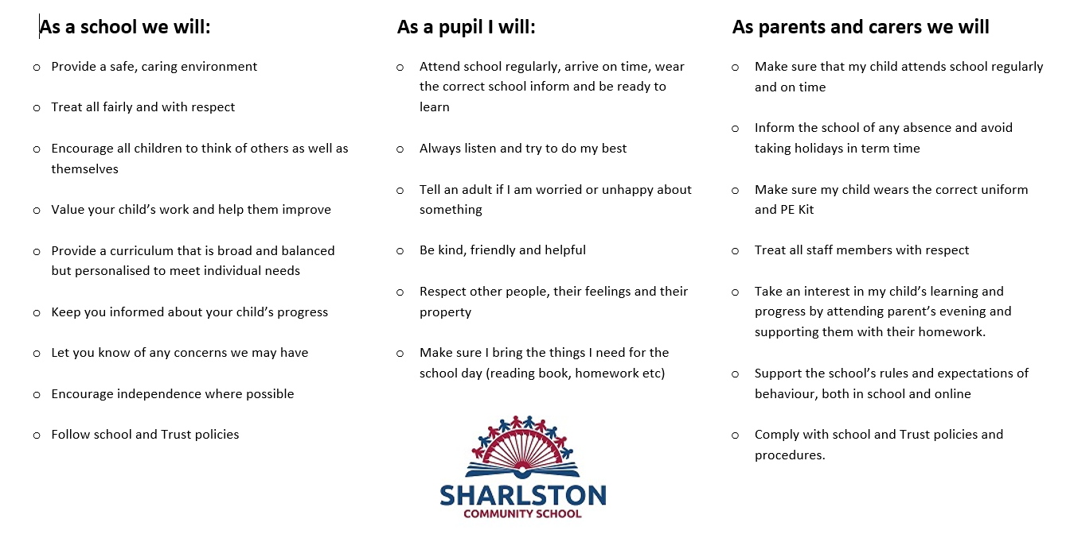
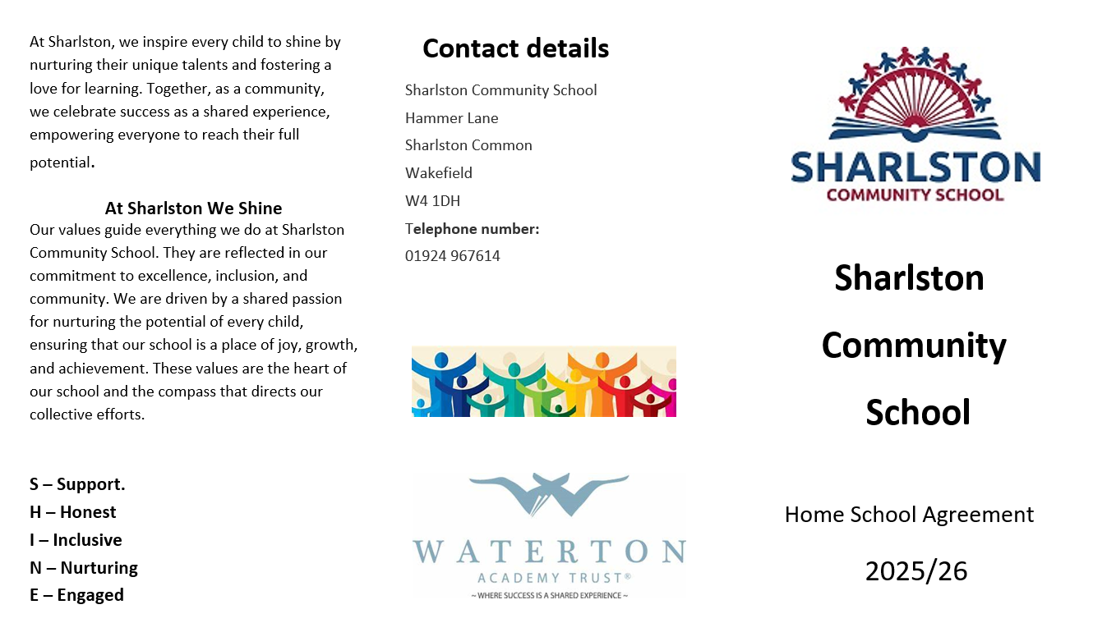
Home School Agreement

Date | Review Date | Lead | Governor
September 2024 | September 2025 | L Oldroyd | C. Allinson
September 2025 | September 2026 | L Oldroyd | C. Allinson

Version | Date | Author | Changes
1 | September 24 | L Oldroyd | Re-written to reflect the current practice in school.
2 | September 25 | L Oldroyd | Updated to reflect positive dojo rewards

