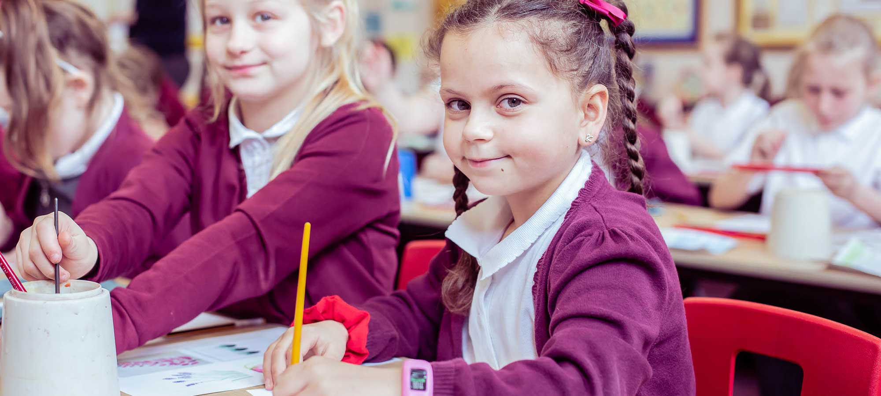
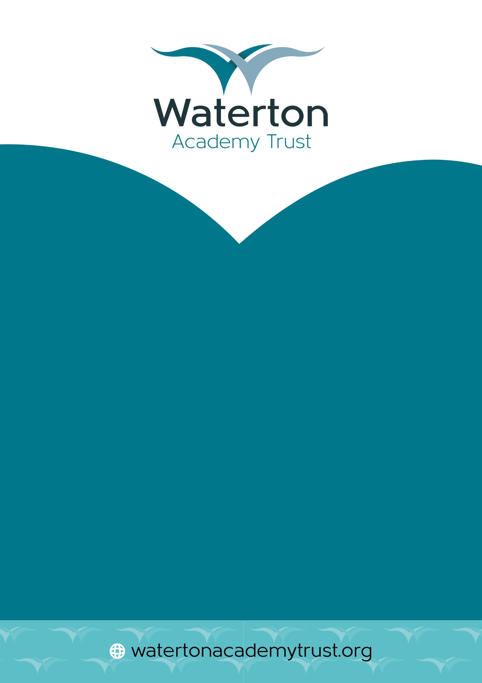
Relationships and Sex Education Policy

Contents
Aims ……………………………………………………………………………………………2
Statutory Requirements 2
Policy Development 2
Definition 2
Curriculum 3
Delivery of RSE 4
Roles and Responsibilities 4
Training 5
Monitoring Arrangements 5
Appendix 1: Relationships and sex education curriculum map (attached under PSHE overview) 6
Appendix 2: By the end of primary school pupils should know. 8
Appendix 3: Parent form - withdrawal from sex education within RSE 11

Aims
The aims of relationships and sex education (RSE) at our school are to:

- Provide a framework in which sensitive discussions can take place.
- Prepare pupils for puberty and give them an understanding of sexual development and the importance of health and hygiene.
- Help pupils develop feelings of self-respect, confidence and empathy.
- Create a positive culture around issues of sexuality and relationships.
- Teach pupils the correct vocabulary to describe themselves and their bodies.

Statutory Requirements
As a primary academy school we must provide relationships education to all pupils as per section 34 of the Children and Social work act 2017. We do not have to follow the National Curriculum, but we are expected to offer all pupils a curriculum that is similar to the National Curriculum including requirements to teach science which would include the elements of sex education contained in the science curriculum. In teaching RSE, we are required by our funding agreements to have regard to guidance issued by the secretary of state as outlined in section 403 of the Education Act 1996. At this school we teach RSE as set out in this policy.

Policy Development
This policy has been developed in consultation with staff, pupils and parents and approved by the trust. The consultation and policy development process involved the following steps:

- Review – The Deputy CEO reviewed all relevant information including relevant national and local guidance to produce a draft template. This was reviewed by the Executive Leadership Team and Headteachers and approved by the CEO.
- Staff consultation – all school staff were given the opportunity to look at the policy and make recommendations.
- Parent/stakeholder consultation – parents and any interested parties were sent information about the policy and were invited to ask questions and make comments.
- Pupil consultation – we investigated what exactly pupils want from their RSE.
- Ratification – once amendments were made in light of the consultations, the policy was shared with senior trust staff and the Academy Standard Committee and ratified.

Definition

Relationships Education
Relationships Education is a statutory requirement for all primary school pupils and focuses on teaching the fundamental building blocks and characteristics of positive relationships. This includes:
- Families and people who care for us, emphasising the diversity of family structures.
- Caring friendships, exploring the qualities of healthy friendships.
- Respectful relationships, promoting mutual respect and understanding.
- Online relationships, teaching safe and respectful behaviour in digital environments.
- Being safe, ensuring pupils understand personal boundaries and how to seek help if they feel unsafe.
The primary aim of Relationships Education is to equip pupils with the knowledge, skills, and attitudes to build healthy, respectful, and safe relationships throughout their lives.
Parents do not have the right to withdraw their children from Relationships Education, as it is considered essential learning for all pupils to navigate modern society safely and respectfully.

Sex Education
Sex Education in primary schools is non-statutory, except for the biological aspects covered within the science curriculum. Any additional teaching beyond this statutory requirement is at the discretion of the school. At our school, the focus of Sex Education includes:
- Preparing boys and girls for the physical and emotional changes that adolescence brings.
- How a baby is conceived and born.

Sex Education lessons are designed to be age-appropriate and sensitive to the needs of all pupils, helping them to understand and manage the changes they experience as they grow.
Parents have the right to withdraw their children from the non-statutory aspects of Sex Education. Requests for withdrawal must be submitted in writing to the headteacher, using the form provided in Appendix 3 of this policy. The school will provide alternative educational activities for pupils who are withdrawn from these lessons.

By clearly differentiating between Relationships Education and Sex Education, this policy aims to ensure transparency and clarity for parents, enabling them to make informed decisions about their child’s education while supporting the school’s mission to foster safe, respectful, and well-informed pupils.

Curriculum
Our curriculum is set out as per Appendix 1, but we may need to adapt it as and when necessary. We have developed the curriculum in consultation with parents, pupils and staff, considering the age, needs and feelings of pupils. If pupils ask questions outside the scope of this policy, teachers will respond in an appropriate manner, so they are fully informed and don’t seek answers online.

Primary sex education will focus on:

- Preparing boys and girls for the changes that adolescence brings
- How a baby is conceived and born

For more information about our curriculum, see our curriculum map in Appendix 1.

Delivery of RSE
RSE is taught within the personal, social, health and economic (PSHE) education curriculum. Biological aspects of RSE are taught within the science curriculum, and other aspects are included in religious education (RE). Pupils also receive stand-alone sex education sessions delivered by a trained health professional. Relationships education focuses on teaching the fundamental building blocks and characteristics of positive relationships including:

- Families and people who care for me
- Caring friendships
- Respectful relationships
- Online relationships
- Being safe

For more information about our RSE curriculum, see Appendices 1 and 2.

These areas of learning are taught within the context of family life taking care to ensure that there is no stigmatisation of children based on their home circumstances (families can include single parent families, LGBT parents, families headed by grandparents, adoptive parents, foster parents/carers amongst other structures) along with reflecting sensitively that some children may have a different structure of support around them (for example: looked after children or young carers).

Roles and Responsibilities
The CEO will approve the RSE policy and hold the Headteacher to account for its implementation.

The Headteacher is responsible for ensuring that RSE is taught consistently across the school, and for managing requests to withdraw pupils from non-statutory/non-science components of RSE (see Parents’ right to withdraw).

Staff are responsible for:
- Delivering RSE in a sensitive way
- Modelling positive attitudes to RSE
- Monitoring progress
- Responding to the needs of individual pupils
- Responding appropriately to pupils whose parents wish them to be withdrawn from the non-statutory/non-science components of RSE.

Staff do not have the right to opt out of teaching RSE. Staff who have concerns about teaching RSE are encouraged to discuss this with the headteacher. All staff will be responsible for teaching RSE within our school.

Pupils are expected to engage fully in RSE and, when discussing issues related to RSE, treat others with respect and sensitivity.

Parents’ right to withdraw - Parents do not have the right to withdraw their children from relationships education. Parents have the right to withdraw their children from the non-statutory/non-science components of sex education within RSE. Requests for withdrawal should be put in writing using the form found in Appendix 3 of this policy and addressed to the headteacher. Alternative work will be given to pupils who are withdrawn from sex education.

Training
Staff are trained on the delivery of RSE as part of their induction and it is included in our continuing professional development calendar. The Headteacher will also invite visitors from outside the school, such as school nurses or sexual health professionals, to provide support and training to staff teaching RSE.

Monitoring Arrangements
The delivery of RSE in our school is monitored by the Headteacher through:

- Lesson observations
- Consultation with staff, children & families

Pupils’ development in RSE is monitored by class teachers as part of our internal assessment systems. This policy will be reviewed by the trust every two years. At every review, the policy will be approved by the CEO.

Appendix 1: Relationships and sex education curriculum map (attached under PSHE overview)

This appendix highlights the Sexual Education unit of work embedded within our Relationships and Sex Education and Health Education curriculum. The content highlighted in red are the non-statutory elements to our curriculum and therefore parents have a right to withdraw from these specific aspects taught in school. All of the text in black is statutory guidance and therefore children must be taught those aspects in line with their peers.
This document provides you with the lesson objectives and lesson content also indicating which year group it will be taught in and at what point in the academic year.
Year Group | Term | Lesson Information
Year 1, 2 | Summer Term 2 | 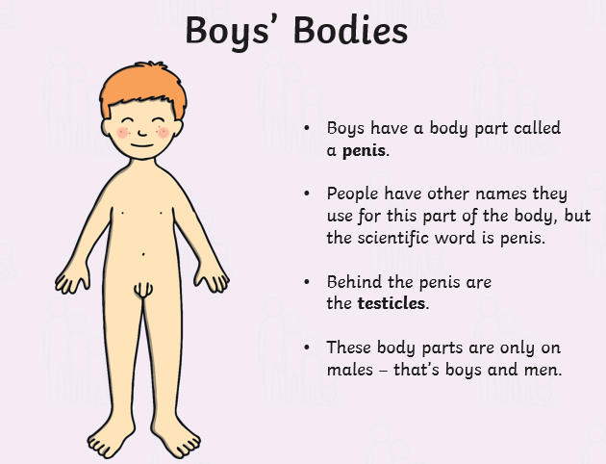  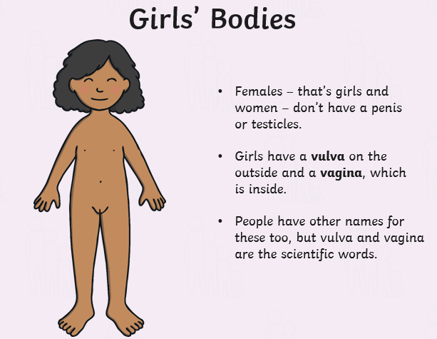  Our bodies  The children will be told that different body parts have special jobs to do. Children will look at the differences between boys and girls from what they can see e.g. arms, legs, lips, toes etc. We will introduce that the differences between boys’ and girls’ bodies are hidden under our underwear. We will explain that they can sometimes be called private parts but today we will use scientific names that a doctor would use to name these. Children will name the external genitalia of a boy and girl, understanding that they are different. The words that the children will use are penis, testicles, vulva and vagina. The children will find out that as we get older we want to cover these parts so will be designing a swimming costume or shorts to link with the learning.
Year 1, 2 | Summer Term 2 | Is it ok?  The children will be learning about physical contact and understanding that consent means we can say yes and no. They will do this by acting out different scenarios with other children where they will ask if it is ok first. For example, ‘Is it ok to play with your toy?’ The children will discuss a variety of questions and provide a teddy some advice. This will reinforce the words private and privacy from the previous learning.  One example-  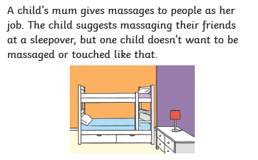  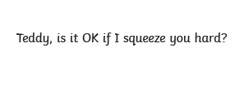
Year 1, 2 | Summer Term 2 | Pink and Blue  The children will start by discussing things that people like e.g. toys, football etc moving towards whether we can tell what people like depending on if they are a boy or a girl. Children will be introduced to what a stereotype is and understanding that everyone can like different things and that is ok. The children will play ‘find somebody who’ game which will reinforce that everyone is unique and has their own set of likes and dislike  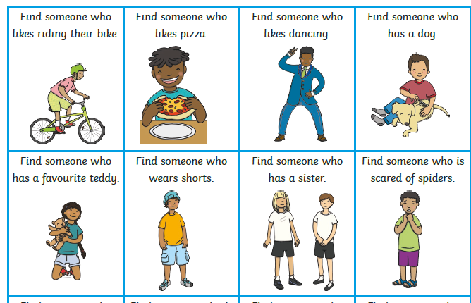
Year 1, 2 | Summer Term 2 | Look at me now  Children will understand how things change as we grow up e.g. learn new things, become more independent and have more responsibilities. The children will discuss what they can do now that they couldn’t do when they were a baby. We will discuss how we need lots of help to do certain things and think about how that might change as we get older.  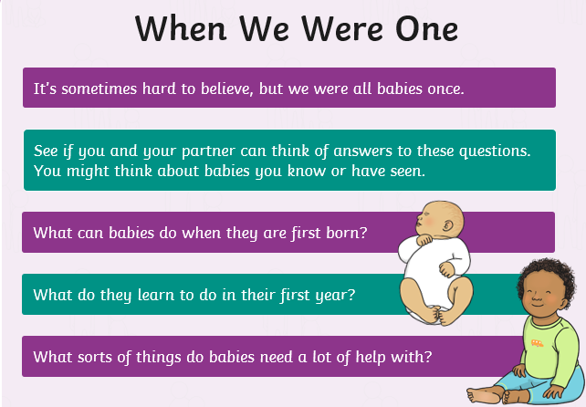
Year 1, 2 | Summer Term 2 | Getting older  Children will be recapping the previous learning about things that they couldn’t do when they were younger that they can now. They will move onto thinking about what changes might happen in the future. The children will find out that our bodies change and devleop. This will be shown with some simple clothed illustrations. The children will then think about what they want to be when they are older and thinking about what responsibilities they might have e.g. feeding a pet, tidying their bedroom.  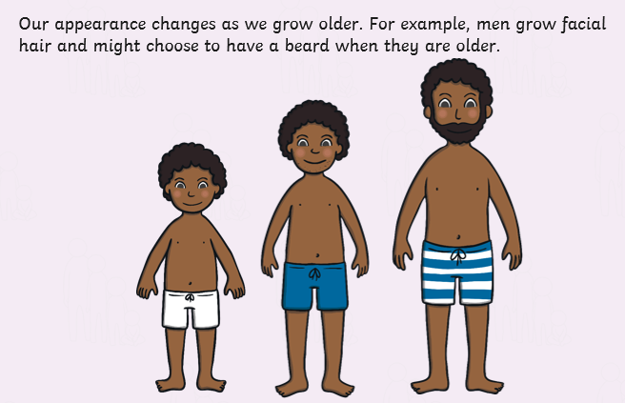  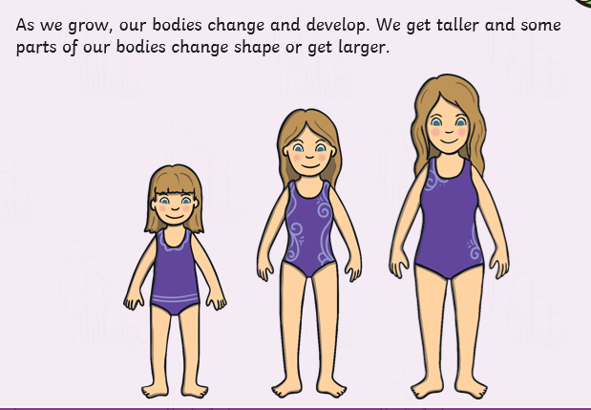
Year 1, 2 | Summer Term 2 | Changes  The children will be introduced to changes focsuing in things that might change in their life. E.g. moving home, losing toys, friends etc. The children will share some scenarios and think about how people might feel? Who they can talk to? And understand that all of these feelings are ok.  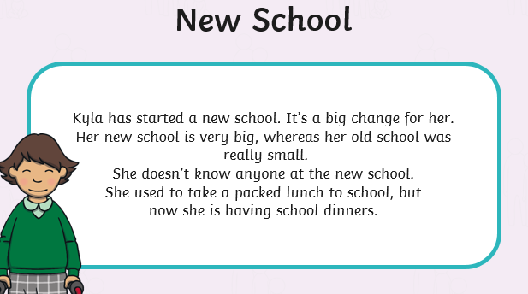  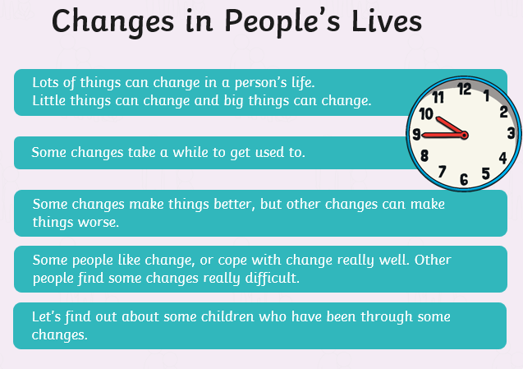
Year Group | Term | Lesson Information
Year 4 | Summer Term 2 | Human Reproduction  The children will discuss the difference between male and female bodies (linking back to naming the parts of the body from KS1). The children will then discuss what reproduction means linking to plants reproducing to make new plants and animals reproducing to make baby animals. The children will then look at diagrams of both male and female bodies and understand that as we grow older the bodies change but are still different to each other. We will find out that there are other similarities and differences that you can’t see as these are on the inside. E.g. lungs = similarities, uterus and ovaries = different. The children will understand that male and female produce a special ingredient needed for human reproduction. The male body makes sperm which is stored in the testicles and the female body makes and stores eggs in the ovaries. They will be told when the sperm and egg meet together, they join to form the start of a baby (foetus). The children will find out that male and female bodies have different jobs so that humans can reproduce.  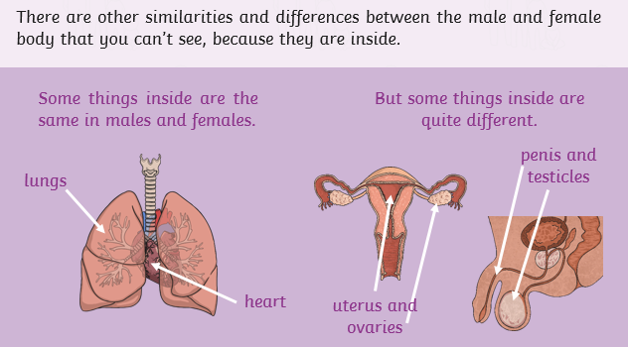  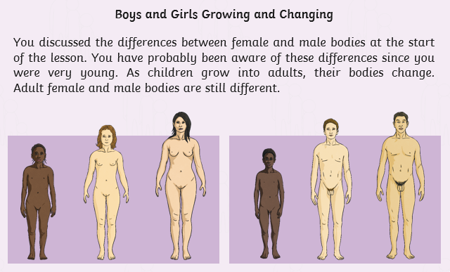  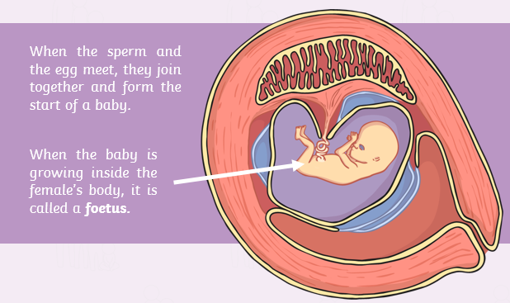  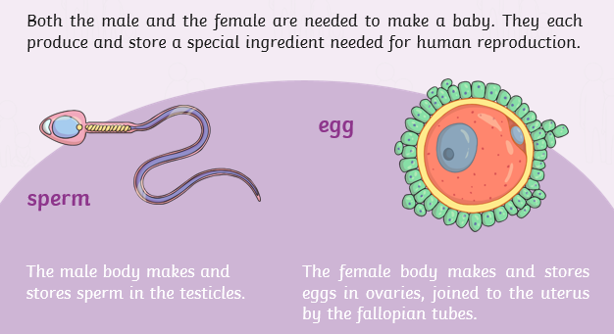
Year 4 | Summer Term 2 | 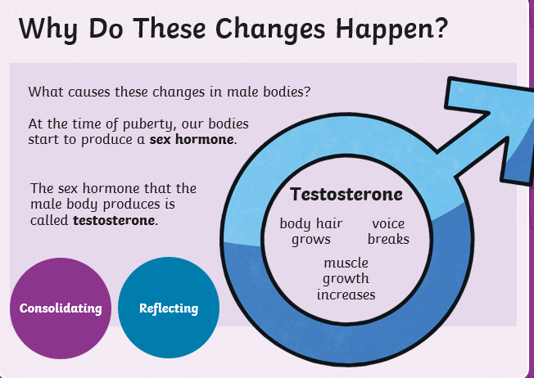  Changes in Boys  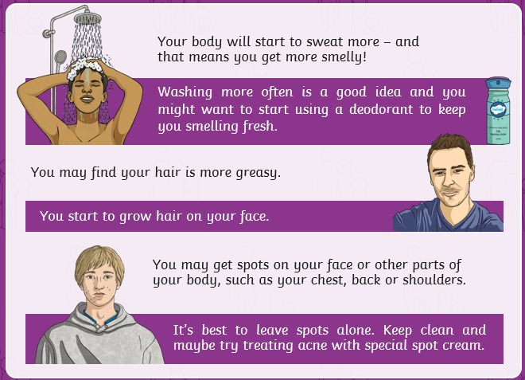  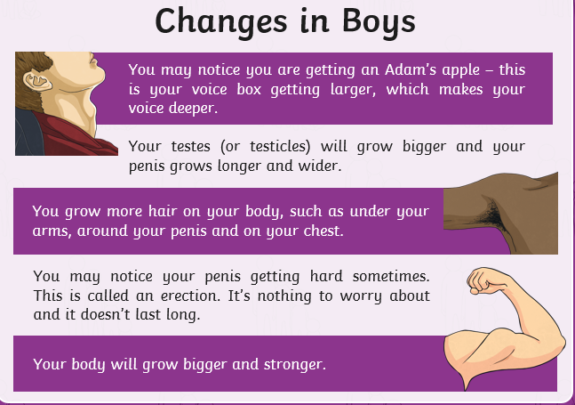  Children to think about the changes to happen to boys’ bodies as they grow up and why they might happen. Children will try to list the differences between boys and men (thinking about men they know dads, uncles etc). Children will find out that boys’ bodies start changing from around the age of 12 but it can be earlier or later and not all the changes happen at once. This change is called puberty and the changes are – deeper voice, Hair will grow (arms, chest, face etc.), sweat more, spots and mixed feelings and mood changes caused by hormones. Our body changes so that one day, if we want to, we can be parents. Children will understand that testosterone (sex hormone) causes the changes in the male bodies. The children will then think about what they are looking forward to as they grow up (jobs, skills, experiences etc).
Year 4 | Summer Term 2 | Changes in girls  Children to think about the changes to happen to girls’ bodies as they grow up and why they might happen. Children will try to list the differences between girls and women (thinking about females they know, mums, aunties etc). Children will be shown an image (shown below) of the inside of a female body. They will discuss how they think this links to periods. Children will find out that girls’ bodies start changing from around the age of 9 but it can be earlier or later and not all the changes happen at once. This change is called puberty and the changes are – release eggs from the ovaries, start your periods, breasts will grow bigger and hips wider, sweat more, spots and mixed feelings and mood changes caused by hormones. Our body changes so that one day, if we want to, we can be parents. Children will understand that testosterone (sex hormone) causes the changes in the female bodies. The female sex hormone is called oestrogen. The children will then think about what they are looking forward to as they grow up (jobs, skills, experiences etc).  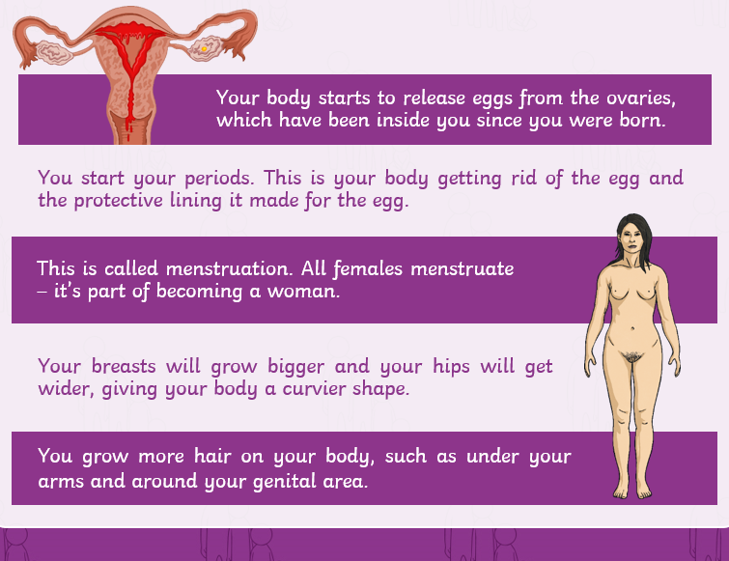  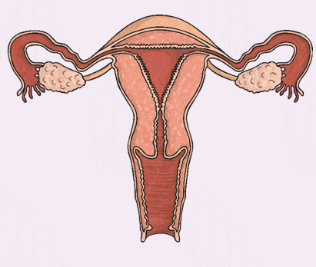  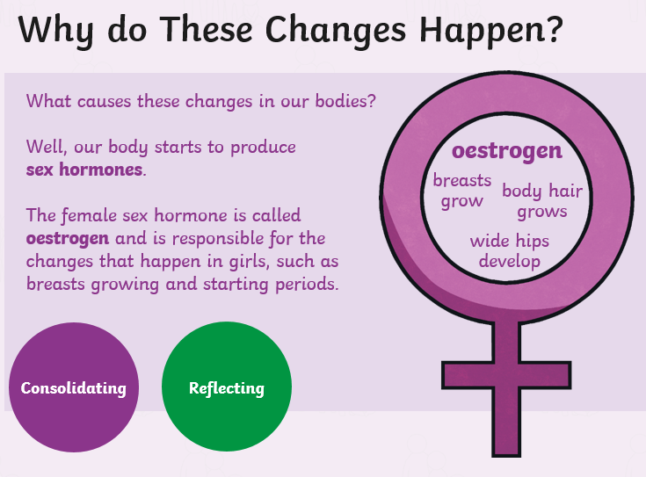  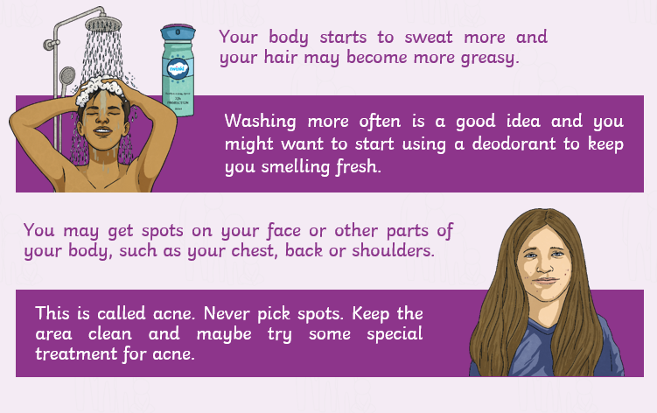
Year 4 | Summer Term 2 | Changing Emotions  The children will recap the changes to both boys and girls from the previous two lessons. They will work together to sort statements into both boy changes, girl changes and changes for both. We will discuss the different changes of emotions due to puberty. We will understand that emotions can change suddenly and be completely different. We will look at a variety of facial expressions and explain what emotion they are showing. We will then reinforce that the changes in emotions are due to hormones which are responsible for all the changes as our body goes through puberty. Testosterone in boys and Oestrogen in girls are the chemical messengers in our body (recap on prior learning). We will then link these changes to having different feelings towards other people: liking them as a friend, having a crush on them (discussion on what a crush is). The children will then understand how to manage their emotions and explain what we can do to cope or overcome these.  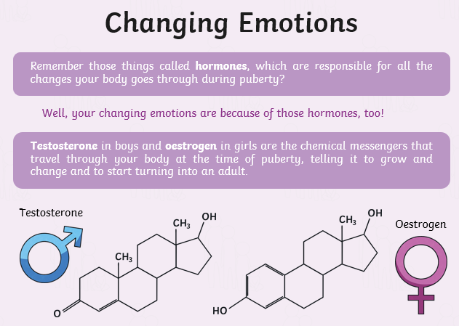  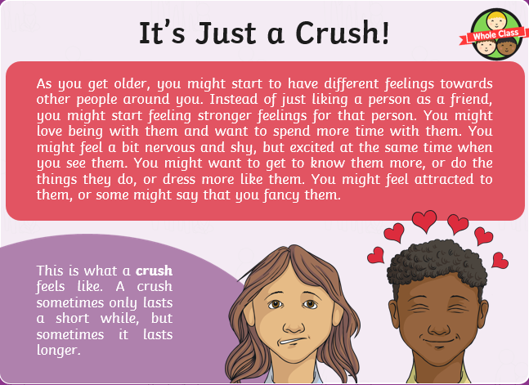
Year 4 | Summer Term 2 | Relationship and Families  The children will think about what a loving relationship is. They will think about their own family and work out who is in it and whether all your family live together. The children will investigate different relationships within families and understand some different terms: parents, children, grandparents, brothers, sisters, aunts, uncles, cousins, half-brothers, half- sisters, step-dads, step-mums, Two mums (lesbian couple), Two dads (a gay couple), single-parent families. The children will then understand that in some families two parents can be married. In others the couple might be in a relationship called a civil partnership. These are both about people comittiing to each other. We will learn that all families can be different (race, size, gender, live together or apart) and there is no right or wrong answer. We will understand that all families have things n common (love, care etc).  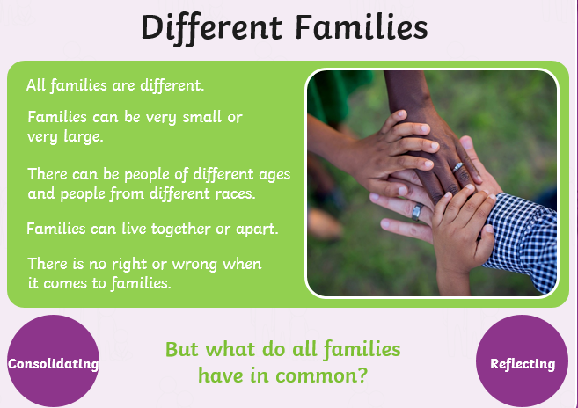  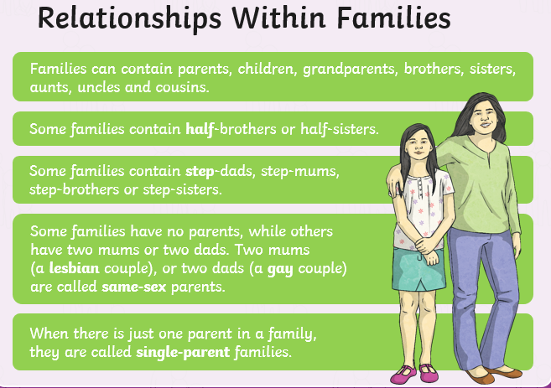  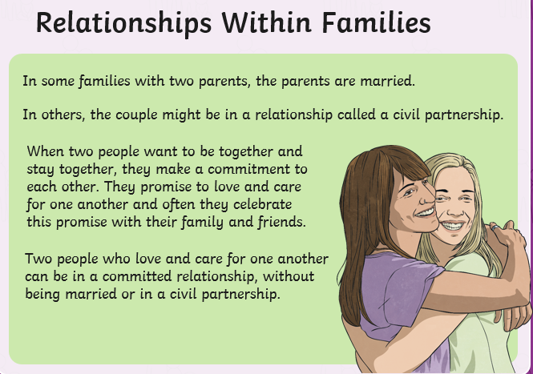
Year 4 | Summer Term 2 | Where do I come from?  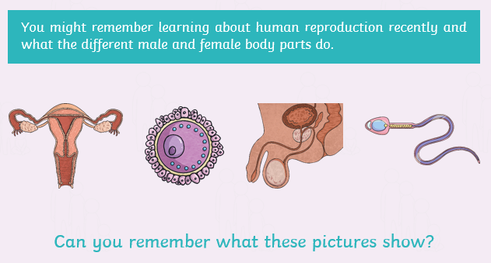  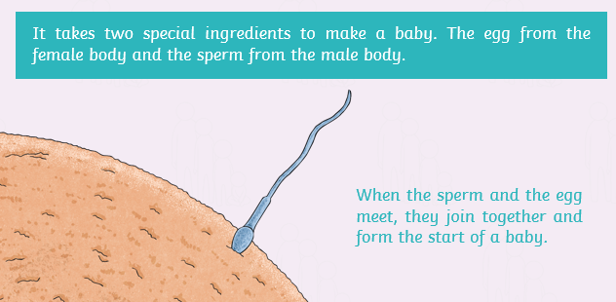  The children will recap on the different male and female reproductive body parts (Sperm, Egg, Testicles, Ovaries). The children will learn it takes two special ingredients to make a baby. The egg from a female joins the sperm from the male body. We understand that when a woman carries a baby inside her is callen being pregnant. We will discuss how a baby grows and develops inside a female’s body. At first it is an embryo and then at eight weeks it becomes a foetus. We will look at some different stages shown below (see pictures). We will understand that the foetus continues to grow and you have scans at a hospital to see this. At around 9 months the baby gets ready to be born and it will be pushed by the mother’s body down through the vagina and will come out between the mother’s legs.  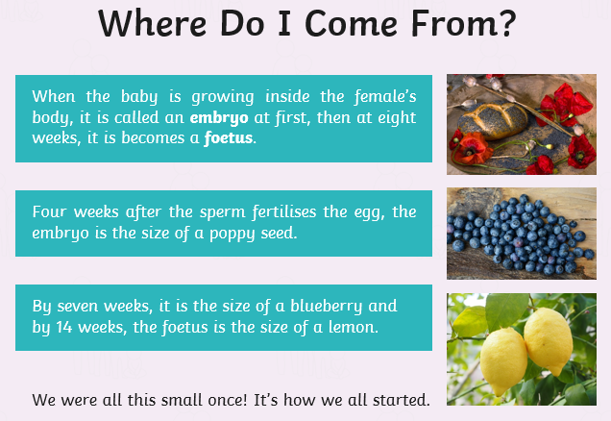  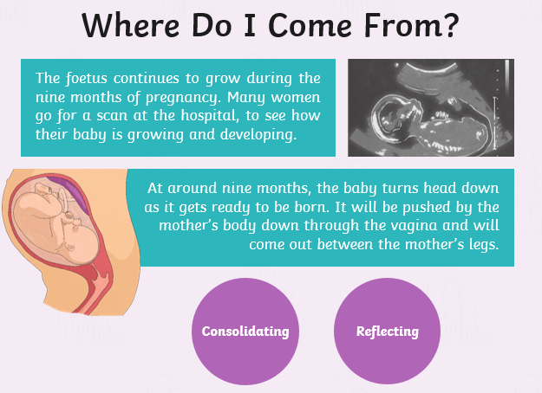  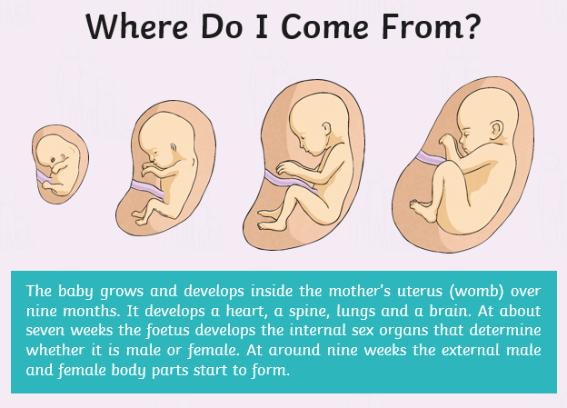  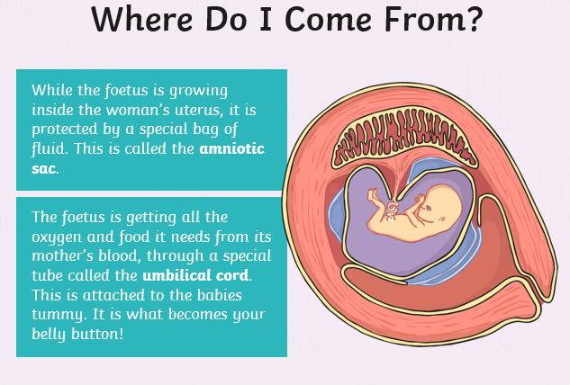
Year Group | Term | Lesson Information
Year 6 | Summer Term 2 | Changing Bodies  The children will recap on the changes that occur in boys’ and girls’ bodies during puberty. The children will understand that puberty is a word which is used to describe when a child’s body starts to change and they become an adult. The children will learn how a boy becomes a man and how a girl becomes a woman, finding out that these changes happen to everyone. Boys between 9-15): start making testosterone in their testicles (sperm), body grows taller and muscular, facial hair, voices break, notice their penis becomes hard (erection). These are all completely normal. Girls between 8 and 13: Body gets curvier, hips get wider, breasts start to develop, female starts producing eggs (released through the menstruation cycle – periods), a white or clear fluid released (discharge). Both: Sweat produced, night emissions or wet dreams, spots or pimples can develop, pubic hair and under-arm hair. The children will learn that is important to be comfortable with your own body and look and touch it. The children will learn that people will start puberty at different times and it is all normal. We will also find out that is really important to look after our bodies and that other people should respect you and you have a right to protect yourself from unwanted contact.  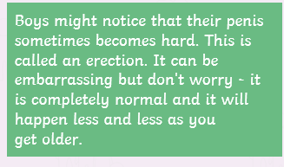  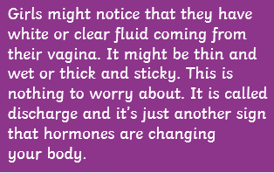  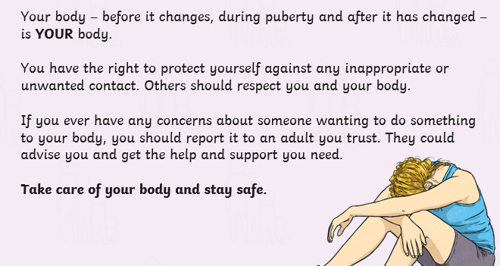  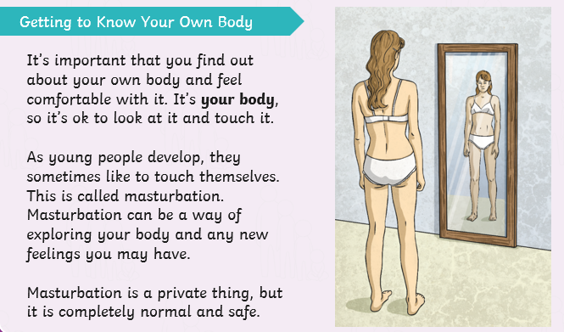  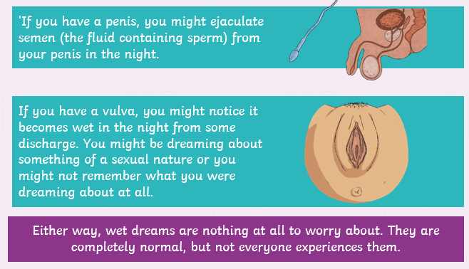  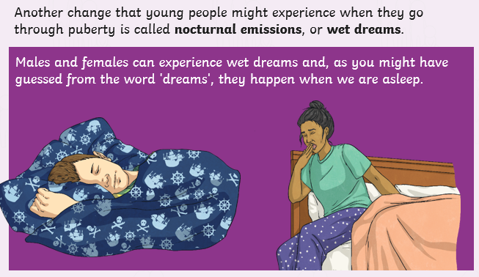
Year 6 | Summer Term 2 | Emotional Changes  The children will think about how their thoughts and feelings might change during puberty. The children will recap about puberty describing the phase when a child’s body develops into an adults. We will understand that puberty can be confusing and even a worrying times and it is important to understand what is happening to your body. We will unpick scenarios about different feelings (having a crush, feeling angry, feeling sad and lonely, feeling like a failure) and offer advice back to each situation. The children will find out that changing moods and strong emotions during puberty happen to everyone and that hormones are responsible for the mixed emotions. We will find out about who you can go to for help (friends, family, adult in school, health professional etc). The children will be shown an information page about child line.  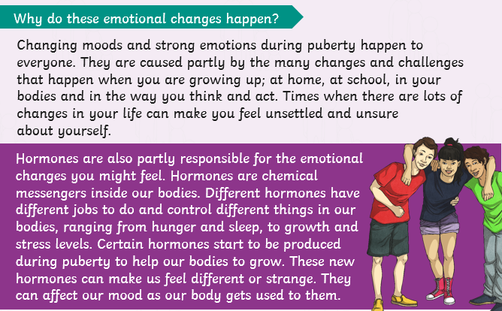  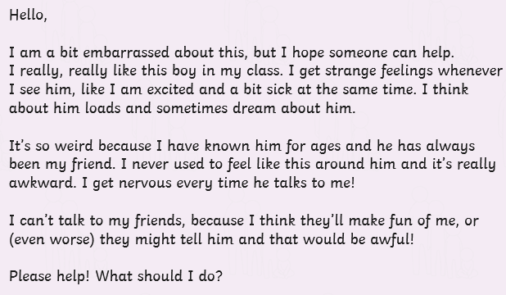  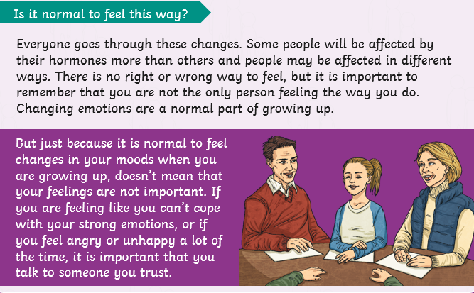  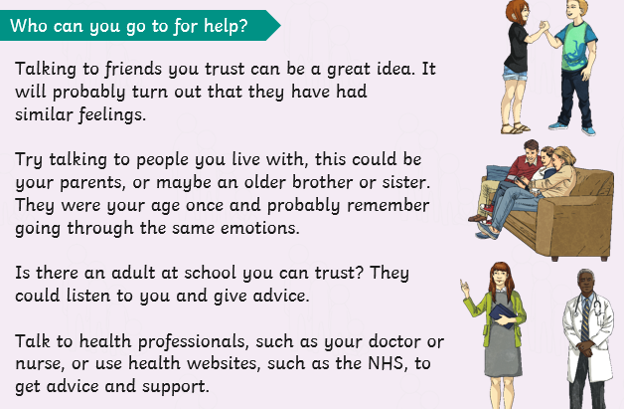
Year 6 | Summer Term 2 | Just the way you are  The children will look around at people in the world and understand the different types of bodies they have, that everyone is unique and that is what is wonderful. We will find out that is important that we look after the body we have. The children will then learn where stereotypical ‘ideal’ or ‘perfect’ bodies are shown (adverts, toys, magazines, images online, music videos). We will discuss why we think that the above tend to feature people with these bodies and what sort of message it brings. The children will then be told about how the media alter photographs and it is not a true reflection of what the person actually looks like. This can be known as retouching. We will then learn that is isn’t just the media that photoshop images. Modern technology on phones always facilities to edit or add filters to images. We will play a game of spot the different between original and edited photographs. We will finish by discussing how that your identity is more than just what you look like. It is about your personality along with lots of other things. We will finish with a something I like about you…game.  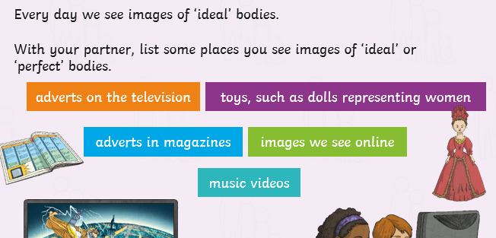  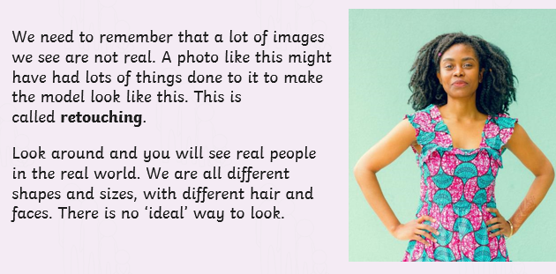  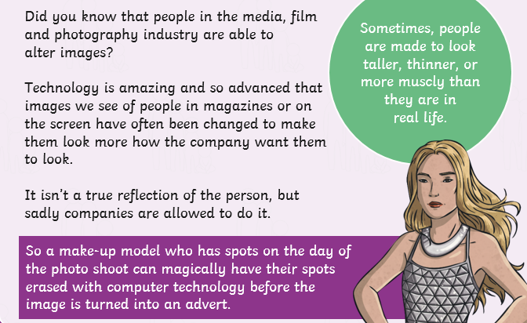
Year 6 | Summer Term 2 | Relationships  The children will think about what a relationship is? What types of relationships you can think of? What is a loving relationship? The children will be exposed to the useful vocabulary (shown below). The children will understand that a loving relationship can be many different things (friends, elderly couple, family) and that we have different loving relationships with different people at different times in our lives. We will discuss that all loving relationships have different elements (shown below). The children will understand that a living relationship between two people in mutual and consensual (both people want to be in the relationship) and that forcing someone to marry is a crime.  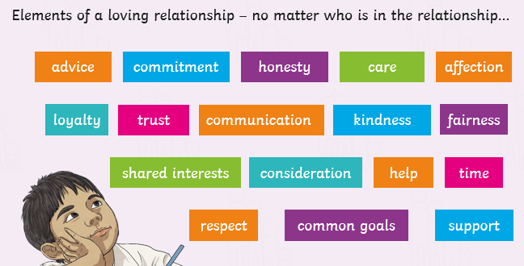  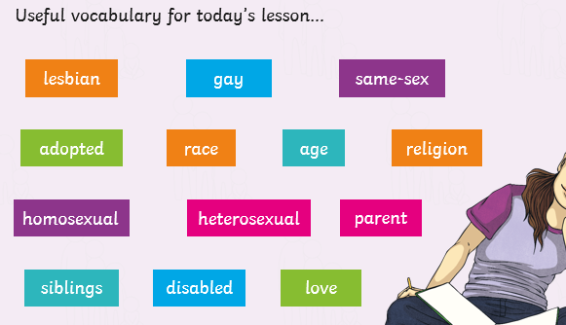
Year 6 | Summer Term 2 | Let’s Talk about Sex  Children will be introduced to the term sexual intercourse through a dictionary definition and understand that sex is short for sexual intercourse. Children will understand that sexual intercourse is one way that two adults in a loving relationship (link back to previous learning) may show love for one another and that it is also the start of the reporduction process (link back to human reproduction). The children will then be provided facts about Sex and the Law (shown below). We will find out that the media (songs and TV) would make use believe that everyone is having sex and being sexy is important when we know that it is not the case (linking back to just because you have a crush on somebody it doesn’t mean you love them or want to have sex with them). The children will then find out that sexual intercouse is necessary for reproduction (in animals including humans). It is how the sperm meets the egg (link back again to human reproduction). The children will then be told that sexual intercouse doesn’t always mean that a baby will be conceived. That contracteption (condoms or the pill) can be used. We will then learn that just like we sneeze and cough into our arms to stop passing germs etc (masks – COVID), we can also pass infection through sexual intercourse. These are known as sexually transmitted infections and some can be serious and make people very ill. We will inform the children that using contraception (condom) prevents infections passing. We will then discuss that looking after your body is essential and people make sensible choices through safe sex (wearing a condom), that you are in charge of your own body and nobody should touch you in a place which makes you feel uncomfortable.  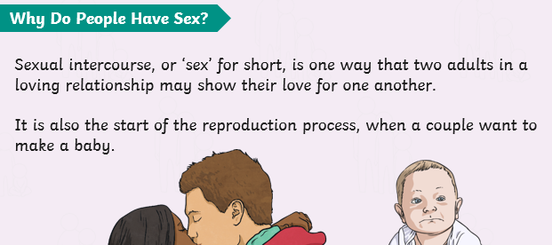  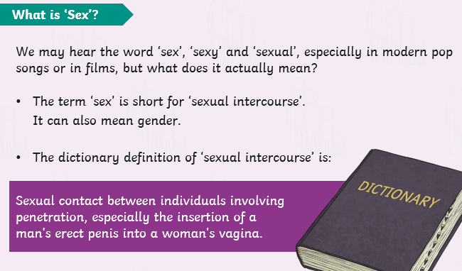  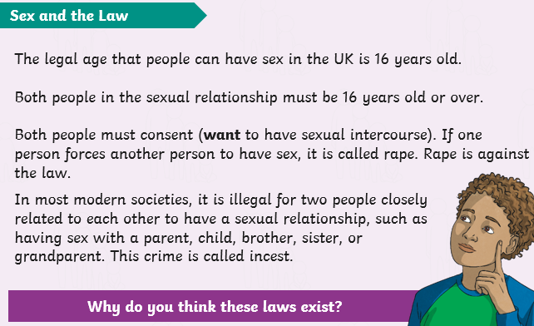  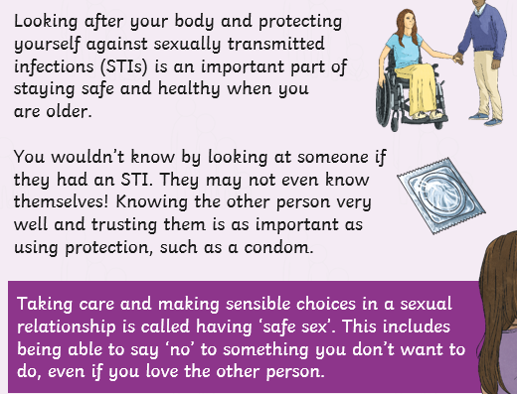  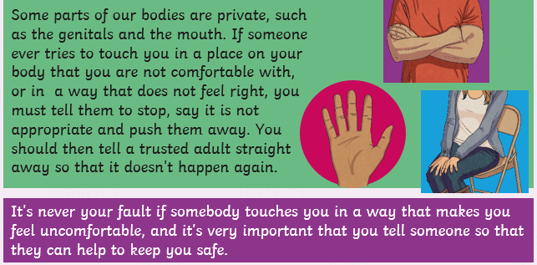  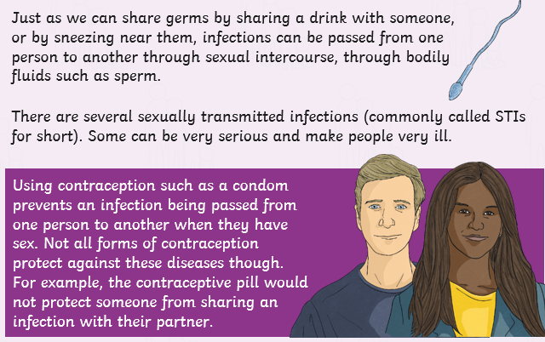  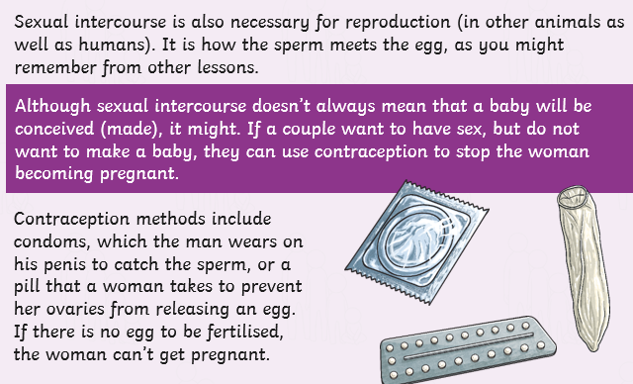
Year 6 | Summer Term 2 | Human Reproduction  The children recap on Human Reproduction from their prior learning in Lower Key Stage 2. The children will know that human contraception is a sperm cell fertisilising an egg (known as conception) to the birth of a baby. They will then find factual information about sperm fertisiling the egg. The specific information is shown in the pictures below. The children will then watch a short video from conception to birth – link provided https://www.youtube.com/watch?app=desktop&v=SK72Iu8TbF4 .  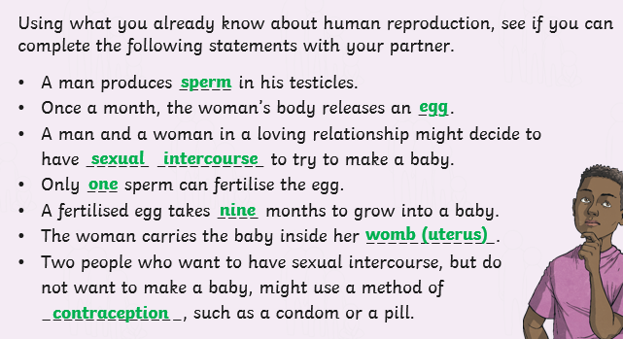  The video just shows scientfic, under the miscroscope, pictures of the conception with images of a baby growing inside the womb. The children will then understand what a Foetus needs: minerals, oxygen, fats, vitamis, protection, protein. The children will find out that after 9 months of growing inside its mother, the baby is ready to be born. This is called labour (building on prior learing). There will be brief explanation explaining the difference when a baby is born by caesarean section.  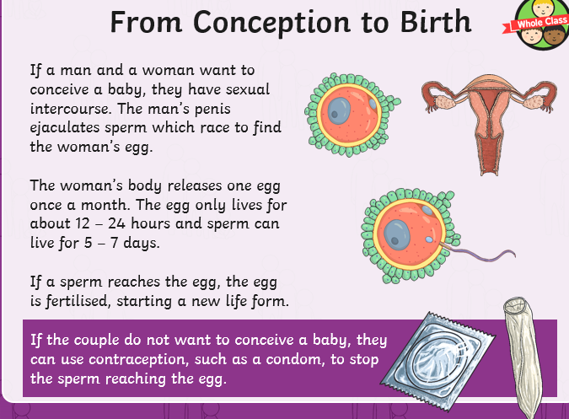  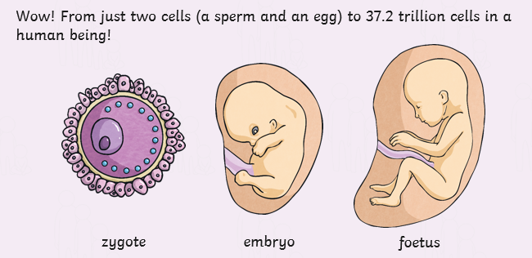  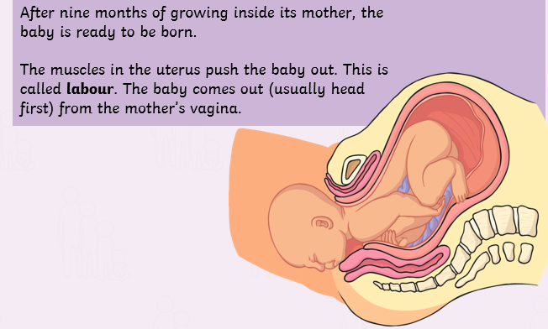  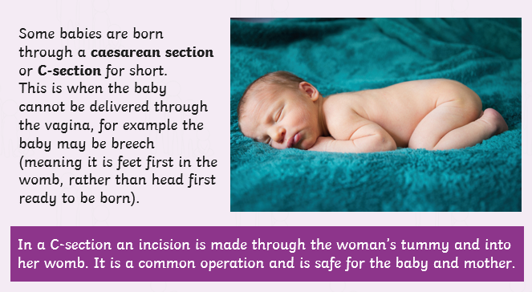

Appendix 2: By the end of primary school pupils should know.

Topic | Pupils should know
Families and people who care about me | - That families are important for children growing up because they can give love, security and stability  - The characteristics of healthy family life, commitment to each other, including in times of difficulty, protection and care for children and other family members, the importance of spending time together and sharing each other’s lives  - That others’ families, either in school or in the wider world, sometimes look different from their family, but that they should respect those differences and know that other children’s families are also characterised by love and care  - That stable, caring relationships, which may be of different types, are at the heart of happy families, and are important for children’s security as they grow up  - That marriage represents a formal and legally recognised commitment of two people to each other which is intended to be lifelong  - How to recognise if family relationships are making them feel unhappy or unsafe, and how to seek help or advice from others if needed
Caring friendships | - How important friendships are in making us feel happy and secure, and how people choose and make friends  - The characteristics of friendships, including mutual respect, truthfulness, trustworthiness, loyalty, kindness, generosity, trust, sharing interests and experiences and support with problems and difficulties  - That healthy friendships are positive and welcoming towards others, and do not make others feel lonely or excluded  - That most friendships have ups and downs, and that these can often be worked through so that the friendship is repaired or even strengthened, and that resorting to violence is never right  - How to recognise who to trust and who not to trust, how to judge when a friendship is making them feel unhappy or uncomfortable, managing conflict, how to manage these situations and how to seek help or advice from others, if needed
Respectful relationships | - The importance of respecting others, even when they are very different from them (for example, physically, in character, personality or backgrounds), or make different choices or have different preferences or beliefs  - Practical steps they can take in a range of different contexts to improve or support respectful relationships  - The conventions of courtesy and manners  - The importance of self-respect and how this links to their own happiness  - That in school and in wider society they can expect to be treated with respect by others, and that in turn they should show due respect to others, including those in positions of authority  - About different types of bullying (including cyberbullying), the impact of bullying, responsibilities of bystanders (primarily reporting bullying to an adult) and how to get help  - What a stereotype is, and how stereotypes can be unfair, negative or destructive  - The importance of permission-seeking and giving in relationships with friends, peers and adults
Online relationships | - That people sometimes behave differently online, including by pretending to be someone they are not  - That the same principles apply to online relationships as to face-to face relationships, including the importance of respect for others online including when we are anonymous  - The rules and principles for keeping safe online, how to recognise risks, harmful content and contact, and how to report them  - How to critically consider their online friendships and sources of information including awareness of the risks associated with people they have never met  - How information and data is shared and used online
Being safe | - What sorts of boundaries are appropriate in friendships with peers and others (including in a digital context)  - About the concept of privacy and the implications of it for both children and adults; including that it is not always right to keep secrets if they relate to being safe  - That each person’s body belongs to them, and the differences between appropriate and inappropriate or unsafe physical, and other, contact  - How to respond safely and appropriately to adults they may encounter (in all contexts, including online) whom they do not know  - How to recognise and report feelings of being unsafe or feeling bad about any adult  - How to ask for advice or help for themselves or others, and to keep trying until they are heard  - How to report concerns or abuse, and the vocabulary and confidence needed to do so  - Where to get advice e.g. family, school and/or other sources

Appendix 3: Parent form - withdrawal from sex education within RSE

To be completed by parents
Name of child |  | Class
Name of parent |  | Date
Reason for withdrawing from sex education within relationships and sex education
Any other information you would like the school to consider
Parent signature

To be completed by the school
Agreed actions from discussion with parents

Document Detail
Document Name: |  |  | Relationships and Sex Education Policy
Version: |  |  | 2
Chief Officer Signature: |  |  | 
Effective From: |  |  | 01/04/2025
Approved by: |  |  | D Dickinson
Approval Meeting Reference: |  |  | ELT 3/3/25
Next Review Date: |  |  | 01/04/2026
Version Control
Version | Date | Author |  | Change/Reference
1 | 01/02/2023 | M Bretherton |  | New Policy
2 | 01/01/2025 | M Bretherton |  | Expanded definitions in relation to Sex Education and Relationships Education

