This appendix highlights the Sexual Education unit of work embedded within our Relationships and Sex Education and Health Education curriculum. The content highlighted in red are the non-statutory elements to our curriculum and therefore parents have a right to withdraw from these specific aspects taught in school. All of the text in black is statutory guidance and therefore children must be taught those aspects in line with their peers.
This document provides you with the lesson objectives and lesson content also indicating which year group it will be taught in and at what point in the academic year.
Year Group | Term | Lesson Information
Year 1, 2 | Summer Term 2 | 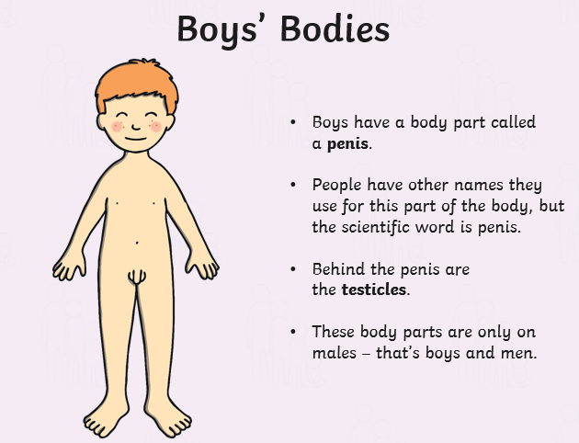  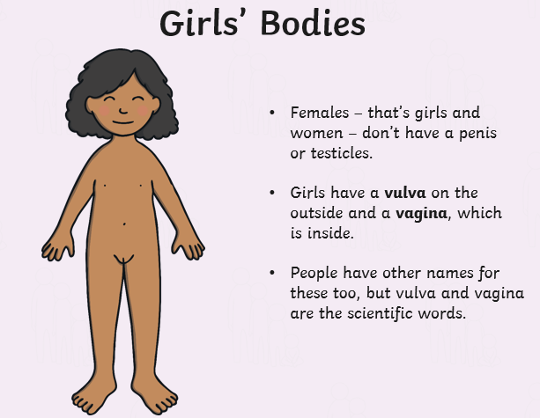  Our bodies  The children will be told that different body parts have special jobs to do. Children will look at the differences between boys and girls from what they can see e.g. arms, legs, lips, toes etc. We will introduce that the differences between boys’ and girls’ bodies are hidden under our underwear. We will explain that they can sometimes be called private parts but today we will use scientific names that a doctor would use to name these. Children will name the external genitalia of a boy and girl, understanding that they are different. The words that the children will use are penis, testicles, vulva and vagina. The children will find out that as we get older we want to cover these parts so will be designing a swimming costume or shorts to link with the learning.
Year 1, 2 | Summer Term 2 | Is it ok?  The children will be learning about physical contact and understanding that consent means we can say yes and no. They will do this by acting out different scenarios with other children where they will ask if it is ok first. For example, ‘Is it ok to play with your toy?’ The children will discuss a variety of questions and provide a teddy some advice. This will reinforce the words private and privacy from the previous learning.  One example-  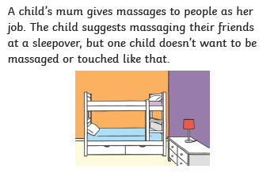  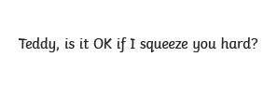
Year 1, 2 | Summer Term 2 | Pink and Blue  The children will start by discussing things that people like e.g. toys, football etc moving towards whether we can tell what people like depending on if they are a boy or a girl. Children will be introduced to what a stereotype is and understanding that everyone can like different things and that is ok. The children will play ‘find somebody who’ game which will reinforce that everyone is unique and has their own set of likes and dislike  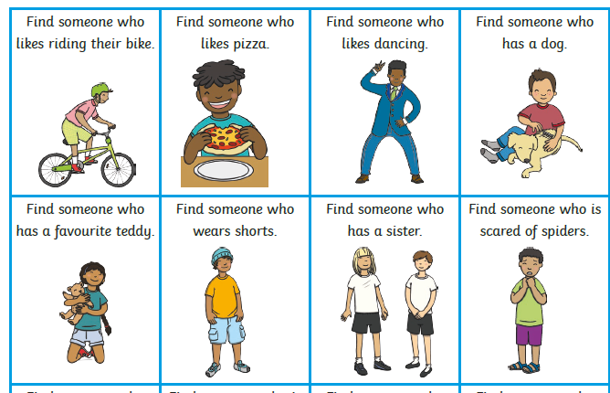
Year 1, 2 | Summer Term 2 | Look at me now  Children will understand how things change as we grow up e.g. learn new things, become more independent and have more responsibilities. The children will discuss what they can do now that they couldn’t do when they were a baby. We will discuss how we need lots of help to do certain things and think about how that might change as we get older.  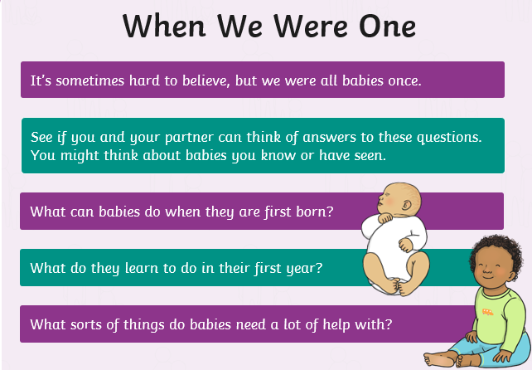
Year 1, 2 | Summer Term 2 | Getting older  Children will be recapping the previous learning about things that they couldn’t do when they were younger that they can now. They will move onto thinking about what changes might happen in the future. The children will find out that our bodies change and devleop. This will be shown with some simple clothed illustrations. The children will then think about what they want to be when they are older and thinking about what responsibilities they might have e.g. feeding a pet, tidying their bedroom.  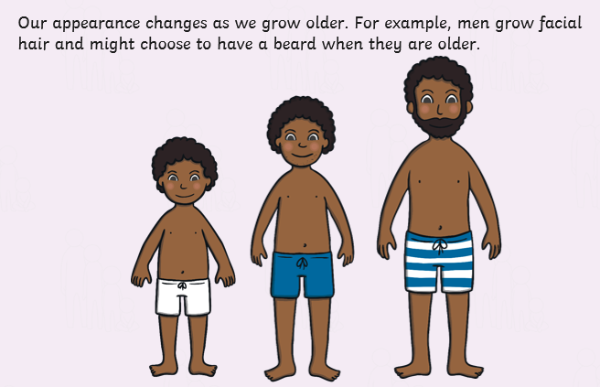  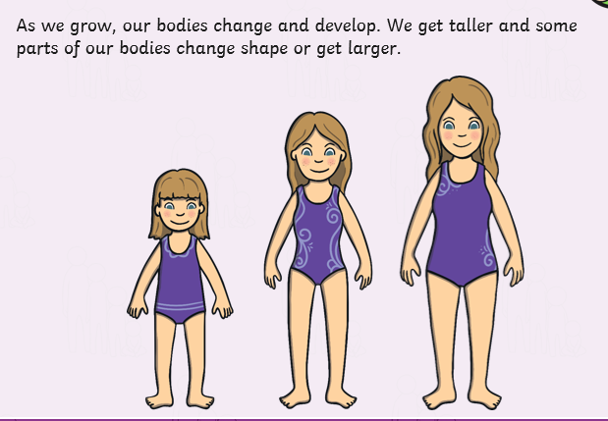
Year 1, 2 | Summer Term 2 | Changes  The children will be introduced to changes focsuing in things that might change in their life. E.g. moving home, losing toys, friends etc. The children will share some scenarios and think about how people might feel? Who they can talk to? And understand that all of these feelings are ok.  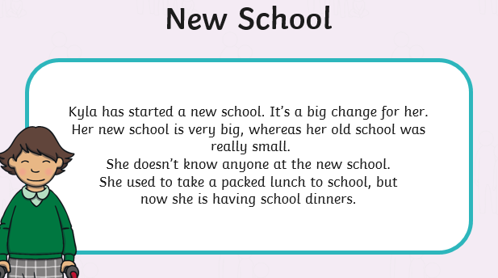  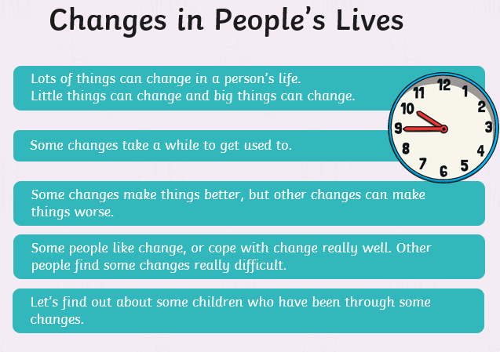
Year Group | Term | Lesson Information
Year 4 | Summer Term 2 | Human Reproduction  The children will discuss the difference between male and female bodies (linking back to naming the parts of the body from KS1). The children will then discuss what reproduction means linking to plants reproducing to make new plants and animals reproducing to make baby animals. The children will then look at diagrams of both male and female bodies and understand that as we grow older the bodies change but are still different to each other. We will find out that there are other similarities and differences that you can’t see as these are on the inside. E.g. lungs = similarities, uterus and ovaries = different. The children will understand that male and female produce a special ingredient needed for human reproduction. The male body makes sperm which is stored in the testicles and the female body makes and stores eggs in the ovaries. They will be told when the sperm and egg meet together, they join to form the start of a baby (foetus). The children will find out that male and female bodies have different jobs so that humans can reproduce.  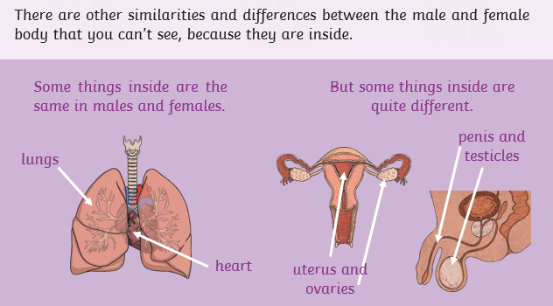  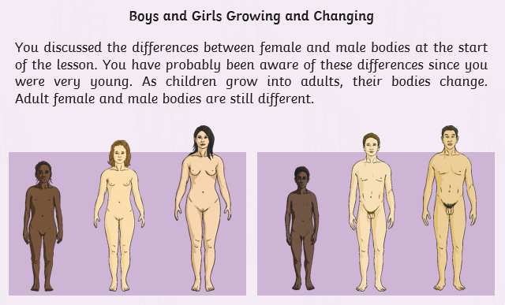  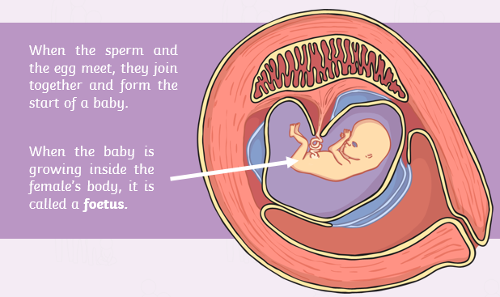  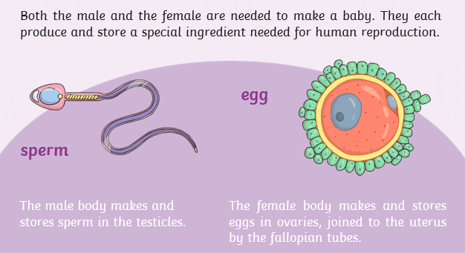
Year 4 | Summer Term 2 | 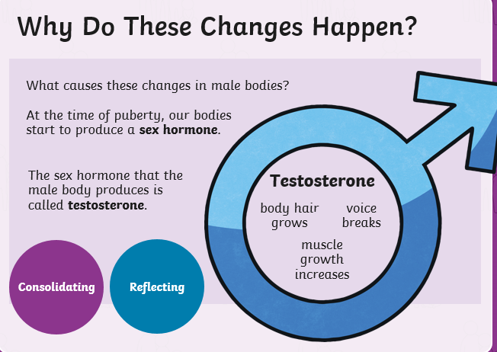  Changes in Boys  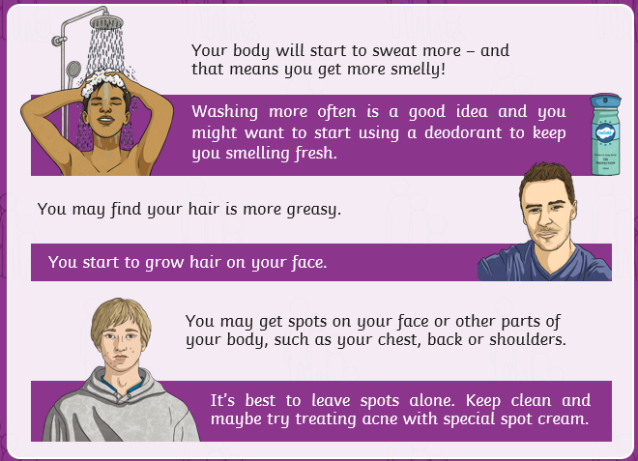  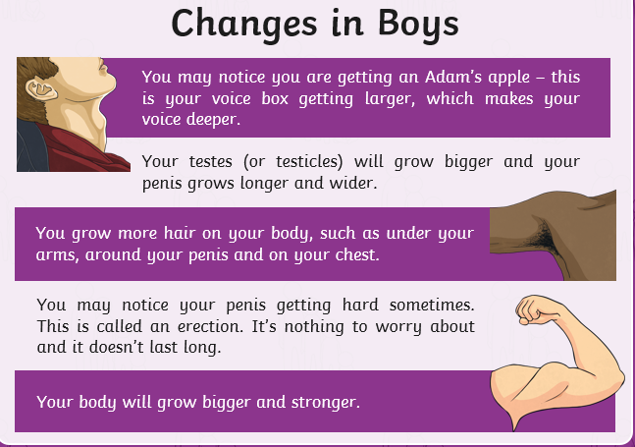  Children to think about the changes to happen to boys’ bodies as they grow up and why they might happen. Children will try to list the differences between boys and men (thinking about men they know dads, uncles etc). Children will find out that boys’ bodies start changing from around the age of 12 but it can be earlier or later and not all the changes happen at once. This change is called puberty and the changes are – deeper voice, Hair will grow (arms, chest, face etc.), sweat more, spots and mixed feelings and mood changes caused by hormones. Our body changes so that one day, if we want to, we can be parents. Children will understand that testosterone (sex hormone) causes the changes in the male bodies. The children will then think about what they are looking forward to as they grow up (jobs, skills, experiences etc).
Year 4 | Summer Term 2 | Changes in girls  Children to think about the changes to happen to girls’ bodies as they grow up and why they might happen. Children will try to list the differences between girls and women (thinking about females they know, mums, aunties etc). Children will be shown an image (shown below) of the inside of a female body. They will discuss how they think this links to periods. Children will find out that girls’ bodies start changing from around the age of 9 but it can be earlier or later and not all the changes happen at once. This change is called puberty and the changes are – release eggs from the ovaries, start your periods, breasts will grow bigger and hips wider, sweat more, spots and mixed feelings and mood changes caused by hormones. Our body changes so that one day, if we want to, we can be parents. Children will understand that testosterone (sex hormone) causes the changes in the female bodies. The female sex hormone is called oestrogen. The children will then think about what they are looking forward to as they grow up (jobs, skills, experiences etc).  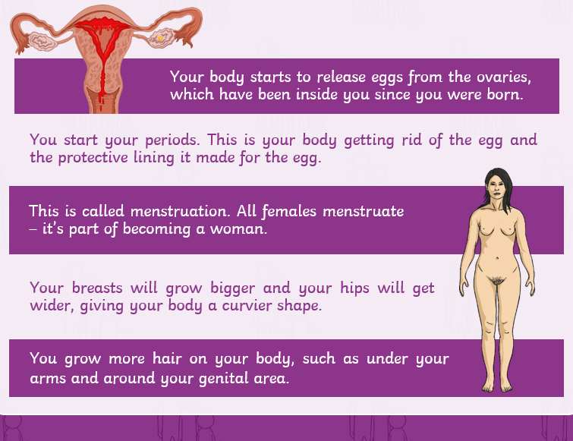  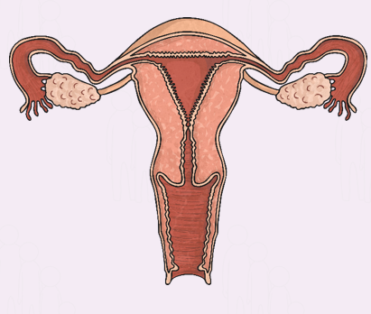  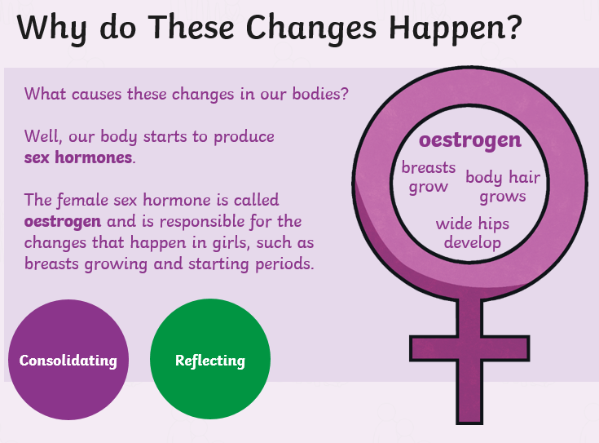  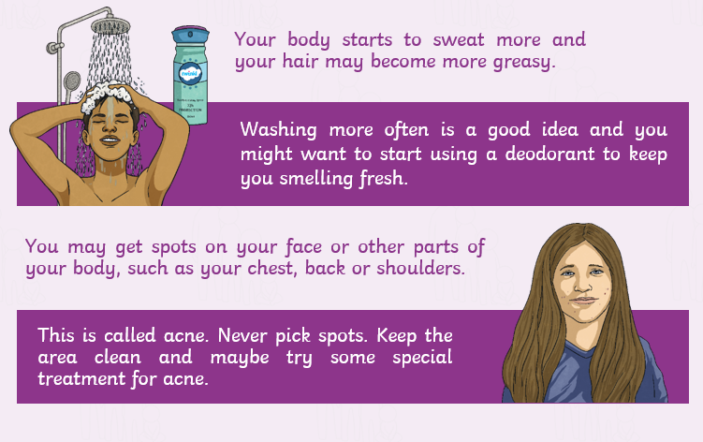
Year 4 | Summer Term 2 | Changing Emotions  The children will recap the changes to both boys and girls from the previous two lessons. They will work together to sort statements into both boy changes, girl changes and changes for both. We will discuss the different changes of emotions due to puberty. We will understand that emotions can change suddenly and be completely different. We will look at a variety of facial expressions and explain what emotion they are showing. We will then reinforce that the changes in emotions are due to hormones which are responsible for all the changes as our body goes through puberty. Testosterone in boys and Oestrogen in girls are the chemical messengers in our body (recap on prior learning). We will then link these changes to having different feelings towards other people: liking them as a friend, having a crush on them (discussion on what a crush is). The children will then understand how to manage their emotions and explain what we can do to cope or overcome these.  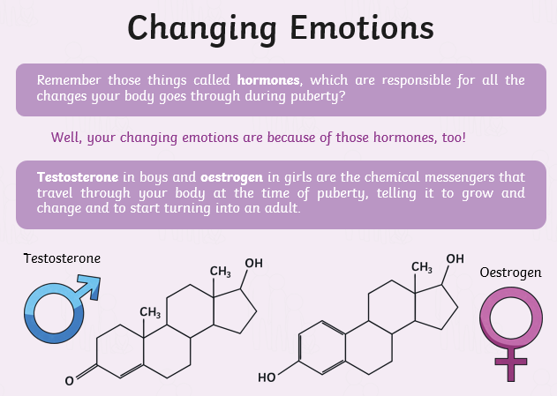  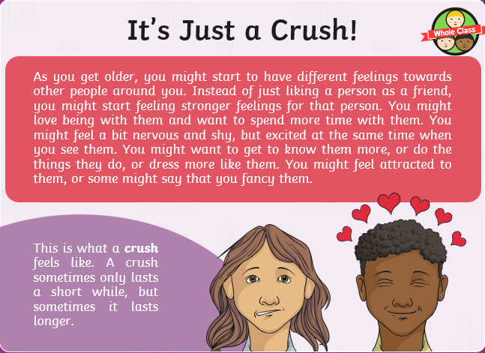
Year 4 | Summer Term 2 | Relationship and Families  The children will think about what a loving relationship is. They will think about their own family and work out who is in it and whether all your family live together. The children will investigate different relationships within families and understand some different terms: parents, children, grandparents, brothers, sisters, aunts, uncles, cousins, half-brothers, half- sisters, step-dads, step-mums, Two mums (lesbian couple), Two dads (a gay couple), single-parent families. The children will then understand that in some families two parents can be married. In others the couple might be in a relationship called a civil partnership. These are both about people comittiing to each other. We will learn that all families can be different (race, size, gender, live together or apart) and there is no right or wrong answer. We will understand that all families have things n common (love, care etc).  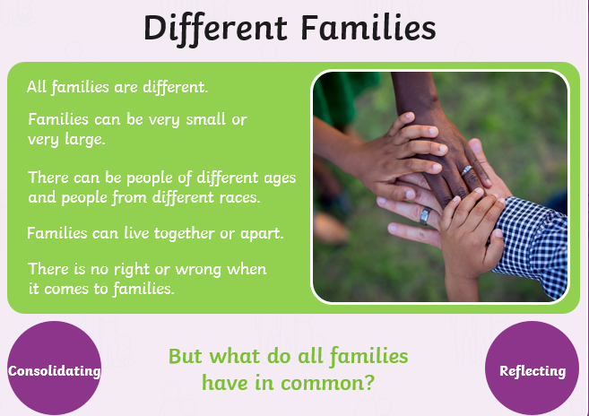  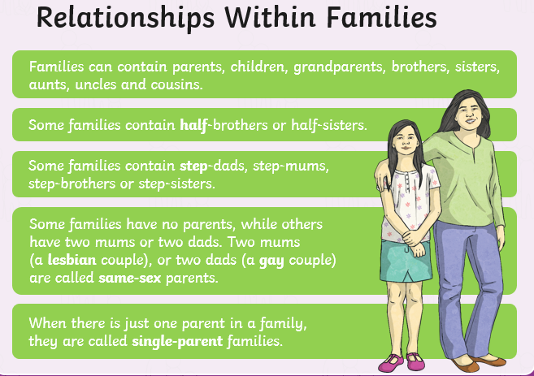  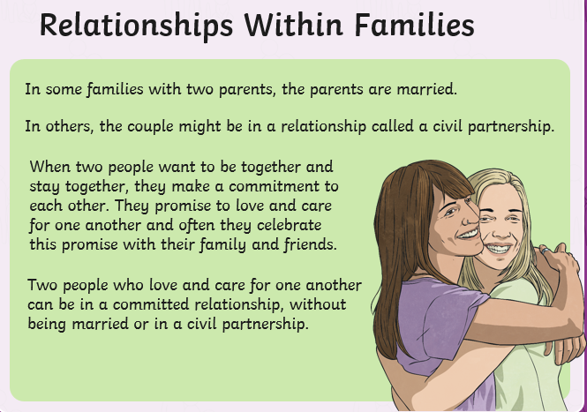
Year 4 | Summer Term 2 | Where do I come from?  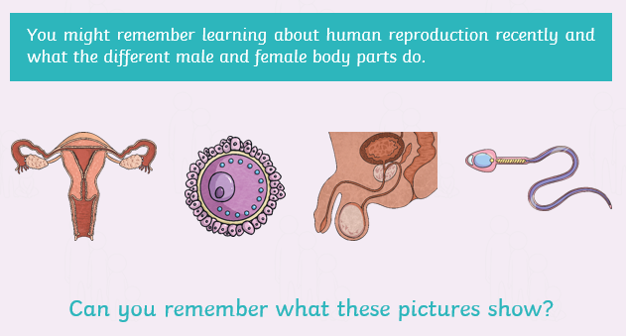  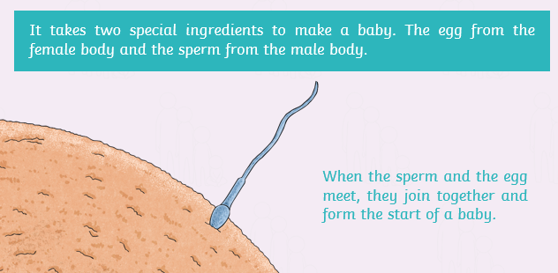  The children will recap on the different male and female reproductive body parts (Sperm, Egg, Testicles, Ovaries). The children will learn it takes two special ingredients to make a baby. The egg from a female joins the sperm from the male body. We understand that when a woman carries a baby inside her is callen being pregnant. We will discuss how a baby grows and develops inside a female’s body. At first it is an embryo and then at eight weeks it becomes a foetus. We will look at some different stages shown below (see pictures). We will understand that the foetus continues to grow and you have scans at a hospital to see this. At around 9 months the baby gets ready to be born and it will be pushed by the mother’s body down through the vagina and will come out between the mother’s legs.  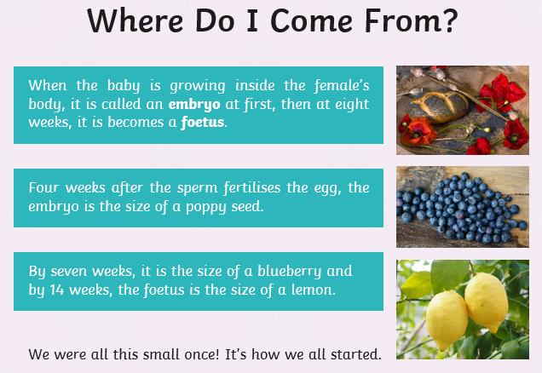  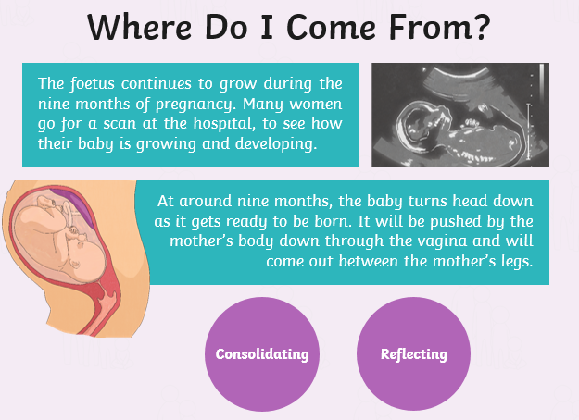  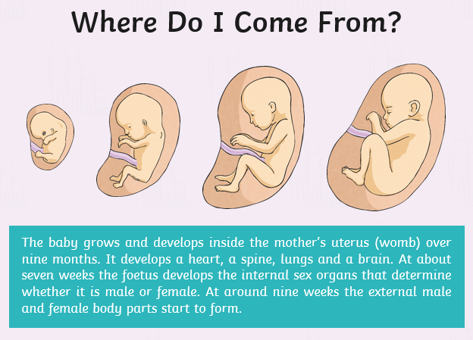  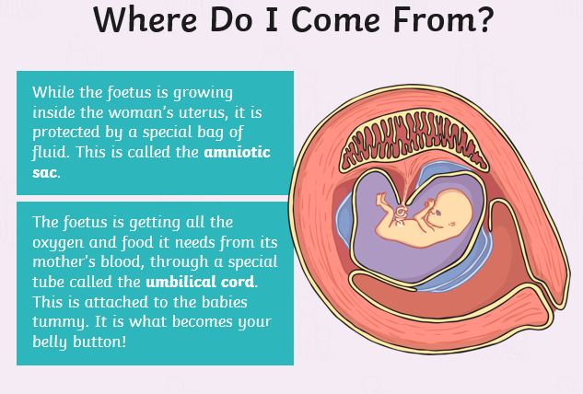
Year Group | Term | Lesson Information
Year 6 | Summer Term 2 | Changing Bodies  The children will recap on the changes that occur in boys’ and girls’ bodies during puberty. The children will understand that puberty is a word which is used to describe when a child’s body starts to change and they become an adult. The children will learn how a boy becomes a man and how a girl becomes a woman, finding out that these changes happen to everyone. Boys between 9-15): start making testosterone in their testicles (sperm), body grows taller and muscular, facial hair, voices break, notice their penis becomes hard (erection). These are all completely normal. Girls between 8 and 13: Body gets curvier, hips get wider, breasts start to develop, female starts producing eggs (released through the menstruation cycle – periods), a white or clear fluid released (discharge). Both: Sweat produced, night emissions or wet dreams, spots or pimples can develop, pubic hair and under-arm hair. The children will learn that is important to be comfortable with your own body and look and touch it. The children will learn that people will start puberty at different times and it is all normal. We will also find out that is really important to look after our bodies and that other people should respect you and you have a right to protect yourself from unwanted contact.  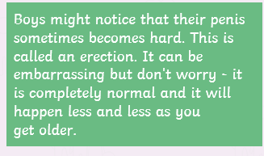  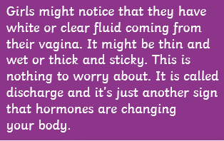  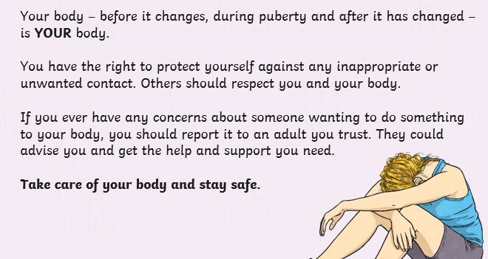  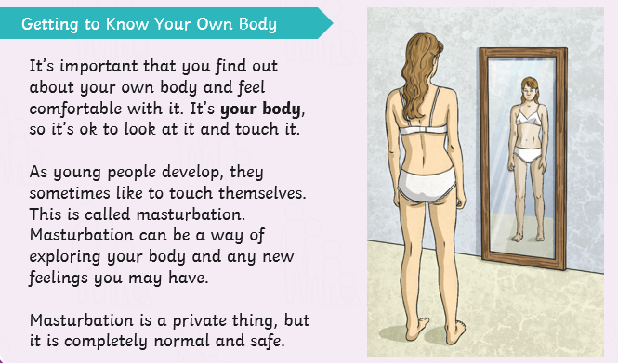  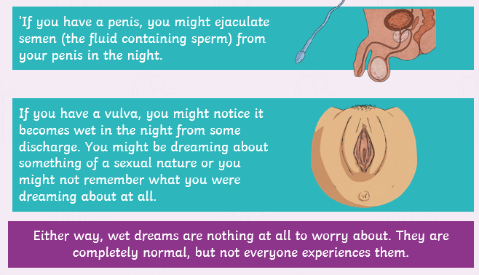  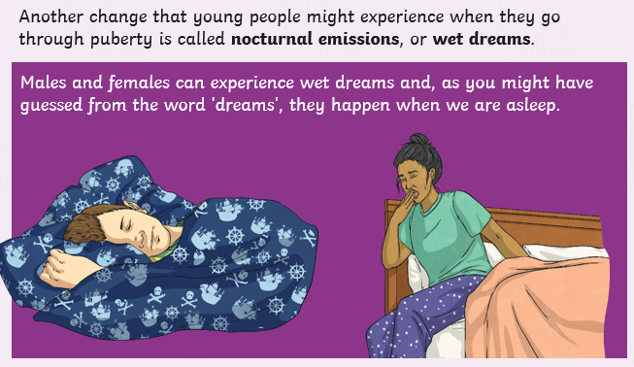
Year 6 | Summer Term 2 | Emotional Changes  The children will think about how their thoughts and feelings might change during puberty. The children will recap about puberty describing the phase when a child’s body develops into an adults. We will understand that puberty can be confusing and even a worrying times and it is important to understand what is happening to your body. We will unpick scenarios about different feelings (having a crush, feeling angry, feeling sad and lonely, feeling like a failure) and offer advice back to each situation. The children will find out that changing moods and strong emotions during puberty happen to everyone and that hormones are responsible for the mixed emotions. We will find out about who you can go to for help (friends, family, adult in school, health professional etc). The children will be shown an information page about child line.  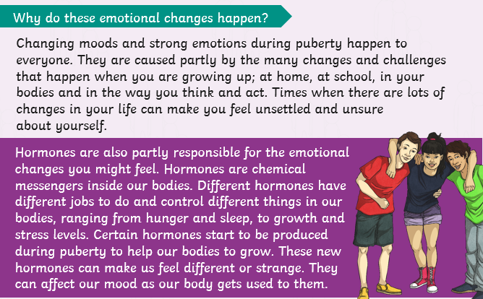  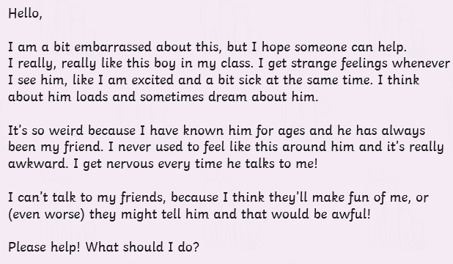  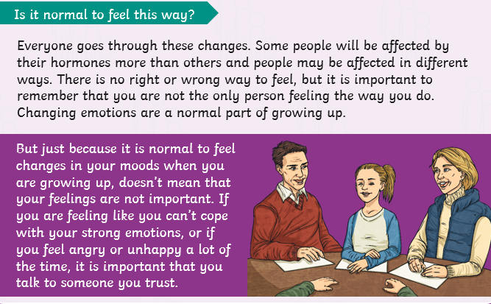  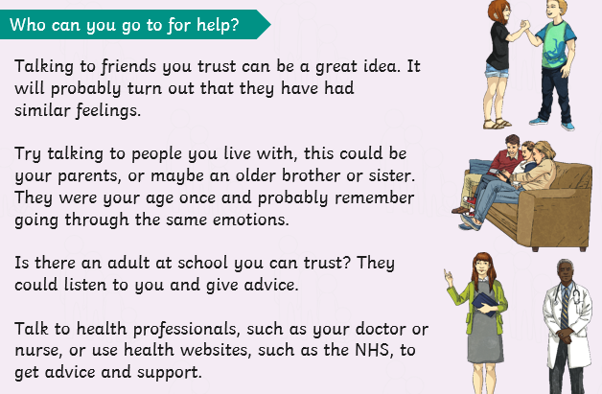
Year 6 | Summer Term 2 | Just the way you are  The children will look around at people in the world and understand the different types of bodies they have, that everyone is unique and that is what is wonderful. We will find out that is important that we look after the body we have. The children will then learn where stereotypical ‘ideal’ or ‘perfect’ bodies are shown (adverts, toys, magazines, images online, music videos). We will discuss why we think that the above tend to feature people with these bodies and what sort of message it brings. The children will then be told about how the media alter photographs and it is not a true reflection of what the person actually looks like. This can be known as retouching. We will then learn that is isn’t just the media that photoshop images. Modern technology on phones always facilities to edit or add filters to images. We will play a game of spot the different between original and edited photographs. We will finish by discussing how that your identity is more than just what you look like. It is about your personality along with lots of other things. We will finish with a something I like about you…game.  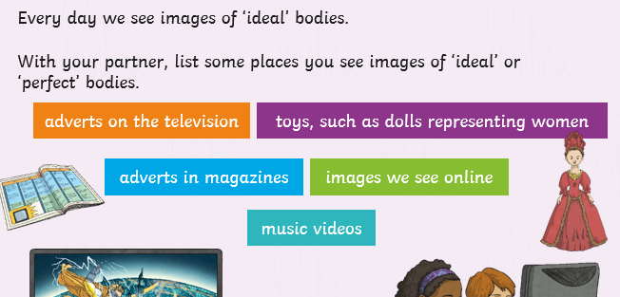  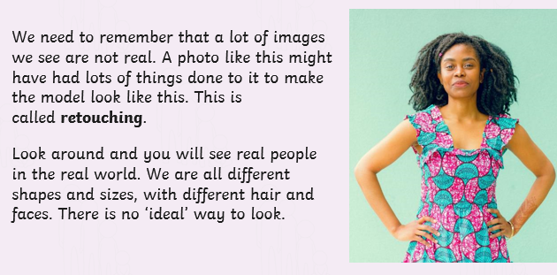  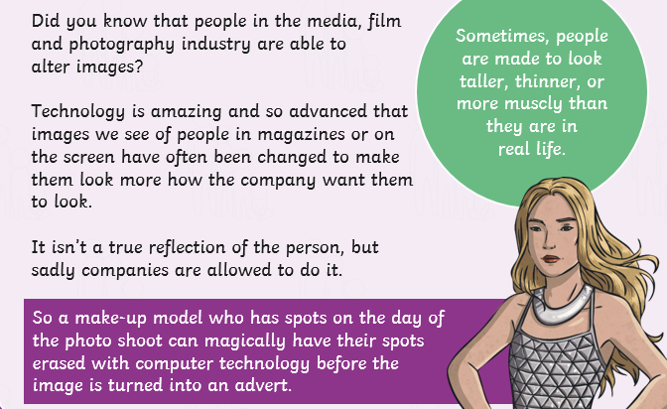
Year 6 | Summer Term 2 | Relationships  The children will think about what a relationship is? What types of relationships you can think of? What is a loving relationship? The children will be exposed to the useful vocabulary (shown below). The children will understand that a loving relationship can be many different things (friends, elderly couple, family) and that we have different loving relationships with different people at different times in our lives. We will discuss that all loving relationships have different elements (shown below). The children will understand that a living relationship between two people in mutual and consensual (both people want to be in the relationship) and that forcing someone to marry is a crime.  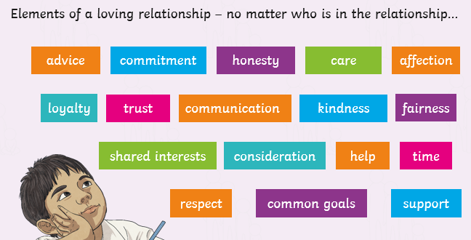  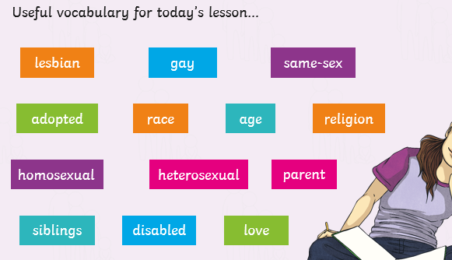
Year 6 | Summer Term 2 | Let’s Talk about Sex  Children will be introduced to the term sexual intercourse through a dictionary definition and understand that sex is short for sexual intercourse. Children will understand that sexual intercourse is one way that two adults in a loving relationship (link back to previous learning) may show love for one another and that it is also the start of the reporduction process (link back to human reproduction). The children will then be provided facts about Sex and the Law (shown below). We will find out that the media (songs and TV) would make use believe that everyone is having sex and being sexy is important when we know that it is not the case (linking back to just because you have a crush on somebody it doesn’t mean you love them or want to have sex with them). The children will then find out that sexual intercouse is necessary for reproduction (in animals including humans). It is how the sperm meets the egg (link back again to human reproduction). The children will then be told that sexual intercouse doesn’t always mean that a baby will be conceived. That contracteption (condoms or the pill) can be used. We will then learn that just like we sneeze and cough into our arms to stop passing germs etc (masks – COVID), we can also pass infection through sexual intercourse. These are known as sexually transmitted infections and some can be serious and make people very ill. We will inform the children that using contraception (condom) prevents infections passing. We will then discuss that looking after your body is essential and people make sensible choices through safe sex (wearing a condom), that you are in charge of your own body and nobody should touch you in a place which makes you feel uncomfortable.  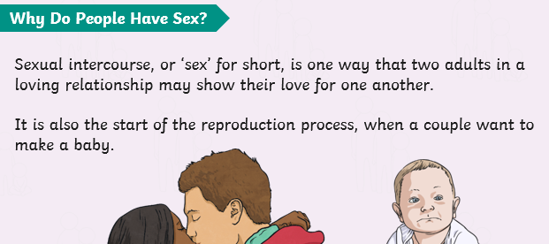  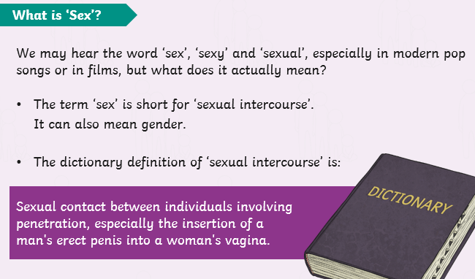  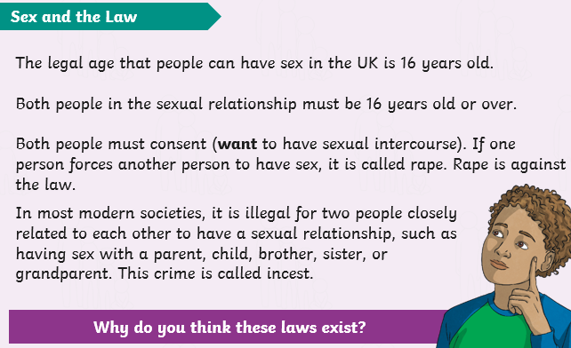  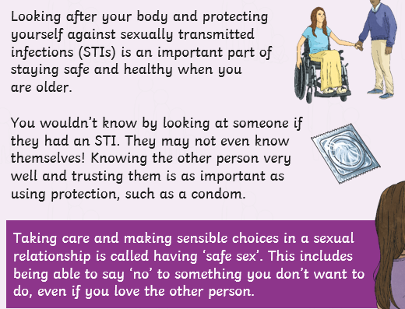  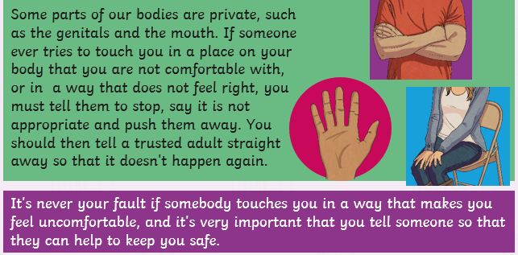  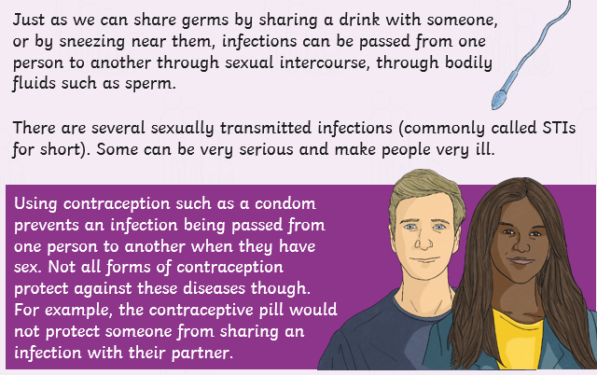  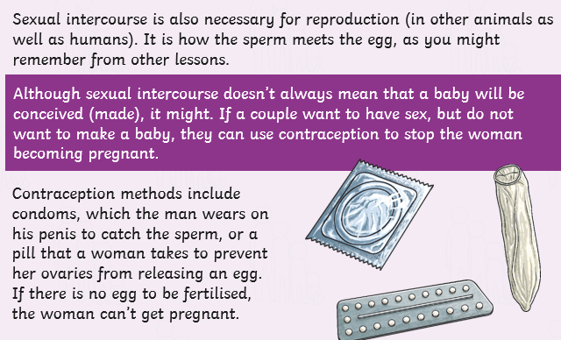
Year 6 | Summer Term 2 | Human Reproduction  The children recap on Human Reproduction from their prior learning in Lower Key Stage 2. The children will know that human contraception is a sperm cell fertisilising an egg (known as conception) to the birth of a baby. They will then find factual information about sperm fertisiling the egg. The specific information is shown in the pictures below. The children will then watch a short video from conception to birth – link provided https://www.youtube.com/watch?app=desktop&v=SK72Iu8TbF4 .  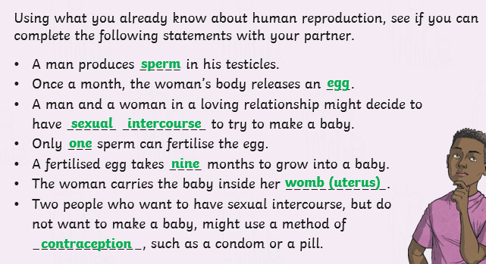  The video just shows scientfic, under the miscroscope, pictures of the conception with images of a baby growing inside the womb. The children will then understand what a Foetus needs: minerals, oxygen, fats, vitamis, protection, protein. The children will find out that after 9 months of growing inside its mother, the baby is ready to be born. This is called labour (building on prior learing). There will be brief explanation explaining the difference when a baby is born by caesarean section.  