Attendance Policy

2025-2026

Contents
Contents 2
Section 1: The Law on School Attendance and a Right to a Full-Time Education 4
Government expectations 4
Legislation 4
Compulsory School Age 5
Irregular Attendance of Non-Compulsory School Aged Children in EYFS 5
Pupils with Medical Conditions or Special Educational Needs and Disabilities 5
Persistent and Severe Absence 5
Section 2: Importance of School Attendance 6
Our Approach 7
Core Model for Improving Attendance 7
Promoting and Celebrating Attendance 7
When Attendance Becomes a Concern 8
School Information 8
The School Day 8
Late Arrivals 8
Absence 9
First Day of Absence 9
Safeguarding and Unexplained Absence 9
Immediate response after registration 9
Reasonable enquiries and joint working 10
Children Missing Education (CME) 10
Extended Unexplained Absence 10
Recording and information sharing 11
Authorised Absence 11
Illness 11
Medical Appointments 11
Religious Observance 11
Unauthorised Absence 11
Term Time Holidays or Extended Leave of Absence 12
Exceptional Circumstances 12
Persistent Absence 12
Penalty Notice 14
Keeping Track of Attendance 15
Roles and Responsibilities 15
Evaluation and Review 16
Appendix 1: The Waterton Tiered Approach to Attendance 17
Wave 1: Universal Attendance Approach 17
Wave 2: Targeted Attendance Approach 18
Wave 3: Intensive Attendance Approach 19
Appendix 2: Waterton Attendance Essentials for Parents 20
Working With Parents 20
The School Day 20
Late Arrivals 21
Absence from School 21
Appendix 3: Penalty notice flow chart 22
Appendix 4: DFE Summary tables of responsibility for school attendance (August 2024) 23
All pupils 23
Pupils at risk of becoming persistently absent 24
Persistently absent pupils 25
Severely absent pupils 26
Support for cohorts of pupils with lower attendance than their peers 26
Support for pupils with medical conditions or SEND with poor attendance 27
Support for pupils with a social worker 28
Looked after and previously looked after children 29
Monitoring 30
Appendix 5: Waterton Attendance Essentials for Parents 31
Working With Parents 31
The School Day 31
Late Arrivals 32
Absence from School 32
Document Detail 33
Version Control 33

Section 1: The Law on School Attendance and a Right to a Full-Time Education
The law entitles every child to an efficient, full-time education suitable to their age, aptitude and any special educational need they may have. It is the legal responsibility of every parent to make sure their child receives that education either by attendance at school or by education otherwise than at school. Where a parent decides to have their child registered at school, they have an additional legal duty to ensure their child attends regularly (DFE 2022).

Regular attendance means children must attend every day the school is open, except where a statutory reason applies, for example illness or leave of absence authorised in advance by the headteacher (DFE 2024). Absence can indicate safeguarding concerns. See Unexplained Absence Protocol and Children Missing Education.

Government expectations
As set out in Working Together to Improve School Attendance (2024):
Schools and academies must:
- promote good attendance and reduce absence, including persistent and severe absence;
- ensure every pupil has access to the full-time education to which they are entitled;
- act early to address patterns of absence;
- work in partnership with families and local authorities.
Parents must:
- ensure children of compulsory school age who are registered at a school attend regularly;
- engage with support offered by the school and local authority to remove barriers to attendance.
Pupils are expected to attend punctually and be ready to learn.

For the purposes of this policy, a parent means:
- all natural parents, whether they are married or not;
- any person who has parental responsibility for a child or young person; and,
- any person who has care of a child or young person (i.e. lives with and looks after the child).

Legislation
The principal legal powers and duties governing school attendance are set out in:
- Education Act 1996 (including Section 444 on parental duty);
- The Education (Pupil Registration) (England) Regulations 2006, as amended;
- The Education (Penalty Notices) (England) Regulations 2007;
- Children Missing Education Statutory Guidance (DfE 2024);
- Keeping Children Safe in Education (KCSIE 2025);
- Working Together to Improve School Attendance (DfE, 2024 – now statutory).
Failure to ensure regular school attendance of compulsory school age children may result in legal action by the Local Authority, including Penalty Notices or prosecution. Under Section 444(1A) of the Education Act 1996, knowingly allowing absence is a separate offence and can carry more serious penalties

Compulsory School Age
Compulsory school age is set out in section 8 of the Education Act 1996 and The Education (Start of Compulsory School Age) Order 1998. A child reaches compulsory school age on the prescribed day following their fifth birthday (or on their fifth birthday if it falls on a prescribed day). The prescribed days are 31 December, 31 March and 31 August. The term ‘summer born’ is used to refer to children born from 1 April to 31 August. These children are not required to start school until a full school year after the point at which they could first have been admitted.

Admission authorities are required to provide for the admission of all children in the September following their fourth birthday. Flexibilities exist for children whose parents do not feel they are ready to begin school before they reach compulsory academy age.

Irregular Attendance of Non-Compulsory School Aged Children in EYFS
Good attendance and punctuality are expected and promoted from the point of entry to the early years foundation stage. Academies will work proactively with families where attendance or punctuality causes concern, helping children establish positive habits from the outset.

Pupils with Medical Conditions or Special Educational Needs and Disabilities
All pupils, including those with long-term medical conditions or SEND, have the right to full-time education. We will maintain the same ambition for attendance for pupils with SEND and long-term medical conditions, make reasonable adjustments, and review impact regularly, in line with KCSIE 2025 and the SEND Code of Practice. Support may include:
- sensitive and solution-focused conversations with parents;
- tailored support plans and reasonable adjustments;
- strategies to remove in-school barriers to attendance;
- regular monitoring of attendance data for vulnerable groups (SEND, Pupil Premium, lowest 20% attainment);
- signposting to additional health, pastoral, or external agency support.
- reasonable adjustments may also include the use of part-time timetables or alternative provision, but only as short-term, clearly documented measures with written agreement from parents and regular review, in line with the Equality Act 2010 and DfE guidance.

Persistent and Severe Absence
In line with Working Together to Improve School Attendance (DfE, 2024), pupils are classified as:
- Persistently absent if they miss 10% or more of their possible sessions (attendance below 90%).
- Severely absent if they miss 50% or more of their possible sessions.
Both persistent and severe absence are recognised nationally as indicators of serious concern and are linked in KCSIE 2025 to safeguarding responsibilities. Reaching these thresholds triggers additional support through the school’s Tiered Approach (appendix 1) and the staged meetings described in Persistent Absence below

Section 2: Importance of School Attendance
At Waterton Academy Trust, every school day counts. We know that children thrive when they feel part of their school community, enjoying learning and building friendships. When children miss school, they miss out not only on lessons but also on these important experiences. That is why regular attendance is so important for academic progress and overall wellbeing. We are determined to work together, with the support of families, to make sure every child has the best chance to succeed and enjoy all that school has to offer.

Under the Education Act 1996, parents are legally responsible for ensuring their child attends school regularly. We ask all families to work with us to promote good attendance and punctuality. While occasional absence may be unavoidable, we aim to reduce absence to the lowest possible levels through clear expectations, celebration of good attendance, and support for children and families where challenges arise. Waterton Trust Academies recognise that absence can be a safeguarding indicator, and actions will in line with KCSIE 2025

The Trust employs an Education Welfare Officer (EWO) who works closely with schools and families to provide additional expert support for improving attendance in line with the Waterton Tiered Approach. If supportive measures do not lead to improvement, formal action may be taken, including written warnings or legal sanctions.

Waterton Academy Trust does not permit flexi-schooling arrangements. All registered pupils are expected to attend school full-time unless otherwise agreed in line with DfE guidance (e.g. for part-time timetables as a short-term support strategy for reintegration).

This policy should be read alongside the Waterton policies on: Safeguarding and Child Protection; SEND; Supporting Pupils with Medical Conditions; and Suspension and Exclusion.

It must also be read in conjunction with the following statutory guidance: Keeping Children Safe in Education (DfE, 2025); Working Together to Improve School Attendance (DfE, 2024 – statutory from August 2024); Children Missing Education – Statutory Guidance for Local Authorities and Schools (DfE, 2024); Parental Responsibility Measures for School Attendance (DfE, updated 2024).
Together, these documents set out the legal duties and safeguarding responsibilities that underpin this Attendance Policy.

Abbreviations
EWS – Education Welfare Service, EWO – Education Welfare Officer, CME – Child Missing Education, WAT – Waterton Academy Trust, LA – Local Authority
PN – Penalty Notice, PA Persistent Absence. SA Severe Absence. (For a 190-day year, PA is typically 19 days or more missed, SA is typically 95 days or more missed.

Our Approach
At Waterton Academy Trust, attendance is a shared responsibility. Our culture is built on belonging and strong relationships, with early intervention where needed. We use accurate and timely data and a three-tier model of support, see Appendix 1. Together, we aim to ensure every child attends regularly, is ready to learn, and can thrive.

Core Model for Improving Attendance
The Waterton Tiered Approach to attendance is based on the following shared commitment to promoting and sustaining high attendance.
- Understand pupils and families holistically
- Foster community, connection, and belonging
- Communicate clearly and constructively with families
- Strengthen classroom provision and engagement
- Deliver targeted interventions where needed
- Use research evidence to inform our work
- Monitor and review impact regularly
- Avoid initiative overload by following implementation guidance
- Ensure governors play a strategic and accountable role

Our approach aligns with the Department for Education’s six principles:
- Expect: Set high standards and build a culture that values attendance
- Monitor: Use data to spot issues early at individual and group level
- Listen and Understand: Explore barriers with families and agree next steps
- Support: Remove in-school barriers and help access wider support
- Formalise: Be clear about expectations and consequences if support isn’t working
- Enforce: Use legal powers when all other avenues have been exhausted

Our commitment and these principles are enacted through Tier 1 universal culture and curriculum, Tier 2 targeted help, and Tier 3 multi-agency and legal routes:

Promoting and Celebrating Attendance
Attendance and punctuality are promoted through class teaching, assemblies, and celebrations. Each school develops its own approach to rewarding and improving attendance in line with the Waterton Tiered Approach to attendance. This is outlined in the document Appendix 2 Template: Attendance Essentials for Parents

When Attendance Becomes a Concern
When absence or lateness becomes persistent or shows little improvement, the academy will take the following actions delivered through Tier 2 targeted support and, where needed, Tier 3 statutory intervention outlines in the Waterton Tiered Approach (appendix 1).
- Monitoring individual cases and attendance trends
- Working together with children and families to build positive routines
- Developing attendance improvement plans with tailored interventions to meet specific needs
- Using formal escalation procedures, including legal action if required

School Information
The agreed attendance target is 96% for the academic year 2025 - targets are set alongside cohort analysis for Pupil Premium and SEND pupils.

Luke Oldroyd is the designated attendance champion for the senior leadership team.

The School Day
The law states that children should arrive at school on time, every day. Each day has two sessions. The register is taken at the start of the morning session and again at the start of the afternoon session. Pupils attend school for 380 sessions or 190 days during a school year. It is a legal requirement that the attendance register be taken at the start of each morning and afternoon session.

The expectations for Sharlston Community School are as follows:

KS1 and EYFS
- 8.45 - The start of the school day. Doors open to pupils and the registration period begins.
- 8.55 - Registration period closes. All external classroom and cloakroom doors are secured and lessons begin.
KS2
- 8.40 - The start of the school day. Doors open to pupils and the registration period begins.
- 8.50 - Registration period closes. All external classroom and cloakroom doors are secured and lessons begin.

Late Arrivals
Late arrivals impact on learning and progress and may also disrupt classroom routines for the class as well as the late pupil.

- Arrivals after 8.55 enter the school through the main door and report to the school office. Parents are required to record the time of arrival and reason for lateness.
- Pupils who arrive late, but before the register has closed (9.10) will be recorded as L in the register. This is counted as a present mark but shows lateness.
- Pupils who arrive late after the register has closed (9.15 onwards) will be coded as U (unauthorised) in the register. This is counted as an unauthorised absence.

At the point of five U coded sessions (within a half term) a warning letter will be issued to parents. This is notification that a Penalty Notice may be issued if persistent lateness after close of registration continues. Persistence lateness is defined as 10 U coded sessions within a 10-week period.

The school register is a legal document, checked regularly by the Headteacher and Trust Education Welfare Officer. Checks ensure registers are being maintained accurately and assess the reasons and frequency of any absence.

Absence
Parents who choose to register their child at school have a legal duty to ensure they attend regularly—this means every day the school is open, unless the child is too ill or leave has been authorised in advance by the headteacher due to exceptional circumstances. All absences should be avoided wherever possible, as even short periods of non-attendance can impact learning.

First Day of Absence
When a child is too unwell to attend school, parents must notify the school by telephone (01924 967614) or email (sharlstonabsence@watertonacademytrust.org) on the first day of absence, clearly stating the reason.

Safeguarding and Unexplained Absence
In line with Keeping Children Safe in Education (KCSIE) 2025, absence from education can indicate a safeguarding concern. The school must follow up unauthorised absence and act swiftly where children are missing. The school will implement the following procedures as part of its Tiered Approach to attendance.

Immediate response after registration
Thirty minutes after the close of registration, if a pupil’s absence remains unexplained, the school will begin its safeguarding response:
- The school will attempt to contact parents or carers by telephone between [9.20 and 9.40]. The school will try at least two emergency contacts, as schools should hold more than one emergency contact number wherever reasonably possible
- If no contact is made, a home visit must be carried out by the members of the school’s pastoral or safeguarding team and may involve the Trust Education Safeguarding Officer.
- Where concerns persist, the Headteacher or Designated Safeguarding Lead will review the information and determine next steps.
- Where the child’s safety cannot be established, the Headteacher or Designated Safeguarding Lead will escalate without delay. This may include informing the Trust Education Welfare Officer, making a referral to Children’s Social Care, and requesting a safe and well check by the police.

Reasonable enquiries and joint working
- When a pupil’s whereabouts are unclear or unknown, schools and the local authority should make reasonable enquiries immediately and jointly, allocating responsibilities and completing checks promptly. These enquiries must be thorough and support-focused, with actions tailored to the specifics of the case.
- The school will use local information-sharing routes and, where appropriate, ask the local authority to use GIAP (Get Information About a Pupil) and S2S (School to School) systems to check whether the child is on roll elsewhere and to trace pupil files.
All staff are reminded, as set out in KCSIE 2025, that “absence from school can be a potential indicator of abuse or neglect” and that “schools must follow up on unauthorised absence and take swift action where children are missing.”

Records of all actions taken must be kept and shared with safeguarding partners in line with statutory duties, Working Together to Improve School Attendance, and the Trust’s Safeguarding and Child Protection Policy.

Children Missing Education (CME)
As defined in KCSIE 2025 and Children Missing Education statutory guidance (DfE 2025), Children Missing Education (CME) are children of compulsory school age who:
- Are children of compulsory school age who are not registered at a school and not receiving suitable education otherwise (e.g. via alternative provision or home education).
- Elective Home Education that is assessed as unsuitable may constitute CME.

The guidance makes clear that children on roll but persistently absent, those receiving suitable elective home education, or those awaiting a school place but still in education do not count as CME.

Extended Unexplained Absence
In line with KCSIE 2025 and Working Together to Improve School Attendance, any period of unexplained absence is treated as a serious safeguarding concern.
- After ten consecutive school days of absence with no successful contact, the case will be reviewed by the Designated Safeguarding Lead and the Trust Education Welfare Officer as a safeguarding matter and managed within Tier 3 of the attendance protocol.
- Where absence continues and the child’s whereabouts cannot be established, the case will be referred to the Local Authority’s Children Missing Education (CME) Officer in line with statutory duties.
- A pupil may be removed from the admission register only on a lawful ground and only after all reasonable enquiries have been made and in consultation with the local authority, for example following 10 consecutive school days of unauthorised absence where whereabouts remain unknown. The school will inform the local authority without delay when removing a pupil from roll at both standard and non-standard transition points and will provide required information.).

Recording and information sharing
The school will record all actions and decisions on its safeguarding and attendance systems and share information with safeguarding partners where necessary to protect a child, in line with KCSIE 2025 and data protection law.

Authorised Absence
Some absences are unavoidable, usually due to illness, bereavement or exceptional family circumstances, and these can be classed as an Authorised Absence. The decision as to whether an absence is deemed authorised or not lies with the Headteacher.

Illness
Children who are reported by a parent as absent through illness are marked with an ‘I’ code. If the authenticity of illness is in doubt or the pupil is absent regularly with the same illness, the school can request medical evidence to support the absence.

Medical Appointments
We request that dental and medical appointments be made out of school hours wherever possible. Where this is not possible, parents are required to verify the appointment at the school office. Pupils should only be out of school for the minimum amount of time necessary for the appointment. Pupils who are reported absent because they are attending a medical appointment are marked with an ‘M’ code. If a pupil returns to school during the sessional time following a medical appointment this will be recorded as present. Evidence of the medical appointment must be provided at the school office once the pupil returns to school.

Religious Observance
Absence due to religious observance is authorised absence. The day must be exclusively set apart for religious observance by the religious body to which the parents belong. Children who are reported as absent due to religious observance are marked with an ‘R’ code.

Unauthorised Absence
Unauthorised absence is that which is not permissible in law, e.g. birthdays, shopping trips, days out, term time holidays, visiting relatives, medical appointments that can’t be verified, and absences where no explanation has been given. The school will closely monitor all unauthorised absence with the Trust Education Welfare Officer and act when thresholds are reached.

Term Time Holidays or Extended Leave of Absence
In line with the government’s amendments to the Education Regulations 2006, the Headteacher will not grant leave of absence for family holidays in term time or extended leave of absence unless there are exceptional circumstances. This applies to all children of compulsory school age. In order to enforce this decision, the Board of Trustees has agreed to the issuing of Penalty Notices for parents taking their children out of school during term time for holiday or extended leave.

Parents who intend to take pupils out of school for a term time holiday or extended leave are required to write to the Headteacher requesting a leave of absence for their child stating the purpose, no later than 4 weeks before the holiday or leave is due to commence. Parents should complete the Leave of Absence Request Form available from the school office or website.

Parents will be notified in writing within two weeks of the Headteacher’s decision and the intention to issue a Penalty Notice should the unauthorised term time holiday or extended leave go ahead. Pupils who are absent from school during term time because of a holiday will be marked with a ‘G’ code (family holiday not authorised) on the school registration system.

Exceptional Circumstances
Only exceptional circumstances warrant a leave of absence. The headteacher will consider each application individually considering specific facts and circumstances and relevant background context behind the request. In situations where exceptional circumstances arise, parents are asked to arrange a confidential meeting as soon as is practicable with the headteacher to discuss these. If a leave of absence is granted, the headteacher will determine the length of time the pupil can be away from school.

As headteachers may only grant a leave of absence in exceptional circumstances, it is unlikely a leave of absence will be granted for the purposes of a family holiday.

The Board of Trustees recognises exceptional circumstances as those relating to: families in crisis; a terminal illness within the immediate family; pre and post operational leave for armed forces families.

Persistent Absence
Persistent absence is when a pupil misses more than 10% or more of school for any reason and where attendance falls below 90%. In keeping with Working Together to Improve School Attendance, absence data will be reviewed on a daily and weekly basis with a focus on disadvantaged pupils, pupils with SEND and pupils in the lowest twenty per cent by prior attainment. In cases where a pupil's absence becomes a cause for concern, the school will actively engage with families to provide appropriate support in line with the Tiered Approach. Where a pupil’s absence is due to a known illness or exceptional circumstances, it will be monitored closely and sensitively in a supportive capacity at Stage 1.

In line with the Tiered Approach, schools will take a proactive and supporting approach to working with parents to ensure pupils who are at risk of being persistent absentees do not become so. Parents/carers will be invited to attend informal meetings at the school for an where attendance is causing concern before reaching stage 1 to improve attendance and avoid Persistent Absence.

Stage 1 Persistent Absence Review Meeting
Where a pupil’s absence falls below 90%, a written warning will be issued and parents will be required to attend a Stage 1 Persistent Absence Review Meeting with the Trust Education Welfare Officer and Luke Oldroyd. At this meeting, an absence review will be carried out, the reasons for absence discussed, and strategies for improvement agreed. Parents will receive a letter detailing the outcomes of the meeting. Parents will be required to show improvement within the next four school weeks.

Stage 2 Serious Concern Persistent Absence Review Meeting
At the end of the four-week period, if there is no evidence of improvement, parents will be required to attend a Stage 2 Serious Concern Persistent Absence Review Meeting with the Trust Education Welfare Officer and Headteacher or deputising senior leader. This is an escalation to serious concern. A further review of continued absence will be carried out and a formalised Attendance Improvement Plan agreed. Parents will be required to meet the actions of the Attendance Improvement Plan within the next four school weeks.

Should further extension be required at Stage 2, this will be limited to a maximum of two additional weeks, with the clear expectation that parents work in full partnership with the school to secure rapid and sustained improvement in attendance

Stage 3 Statutory intervention
Where all other avenues have been exhausted and support is not working and not being engaged with, we will enforce attendance through statutory intervention and prosecution to protect the pupil’s right to an education.

Stage 1 aligns with Tier 2 targeted support. Stage 2 and Stage 3 align with Tier 3 where multi-agency and legal routes may be required. See appendix 1.

Where there is no improvement within four school weeks following the introduction of the Attendance Improvement Plan, parents will be notified that the matter has been referred to the Local Authority Education Welfare Service. This stage leaves parents at risk of a Penalty Notice and/or legal action. Persistent absence not resulting from a known illness or exceptional circumstances also meets the threshold for a social care referral.

Penalty Notice
Schools are required to follow the National Framework for Penalty Notices (August 2024).

Penalty notices will be issued for:

Term Time Leave: Penalty Notice Fines will be issued if parents take unauthorised Term Time Leave of 5 or more consecutive days or accumulative days.
10 Sessions of Unauthorised Absence in a 10 Week Period: A Penalty Notice may be considered/issued when a pupil has had 10 sessions of unauthorised absence in a 10 week period (school weeks). A session is a half day. Ten sessions equals five school days.
Income from fines relating to Penalty Notices go directly to the Local Authority for Court Costs and do not contribute to academy finances.

PER PARENT / PER CHILD
Penalty Notice Fines will continue to be issued per parent per child For Example: 3 Siblings absent for term time leave, would result in each parent receiving 3 separate fines.

FIRST OFFENCE
The first time a Penalty Notice is issued for a Term Time Holiday or Irregular School Attendance the Penalty Notice will be charged at:
£160 per parent, per child if paid within 28 days of issue, reducing to £80 if paid within 21 days.**

SECOND OFFENCE (within 3 years of the First Offence)
Where it is deemed appropriate to issue a second Penalty Notice to the same parent for the same pupil within 3 years of the first notice, the second Penalty Notice will be charged at:
£160 if paid within 28 days (no reduced fee for paying early).
(**Unpaid Penalty Notices after 28 days may result in a parental prosecution).

THIRD OFFENCE (within 3 years of the First Offence)
On the third time that an offence is committed for either a Term Time Holiday and / or Irregular Attendance a Penalty Notice will not be issued, the case may proceed straight to Parental Prosecution under the Single Justice Procedure. If found guilty of the offence of ‘Failure to send a child to school’ the Magistrates can impose a fine up to £1000. Other prosecution tools may also be considered.

See appendix 2 Penalty notice flow chart

Keeping Track of Attendance
At Waterton Academy Trust we use attendance data proactively to identify patterns, inform early intervention, and monitor the impact of our strategies across all academies. We analyse attendance trends at trust, school, year group, and individual pupil levels—placing particular focus on disadvantaged groups, including pupils eligible for Pupil Premium, those with SEND, and the lowest 20% by prior attainment. By tracking these groups closely, we ensure our actions are equitable, targeted, and effective in reducing persistent and severe absence. This data-led approach enables leaders and staff to respond swiftly, tailoring support to where it is most needed to improve outcomes for all pupils.
To ensure parents can keep track of attendance, we will issue an attendance summary at least termly for each pupil detailing the number of days missed. The summary is colour coded to indicate the following:
Great Attendance:  Blue 98% - 100%  No more than 4 school days missed in a year | The best chance of success!
Good Attendance:  Green: 96 – 98%  No more than 8 school days missed in a year | Getting pupils off to a flying start!
Cause for Concern:  Amber: 91 – 95%  Between 10 and 17 school days missed in a year | Less chance of success because of periods of lost learning time.  Gaps in attendance make it harder for pupils to progress well.
Serious Concern:  Red: below 90%  19 or more days missed in a school year | Significant loss of learning time.  Categorised as persistently absent and monitored by the EWO. Could result in a Penalty Notice.

Roles and Responsibilities
The Headteacher, DSL and Senior Attendance Champion ensures staff training in line with Working Together 2024.

Governors will receive a termly attendance report that includes PA and SA rates for key cohorts and the impact of Tier 2 and Tier 3 interventions.

The DFE tables in appendix 3summarise the attendance responsibilities for parents, schools, academy trusts and governing bodies, and local authorities which are outlined in the Working together to improve school attendance guidance DFE (Updated August 2024).

These should be read alongside the statutory guidance documents on parental responsibility measures, children missing education, supporting pupils at school with medical conditions, suspensions and exclusions, alternative provision, and safeguarding.

Evaluation and Review
The Trust will review this policy annually and update accordingly to include changes in the law and guidance on good practice. The policy will be promoted throughout our academy communities and shared with outside agencies and partners as required.

Appendix 1: The Waterton Tiered Approach to Attendance
Waterton schools have a tiered approach to managing attendance, ensuring clear responsibilities for: parents/carers, pupils, school, and external agencies. The approach is structured in three tiers:
Tier 1 – Universal: Strategies for all pupils to promote good attendance.
Tier 2 – Targeted: Additional support for pupils whose attendance is declining or at risk.
Tier 3 – Intensive: Intensive support for pupils with persistent absence or complex attendance needs.

Wave 1: Universal Attendance Approach
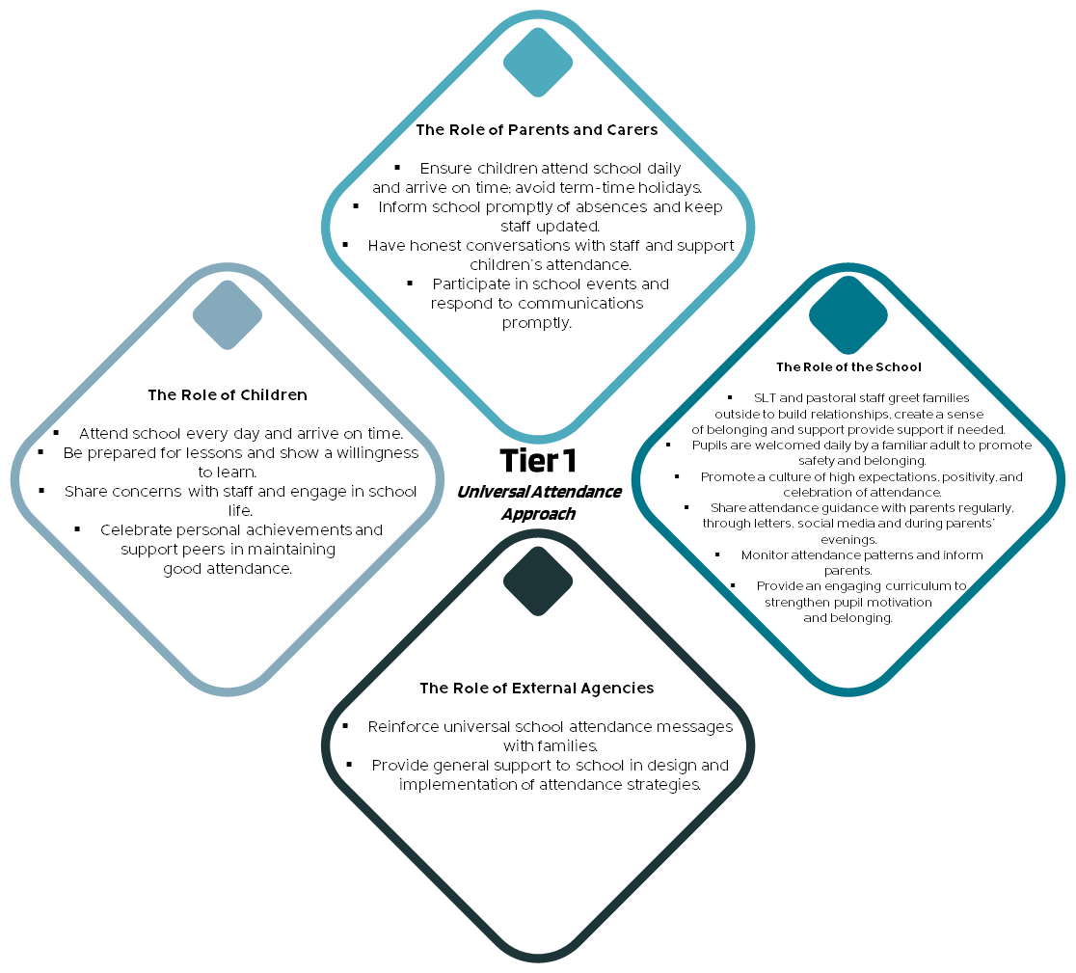
A positive school culture that encourages regular attendance for all and early identification and support for potential attendance issues.

Wave 2: Targeted Attendance Approach
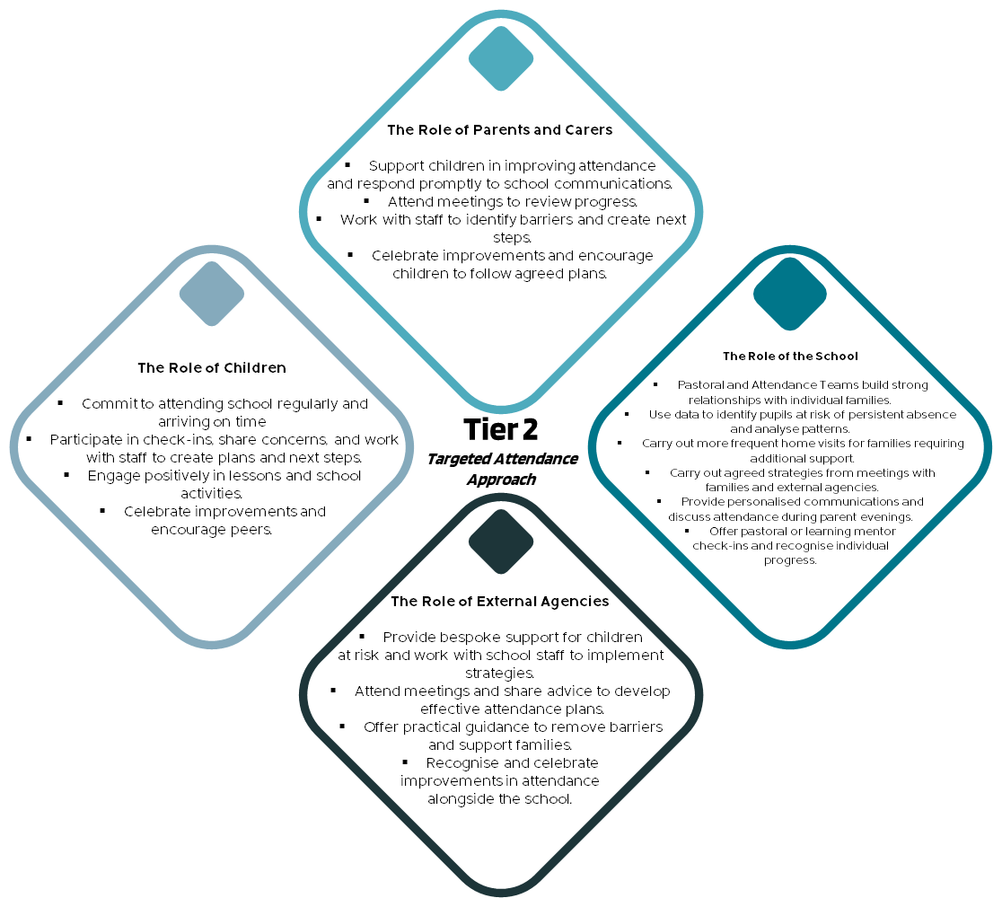
Early intervention and bespoke support for pupils whose attendance is declining or at risk of becoming Persistently Absent (90% attendance or less).

Wave 3: Intensive Attendance Approach
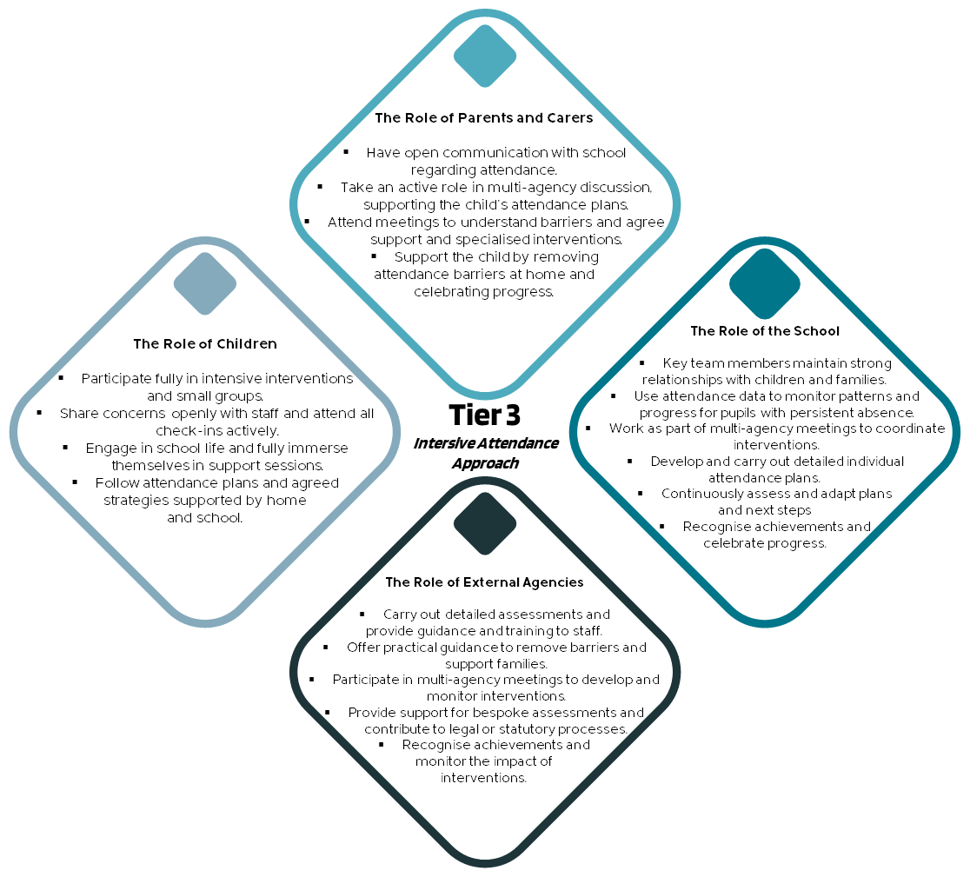
High-level, personalised support for pupils with Persistent Absence (less than 90% attendance) or complex attendance needs.

Appendix 2: Waterton Attendance Essentials for Parents
At Waterton Academy Trust we believe that good attendance underpins every child’s ability to learn, make friends and achieve their best. Every school within our Trust follows the Waterton Attendance Policy and develops its own Attendance Strategy to reflect its unique community, routines and support systems.
At Sharlston Community School, we believe that every day in school counts. Good attendance supports learning, wellbeing, and long-term success. At Sharlston Community School, we know that the best way to help children succeed is by working with parents and carers. We value the strong relationships we build with families and believe that good communication, trust and teamwork make a real difference. Together we can celebrate achievements, spot any worries early, and make sure every child feels happy, supported and ready to learn.

This document sets out what parents at Sharlston Community School need to know at a glance to support good attendance in line with the Waterton Academy Trust Attendance Policy and Tiered Approach to attendance. It also explains how Sharlston Community School promotes excellent attendance, celebrates success, and works with families where attendance becomes a concern through the Tiered Approach to attendance.

Working With Parents
We want every child to attend school at least 96% of the time, as this gives them the best chance to learn and succeed.
- If attendance drops below 95%, we will contact you to talk through any concerns and offer support so improvements can be made.
- The government defines Persistent Absence as attendance below 90%. At this stage, children miss a significant amount of learning, and we work closely with families to address barriers and put plans in place.
Our tiered approach to attendance shows how we support all families – from celebrating good attendance, to offering extra help when attendance begins to fall, through to more intensive support where it is needed most.

The School Day
The law states that children should arrive at school on time, every day. Each school day has two sessions. The register is taken at the start of the morning session and again at the start of the afternoon session. Pupils attend school for 380 sessions or 190 days during a school year.

KS1 and EYFS
- 8.45 - The start of the school day. Doors open to pupils and the registration period begins.
- 8.55 - Registration period closes. All external classroom and cloakroom doors are secured and lessons begin.
KS2
- 8.40 - The start of the school day. Doors open to pupils and the registration period begins.
- 8.50 - Registration period closes. All external classroom and cloakroom doors are secured and lessons begin.

Late Arrivals
Late arrivals affect learning and progress and may also disrupt classroom routines for the class as well as the late pupil.
- Arrivals after 8.55am enter the school through the main door and report to the school office. Parents are required to record the time of arrival and reason for lateness.
- Pupils who arrive late, but before the register has closed (9.10am) will be recorded as L in the register. This is counted as a present mark but shows lateness.
- Pupils who arrive late after the register has closed (9.15 onwards) will be coded as U (unauthorised) in the register. This is counted as an unauthorised absence.

Absence from School
If your child is too unwell to attend school, parents must notify the school by telephone (01924 967614) or email (sharlstonabsence@watertonacademytrust.org) on the first day of absence, clearly stating the reason. Any unexplained absence will be treated as a possible safeguarding concern.

If your child is absent from school without a reason, a member of our team will contact you by phone call at the start of the school day. If we are unable to contact you, we will follow up with a phone call from 9.20am. If we are unable to make contact by 10.00am we will follow up with a possible home visit or referral if concerns remain.

Celebrating and Promoting Attendance at Sharlston Community School

- Class awards - weekly attendance league table (EYFS, KS1 and KS2) – Winners get rewards (100%, phase winners, better than the school’s target
- Individual awards – 100% for the week and enter into a prize draw
- Individual awards – 96%+ for a half term and receive a certificate
- Promotion through Instagram and newsletters
- Individual recognition ongoing throughout the year
- Reported to parents each term during Parents’ Evenings.

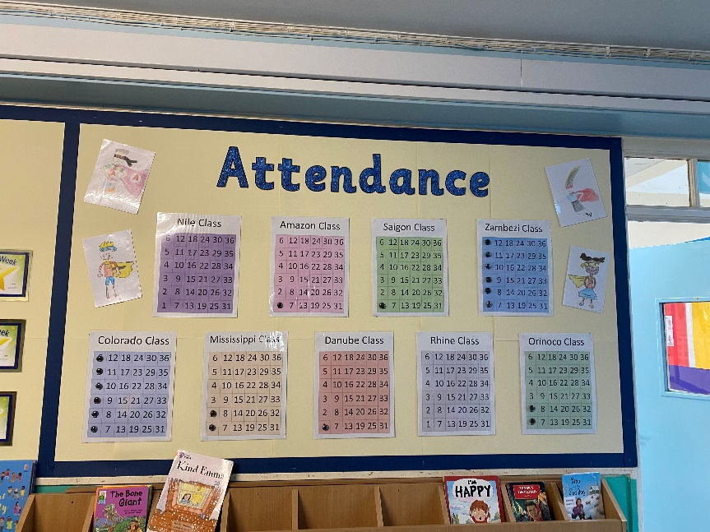

For attendance questions and support contact: Luke Oldroyd – Headteacher

Appendix 3: Penalty notice flow chart
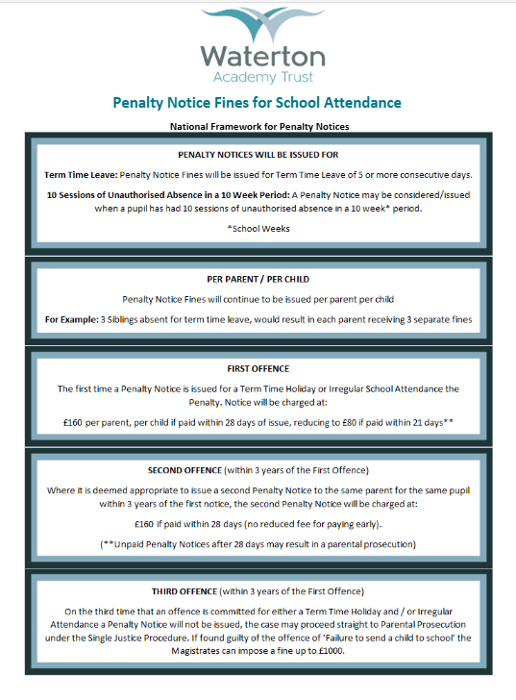

Appendix 4: DFE Summary tables of responsibility for school attendance (August 2024)

All pupils
Parents are expected to: | Schools are expected to: | Academy trustees and governing bodies are expected to: | Local authorities are expected to:
Ensure their child attends every day the school is open except when a statutory reason applies.  Notify the school as soon as possible when their child has to be unexpectedly absent (e.g. sickness).  Only request leave of absence in exceptional circumstances and do so in advance.  Book any medical appointments around the school day where possible. | Have a clear school attendance policy on the school website which all staff, pupils and parents understand.  Develop and maintain a whole school culture that promotes the benefits of good attendance.  Accurately complete admission and attendance registers.  Have robust daily processes to follow up absence.  Regularly monitor data to identify patterns and trends and understand which pupils and pupil cohorts to focus on.  Have a dedicated senior leader with overall responsibility for championing and improving attendance. | Take an active role in attendance improvement, support their school(s) to prioritise attendance, and work together with leaders to set whole school cultures.  Ensure school leaders fulfil expectations and statutory duties.  Use data to understand patterns of attendance, compare with other local schools, identify areas of progress and where greater focus is needed.  Ensure school staff receive training on attendance. | Have a strategic approach to improving attendance for the whole area and make it a key focus of all frontline council services.  Have a School Attendance Support Team that works with all schools in their area to remove area-wide barriers to attendance.  Provide each school with a named point of contact in the School Attendance Support Team who can support with queries and advice.  Offer opportunities for all schools in the area to share effective practice.

Pupils at risk of becoming persistently absent
Parents are expected to: | Schools are expected to: | Academy trustees and governing bodies are expected to: | Local authorities are expected to:
Work with the school and local authority to help them understand  their child’s barriers to attendance.  Proactively engage with the support offered to prevent the need for more formal support. | Proactively use data to identify pupils at risk of persistent absence.  Work with each identified pupil and their parents to understand and address the reasons for absence, including any in-school barriers to attendance.  Where out of school barriers are identified, signpost and support access to any required services in the first instance and act as lead practitioner if attendance is the only issue and/or the local threshold for formal early help is not met.  If the issue persists, take an active part in the multi-agency effort with the local authority and other partners. If a case meets the local threshold for formal early help/family support, this includes conducting the early help assessment and acting as the lead practitioner where all partners agree that the school is the best placed lead service. Where the lead practitioner is outside of the school, continue to work with the local authority and partners. | Regularly review attendance data and help school leaders focus support on the pupils who need it. | Hold a regular conversation with every school to identify, discuss and signpost or provide access to services for pupils who are persistently or severely absent or at risk of becoming so.  Where there are out of school barriers, provide each identified pupil and their family with access to services they need in the first instance.  If the issue persists, and there are multiple needs consider whether the threshold for early help is met and facilitate access where it is. Regardless, take an active part in the multi-agency effort with the school and other partners. Provide the lead practitioner in cases where threshold is met and all partners agree that a local authority service is best placed to lead. Where the lead practitioner is outside of the local authority, continue to work with the school and partners.

Persistently absent pupils
Parents are expected to: | Schools are expected to: | Academy trustees and governing bodies are expected to: | Local authorities are expected to:
Work with the school and local authority to help them understand their child’s barriers to attendance.  Proactively engage with the formal support offered – including any parenting contract or voluntary early help plan to prevent the need for legal intervention. | Continue support as for pupils at risk of becoming persistently absent and:  Where absence becomes persistent, put additional targeted support in place to remove any barriers. Where necessary this includes working with partners.  Where there is a lack of engagement, hold more formal conversations with parents and be clear about the potential need for legal intervention in future.  Where support is not working, being engaged with or appropriate, work with the local authority on legal intervention.  Where there are safeguarding concerns, intensify support through a referral to statutory children’s social care.  Work with other schools in the local area, such as schools previously attended and the schools of any siblings. | Regularly review attendance data and help school leaders focus support on the pupils who need it. | Continue support as for pupils at risk of becoming persistently absent and:  Work jointly with the school to provide formal support options including attendance contracts and education supervision orders.  Where there are safeguarding concerns, ensure joint working between the school, children’s social care services and other statutory safeguarding partners.  Where support is not working, being engaged with or appropriate, enforce attendance through legal intervention (including prosecution as a last resort).

Severely absent pupils
Parents are expected to: | Schools are expected to: | Academy trustees and governing bodies are expected to: | Local authorities are expected to:
Work with the school and local authority to help them understand their child’s barriers to attendance.  Proactively engage with the formal support offered – including any parenting contract or voluntary early help plan to prevent the need for legal intervention. | Continue support as for persistently absent pupils and:  Agree a joint approach for all severely absent pupils with the local authority. | Regularly review attendance data and help school leaders focus support on the pupils who need it. | Continue support as for persistently absent pupils and:  All services should make this group the top priority for support. This may include a whole family plan, consideration for an education, health and care plan, or alternative form of educational provision.  Be especially conscious of any potential safeguarding issues, ensuring joint working between the school, children’s social care services and other statutory safeguarding partners. Where appropriate, this could include conducting a full children’s social care assessment and building attendance into children in need and child protection plans.

Support for cohorts of pupils with lower attendance than their peers
Parents are expected to: | Schools are expected to: | Academy trustees and governing bodies are expected to: | Local authorities are expected to:
Not applicable. | Proactively use data to identify cohorts with, or at risk of, low attendance and develop strategies to support them.  Work with other schools in the local area and the local authority to share effective practice where there are common barriers to attendance. | Regularly review attendance data and help school leaders focus support on the pupils who need it. | Track local attendance data to prioritise support and unblock area wide attendance barriers where they impact numerous schools.

Support for pupils with medical conditions or SEND with poor attendance
Parents are expected to: | Schools are expected to: | Academy trustees and governing bodies are expected to: | Local authorities are expected to:
Work with the school and local authority to help them understand their child’s barriers to attendance.  Proactively engage with the support offered. | Maintain the same ambition for attendance and work with pupils and parents to maximise attendance.  Ensure join up with pastoral support and where required, put in place additional support and adjustments, such as an individual healthcare plan and if applicable, ensuring the provision outlined in the pupil’s EHCP is accessed.  Consider additional support from wider services and external partners, making timely referrals.  Regularly monitor data for such groups, including at board and governing body meetings and with local authorities. | Regularly review attendance data and help school leaders focus support on the pupils who need it. | Work closely with relevant services and partners, for  example special educational needs, educational psychologists, and mental health services, to ensure joined up support for families.  Ensure suitable education, such as alternative provision, is arranged for children of compulsory school age who because of health reasons would not otherwise receive a suitable education.

Support for pupils with a social worker
Parents are expected to: | Schools are expected to: | Academy trustees and governing bodies are expected to: | Local authorities are expected to:
Work with the school and local authority to help them understand their child’s barriers to attendance.  Proactively engage with the support offered. | Know who the pupils who have, or who have had, a social worker are.  Understand how the welfare, safeguarding, and child protection issues that they are experiencing, or have experienced, can have an impact on attendance – whilst maintaining a culture of high aspiration for the cohort.  Provide additional academic support and make reasonable adjustments to help them, recognising that even when statutory social care intervention has ended, there can be a lasting impact on children’s educational outcomes.  Work in partnership with the local authority at a strategic and individual level, sharing data on attendance including, at an individual level, informing the pupil’s social worker if there are any unexplained absences and if their name is to be deleted from the register. | Regularly review attendance data and help school leaders focus support on the pupils who need it. | Ensure that all Children’s Social Care practitioners understand the importance of good attendance for pupil’s educational progress, for their welfare and their wider development – and understand their role in improving it.  Through the work of Virtual School Heads, they should:  - Undertake systemic monitoring and data sharing of the attendance of children with a social worker in their area: developing and implementing targeted cohort level interventions to improve attendance.  - Provide advice, challenge and training to schools on how to promote and secure good attendance for children with a social worker.  - Develop whole system approaches, with social care, to support the attendance of children in need.

Looked after and previously looked after children
Parents are expected to: | Schools are expected to: | Academy trustees and governing bodies are expected to: | Local authorities are expected to:
Work with the school and local  authority to help them understand the child’s barriers to attendance – including the development of  Personal Education Plans.  Proactively engage with the support offered. | Have high expectations for the cohort – with expert support and leadership provided by the designated teacher for looked-after and previously looked-after pupils.  Work in partnership with the local authority Virtual School Head to develop and deliver high quality Personal Education Plans for lookedafter children that support good attendance.  Work directly with parents to develop good home-school links that support good attendance. For previously looked-after pupils this could include discussion on use of the Pupil Premium Plus funding managed by the school. | Designate a member of staff to have responsibility for the promotion of the educational achievement of looked-after and previously looked-after pupils.  Monitor and review attendance of the cohort and consider how school policies, including behaviour policies, are sensitive to their needs and support good attendance. | Promote the educational achievement of looked-after and previously looked-after children – doing everything possible to minimise disruption to education when a pupil enters care.  (LA that looks after the child:) Appoint an expert Virtual School Head (VSH) – will:  - Monitor, report on, and evaluate the education outcomes of looked after children, including their attendance, as if they attended a single school - wherever they live or are educated.  - Ensure schools know when they have a pupil looked after by the authority on their role and that information is shared with the school on issues that may impact on their attendance.  - Ensure that all looked-after pupils have high quality, up to date, effective Personal Education Plans developed in partnership with schools, social workers and carers – including, where necessary, clear interventions and use of pupil premium plus funding to support good attendance.  - Provide expert advice and information on the education of previously looked-after pupils to schools and parents – including their attendance.

Monitoring
Parents: | Schools: | Academy  trustees and governing bodies: | Local authorities:
Schools regularly update parents on their child’s attendance.  (If parents feel the school and/or local authority have not delivered what they are expected to they should discuss the case with the school and/or local authority’s attendance support team.) | The school’s Senior Attendance Champion will ensure all school-based staff complete their attendance responsibilities in line with the school’s policies and procedures.  The governing board or academy trust will hold the headteacher or executive leadership to account for their delegated responsibilities and for compliance with regulatory and statutory requirements. They will review progress and provide challenge when required. The board will help school leaders focus improvement efforts on the individual pupils or cohorts who need it most and ensure that school staff receive adequate training on attendance.  Ofsted will expect schools to do all they reasonably can to achieve the highest possible attendance as part of the behaviour and attitudes judgement. This includes, where attendance is not consistently at or above what could reasonably be expected, that schools have a strong understanding of the causes of absence (particularly for persistent and severe absence) and a clear strategy in place that takes account of those causes to improve attendance for all pupils.  Ultimately, in cases where a school has not met expectations or statutory duties the Secretary of State can consider a complaint. | DfE Regions Group considers multi academy trusts’  efforts on  attendance as part of decision making.  Ofsted considers governing bodies’ efforts as part of inspections. | DfE Regions Group monitors local authority efforts as part of regular interaction.  Ofsted may consider the local area partnership’s approach to improving attendance of children and young people with SEND as part of the SEND Area Inspection, and the local authority’s approach to improving attendance for children with a social worker through inspecting local authority children’s services.  Ultimately, in cases where a local authority has not met expectations or statutory duties the Local Government and Social Care Ombudsman or the Secretary of State can consider a complaint.

Document Detail
Document Name: |  |  | Attendance Policy
Version: |  |  | 4
Chief Officer Signature: |  |  | M Bretherton, DCEO
Effective From: |  |  | November 2023
Approved by: |  |  | ELT
Approval Meeting Reference: |  |  | July 2024
Next Review Date: |  |  | July 2025

Version Control
Version | Date | Author |  | Change/Reference
1 | November 2018 | G Bishop
2 | February 2020 | D Dickinson |  | Changes to Governance structures
3 | June 2022 | L Cavell |  | Updated in line with DfE Guidance Working Together to Improve School Attendance. Policy to be personalised to each school. Table of roles and responsibilities added.
4 | November 2023 | M Bretherton |  | Reformatting and further clarification on timeframes.
5 | July 2024/ Sept 2025 | M Sherrard |  | No significant changes.
6 | Sept 2025 | B Robertson  M Sherrard |  | Policy separated into separate sections on law –section 1 and policy section 2.  Update of the policy wording to reflect introduction of the Waterton Tiered Approach to attendance (created in consultation with HTs and attendance leaders), and to reflect an increased emphasis on working pastorally, building relationships and sense of belonging.  Policy updated in line with 2025 statutory expectations in:  - DFE Working together to improve attendance statutory from August 2024  - KCSiE 2025  - DFE CME statutory guidance September 2025  New appendices:  - Penalty notice guidance;  - Waterton Tiered Approach to Attendance. Attendance Essentials for Parents.  Updated appendices:  - DFE August 2024 tables (replaced 2022 tables).

